

              TEAM TROJAN

**User Experience Engineering (SE3050) -2022**

**Topic** : Life on Land

**Group ID:** SER028

**App Name:** Eco Bash

**Group Details:**

|  |  |
| --- | --- |
| Student ID | Student Name |
| IT20125066 | Chandrasena. A.P.M |
| IT20147082 | D.H.S.V. Dhanapala |
| IT20258030 | Gunawardhana H.P.M.N |
| IT20136710 | Kariyapperuma K.M.K.R |

User Experience Engineering SE3050

Department of Computer Science and Software Engineering, Faculty of Computing, Sri Lanka Institute of Information Technology (SLIIT)

# Declaration

We declare that this is our own work, and this report does not incorporate without acknowledgment any material previously submitted for a degree or diploma in any other university or institute of higher learning, and to the best of my knowledge and belief it does not contain any material previously published or written by another person except where the acknowledgment is made in the text. Also, we hereby grant to Sri Lanka Institute of Information Technology the non-exclusive right to reproduce and distribute our report in whole or part in print, electronic, or another medium. We retain the right to use this content in whole or part in future works (such as articles or books).

|  |  |  |  |
| --- | --- | --- | --- |
| Student No. | Name | Date | Signature |
| IT20125066 | Chandrasena. A.P.M | 11/06/22 |  |
| IT20147082 | D.H.S.V. Dhanapala | 11/06/22 |  |
| IT20258030 | Gunawardhana H.P.M.N | 11/06/22 |  |
| IT20136710 | Kariyapperuma K.M.K.R | 11/06/22 |  |

# Abstract

This is the final phase of the project done under our User Experience Engineering module. This project consists of 7 major milestones. All the details we have done in the respective steps are summarized in this report. In addition, the A-z design of the project and the necessary information up to the final development are included in this document. Basically, an introduction about the app has been made here. A competitor analysis has been done in other segments. There, advantages, disadvantages and our app have been compared with that app. Apart from that, a requirements specialization has been done. This document contains information about the design principle and how the project was managed. Basically, the information related to the documents related to each milestone is also included in this document.

Table of Contents

Declaration 2

Abstract 3

List of Figures 9

List Of Abbreviations 10

1 Introduction 11

2 Background 12

2.1 SDG selection 12

2.2 Design Purpose 12

2.3 Team Members 13

2.4 Contribution Table 13

3 Design Process 14

3.1 User Involvement 14

4 Milestone 1: Identify user groups 15

4.1 Persona(s) – 04 personas from a group 15

4.2 Empathy map(s) – 04 Empathy maps from a group 19

4.3 User stories – 04 User stories from a group 23

4.4 User flow(s) - 04 User flows from a group 24

4.5 Service Blueprint(s) – 01 Service Blueprint from a group 28

5 Milestone 2: Plan and conduct user research 30

5.1 IT 20125066 30

Questionnaire link 31

5.2 IT20147082 38

5.3 IT 20258030 46

5.4 IT20136710 55

6 Milestone 3: Verify the key-user flow(s) 63

**6.1** **IT 20125066** 63

**6.2** **IT20147082** 68

**6.3** **IT 20258030** 0

6.4 IT 20136710 7

**1** **Block Point 2** 10

**2** **Block Point 2** 10

**3** **Block Point 3** 12

**4** **Block Point 2Block Point 3** 12

7 Competitor Analysis 15

8 Milestone 4: Sketching 18

**8.1** **Admin Side Sketches** 23

8.2 IT20125066 26

8.2.1 Low fidelity wireframe 26

8.2.2 Function: Organic Farming Management 26

8.2.3 Function: Organic Farming Management 32

8.3 Prototype Links 38

8.4 User Feedback Gathering 38

8.5 **User Side Wireframes** 44

8.6 **Admin Side Wireframes** 49

**9** **User Responses** 52

**Prototypes Links** 56

9.1 **User Side prototype** 56

9.2 **Admin Side prototype** 56

9.2.1 User Side Wireframes 57

9.2.2 Admin Wire Frames 63

9.2.3 Feedback Google form Link 68

**10** **Feedback Google form Responses** 68

10.1 IT20147082 72

10.1.1 Low fidelity wireframe 72

10.1.2 Function: Organic Farming Management 72

10.1.3 Prototype Links 85

Admin Part 85

User Part : 85

10.1.4 Questionnaire 85

Questionnaire link 85

11 Milestone 5: Wireframes, Prototype 91

11.1 IT20125066 91

11.1.1 User Side 91

91

11.1.2 Admin Side 96

98

99

12 Prototype Links 100

12.1 User Feedback Gathering 100

12.2 IT20258030 101

13 User Side UIs 101

14 Admin Side UIs 110

14.1 Prototype Link 116

14.2 User Feedback Gathering 116

14.3 IT20147082 117

14.4 UI DESIGNIGIN 122

14.4.1 Admin Side 122

124

14.4.2 Prototype Links 125

14.4.3 Admin Part: 125

14.4.4 User Part: 125

14.4.5 User Feedback Gathering 125

14.5 IT20136710 126

14.5.1 User Feedback Gathering 126

14.5.2 Prototypes Links 126

14.5.3 User Side prototype version 2 126

14.5.4 Admin Side prototype version 2 126

14.5.5 User Side UI (Prototype version2) 127

14.5.6 Admin Side UI (prototype version 2) 129

15 Milestone 6: User Feedback for your Prototype 133

**15.1** **IT 20125066** 133

**15.2** **IT20147082** 133

**15.3** **IT 20258030** 133

**15.4** **IT 20136710** 133

16 Milestone 7: Implementation 134

17 Requirement Specification 135

17.1 Usability Goals 135

17.2 User Experience Goals 136

17.3 Functional Requirements 136

17.4 Non-Functional Requirements 136

17.5 Hierarchical Task Analysis 137

18 Design Principles 138

19 Project Management 141

19.1 Meetings 141

19.2 Risk Management 141

19.3 Milestones 141

19.4 Problems Encountered 142

20 Conclusion 143

References 144

Appendix 145

20.1 Initial User Survey Responses 145

20.2 Links to Google Docs / MS Teams 147

20.3 Contribution Table 147

**Tip #1:** The purpose of this template is to ensure you cover the main content required in your report. However, this report template is not absolute. You can add or replace some sections if needed. Marks depend on the quality of the content of the report.

**Tip #2:** There is no minimum or maximum page limit, Note, the report must be professionally and succinctly written with emphasis on clarity. Content that is not essential should not be included. There may be a suggested word limit for some sections.

**Tip #3:** Although not essential, you may choose your own document template to deliver a beautifully presented industry-ready report.

**Tip #4:** Read this whole document early in the course.

# List of Figures

Figure 1-IT20125066.persona 14

Figure 2-IT20147082.persona 15

Figure 3-IT20258030.persona 16

Figure 4-IT20136710.personaFigure 3-IT20258030.persona 16

Figure 4-IT20136710.persona 17

Figure 5-IT20125066.Empathy map 18

Figure 6-IT20147082.Empathy map 19

Figure 7-IT20258030.Empathy map 20

Figure 8-IT 20136710.Empathy map 21

Figure 9-IT20125066.User Flow 23

Figure 10-IT20147082.User Flow 24

Figure 11-IT20258030.User Flow 25

Figure 12-IT20136710.User Flow 26

Figure 13-User Side Service blue print 27

Figure 14-Admin Side service blue print 28

Figure 15-Competitor 01 sample screenshot 15

Figure 16-Competitor 2 sample screenshot 16

Figure 17-Competitor 3 sample screenshot 17

# List Of Abbreviations

|  |  |
| --- | --- |
| UI | User Interface |
| UX | User Experiences |
| API | Application programming interface |
| SDG | Sustainable Development Goals |
| UN | United Nations |

# Introduction

Due to the various bad actions of man and the lack of knowledge to use agricultural activities correctly, the chemical damage to the soil has increased today. The land is desolate because people are least engaged in agriculture. Under this situation, the people of the world focus on agriculture, but they do not have proper knowledge and experience.

As a successful solution to all these challenges, this Eco Bash app can be introduced as an easy-to-use mobile application for providing environmentally friendly agricultural methods and agricultural knowledge. In terms of soil type, soil conservation, soil animal and organic farming, this app has been designed according to people's needs and very creatively.

# Background

## SDG selection

Here we carried out this project based on the Goal of **Life on Land** which comes under the UN Sustainable Development Goals. According to the United Nations, its main objectives are to protect, restore and promote the sustainable use of terrestrial ecosystems, sustainably manage forests, combat desertification, and halt and reverse land degradation and biodiversity loss. Thus, we focused on the chemical damage caused to the soil today due to the various bad actions of man and the lack of knowledge to use agricultural activities correctly. People focus on agriculture but they lack proper knowledge and experience. As a successful solution to all these challenges, we aimed to create an easy-to-use mobile application to provide environmentally friendly agricultural methods and agricultural knowledge.

For one or two decades, farmers began to farm using chemical fertilizers and used versions of unpractical and harmful farming actions. As a result of that, the micro livers like bacterizes began to die or destroy. They are the natural help for the plants to grow. As they no longer exist the soil became useless. As much as environmental activists explain this farmer did not want to listen because the chemicals and other harmful tricks brought them more harvest and money so far. Also, people did not realize the harm because the harm did not bring out in a short period. Not only for the soil but also harms the health of the people in various ways.

Primarily, the SDGs aim to protect, restore and promote the conservation and sustainable use of terrestrial and other ecosystems to conserve biodiversity on land. Soil is a very important element in discussing the land there. Currently, we do not pay much attention to the conservation of this soil. Also, soil conservation and related issues are not discussed so much. Therefore, we chose this topic to socialize details and more tips and tricks on how to engage in daily gardening and agricultural activities without damaging the soil.

## Design Purpose

Mainly we wanted to design a clean and clear UI. The main reason for this is that this app is used by different age groups and is mostly used to gain knowledge. Therefore, we were mainly more concerned about the UI goals of user friendliness, usability and efficiency than attractiveness.

## Team Members

List the team members and their role.

## Contribution Table

|  |  |  |
| --- | --- | --- |
| IT number | Name | Contribution |
| IT20125066 | Chandrasena. A.P.M | * Equally contributed to the document creation * Developed Own functionality of the app * Make own millstone documents |
| IT20147082 | D.H.S.V. Dhanapala | * Equally contributed to the document creation * Developed Own functionality of the app * Make own millstone documents |
| IT20258030 | Gunawardhana H.P.M.N | * Equally contributed to the document creation * Developed Own functionality of the app * Make own millstone documents |
| IT20136710 | Kariyapperuma K.M.K.R | * Equally contributed to the document creation * Developed Own functionality of the app * Make own millstone documents |

# Design Process

## User Involvement

Since the beginning of the designing part the try to always get to involve the users to have a better user-friendly application for the user and our requirements. At the beginning of the designing, we conduct an interview with users and describe our plans for the mobile application. To have better information and requirements we conduct interview with different persons who we thought the application would use in the future. For example, we assume that our application will surely use farmers and specialists of farming and the soil. So, we contact them and get the ideas and requirements to the application. Not only them we assume that some people would use this application who does not have an enough understanding about farming but wants to build a farm and to know about the different type of soil in Sri Lanka. So, when we are selecting users, we focus on all those points and get feedback. Not only that we have created a google form to get more data to analyst the system.

In the UI designing part of the application, we contact the users and get their feedbacks about them. There we mainly focus of the user friendliness about the system. To have a better understanding to the user we have design a prototype version of our system and present it the user to get their feedbacks. According to their feedbacks we have re-design according to what they mentioned. So throughout the design process we have get a closer interaction with the users to build a better product.

# Milestone 1: Identify user groups

## Persona(s) – 04 personas from a group

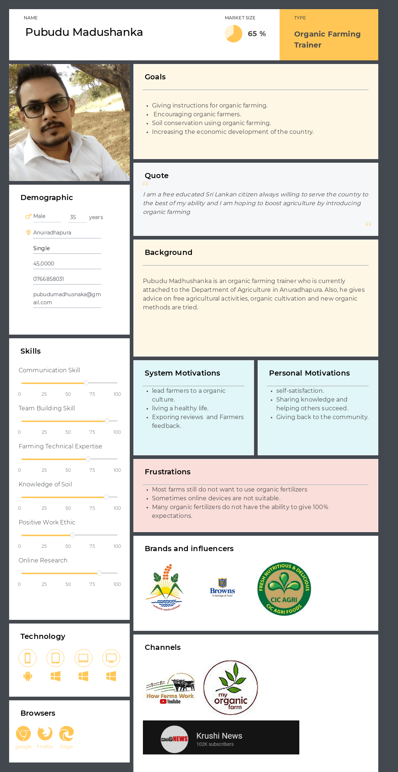

Figure 1-IT20125066.persona

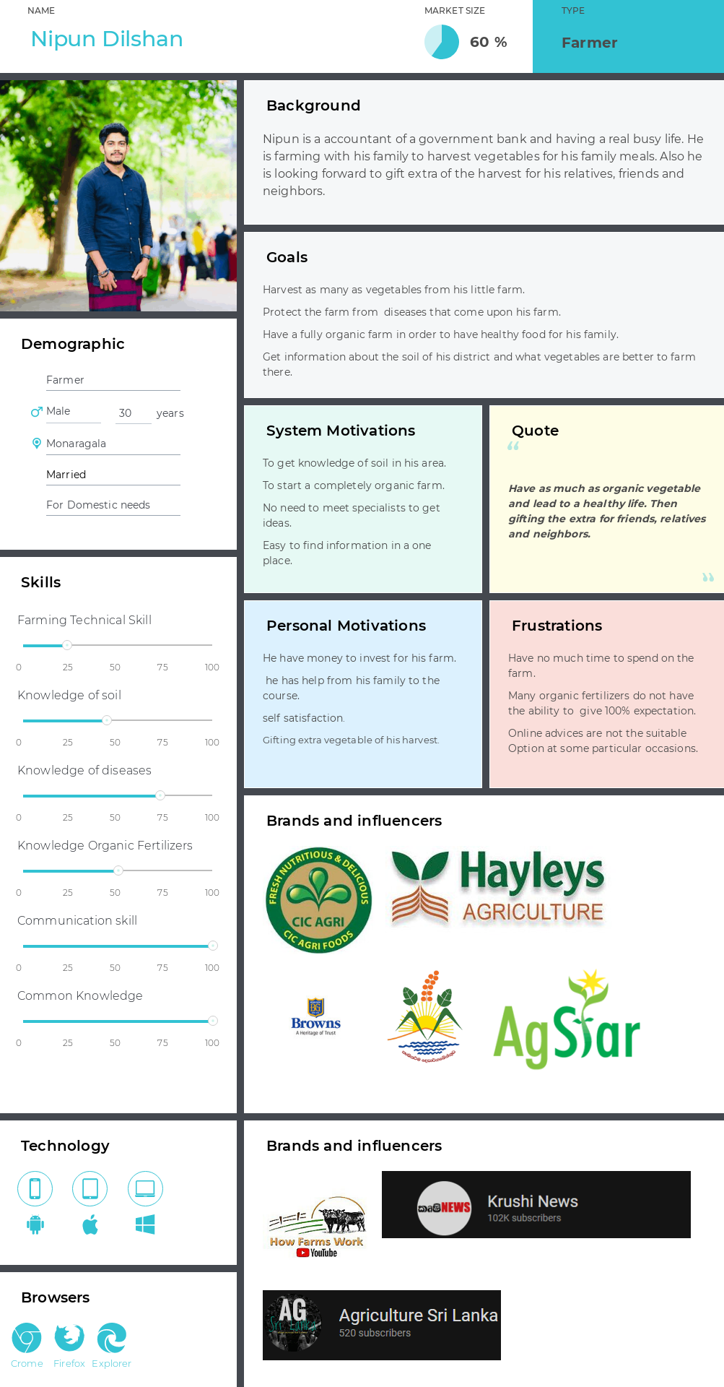

Figure 2-IT20147082.persona

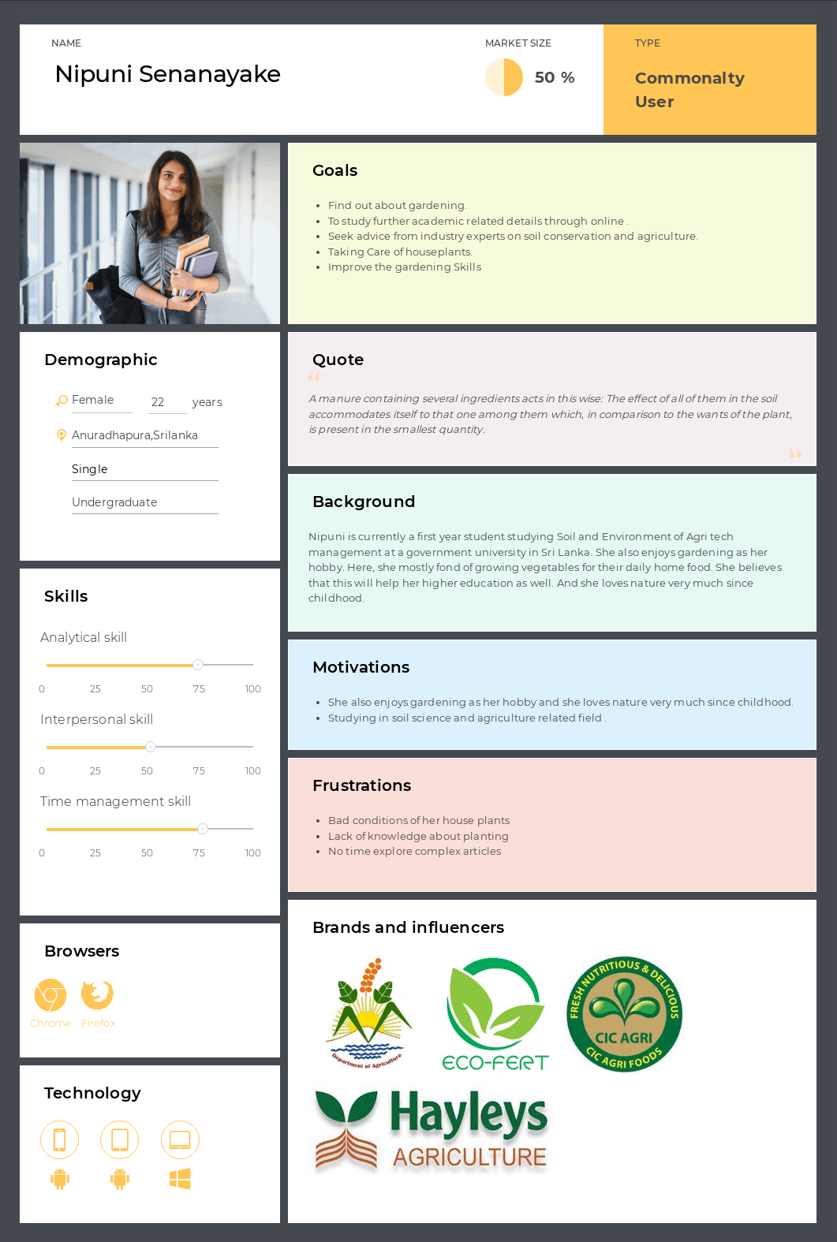

Figure 3-IT20258030.persona

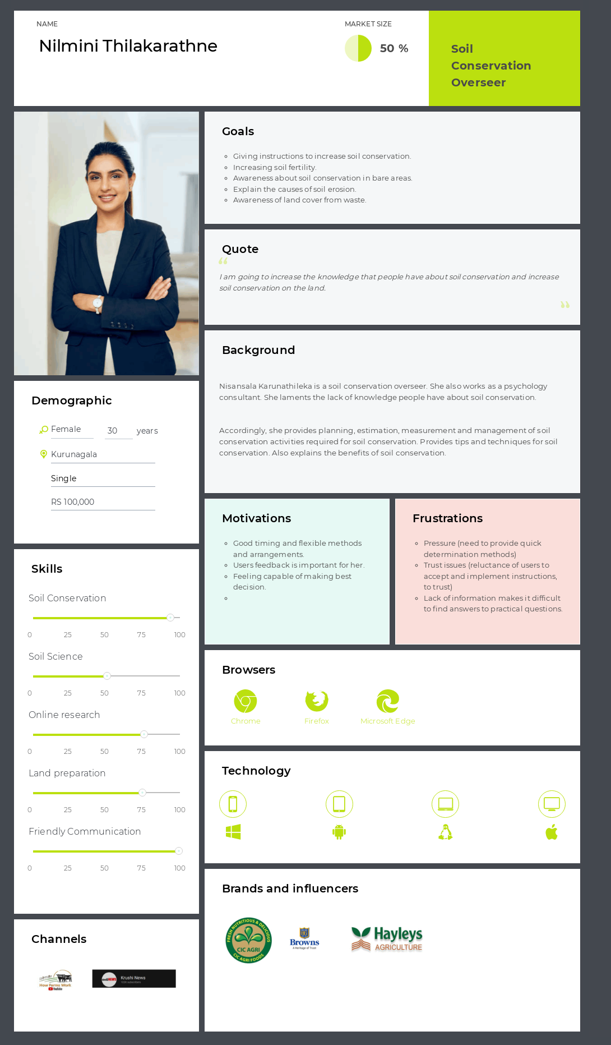

Figure 4-IT20136710.persona

## Empathy map(s) – 04 Empathy maps from a group

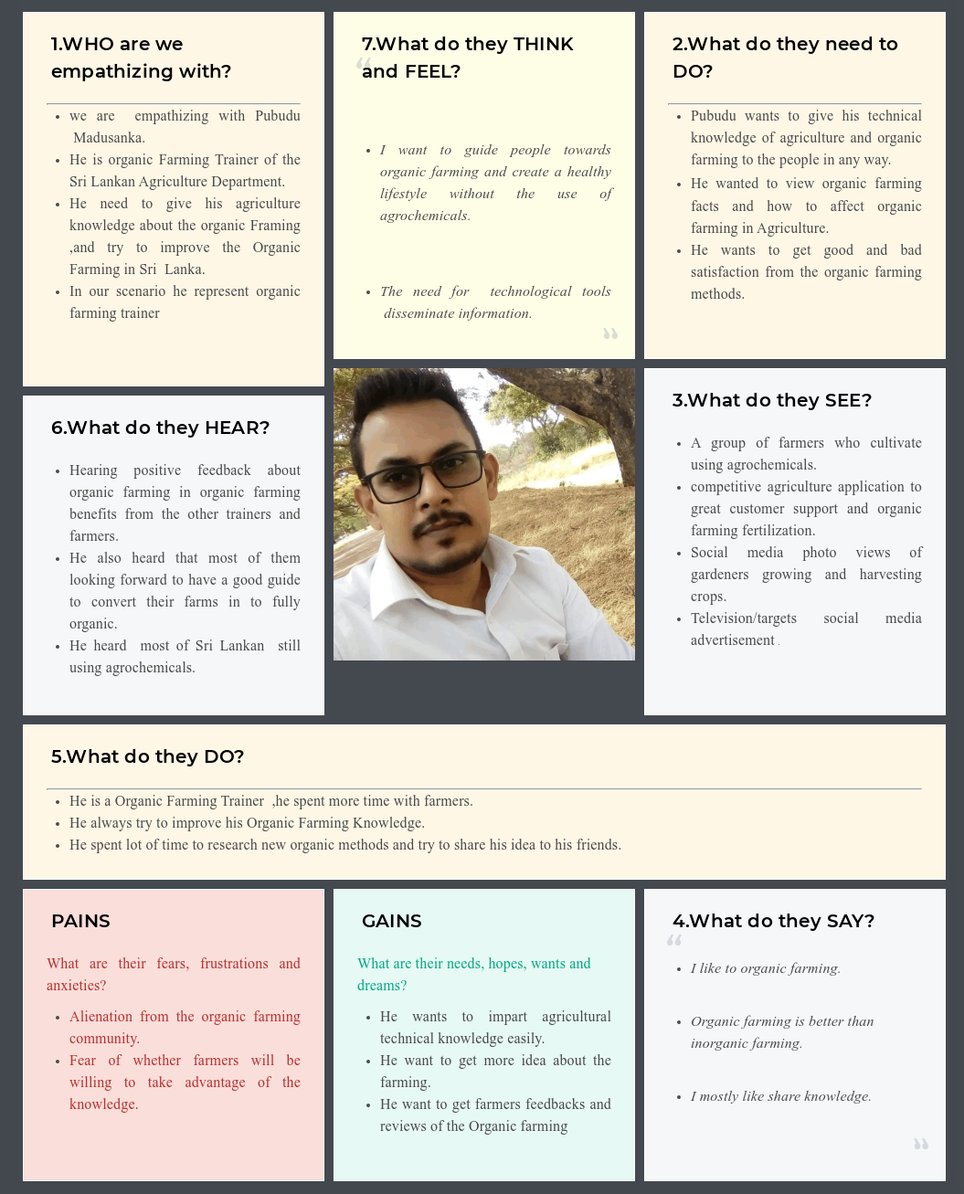

Figure 5-IT20125066.Empathy map

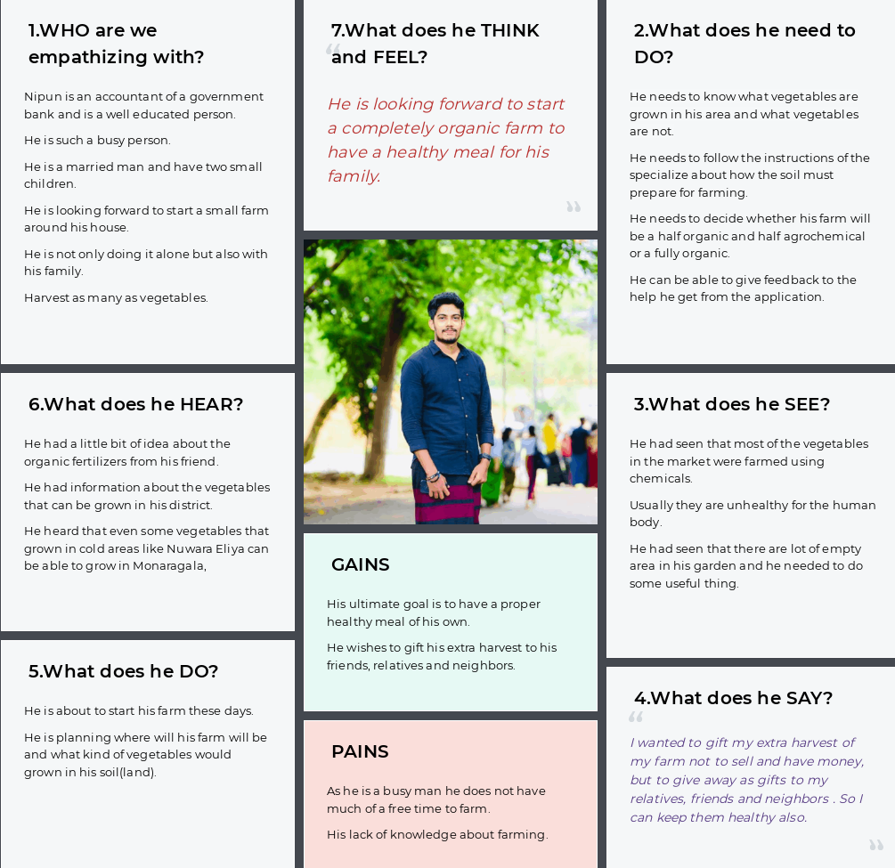

Figure 6-IT20147082.Empathy map

Figure 7-IT20258030.Empathy map

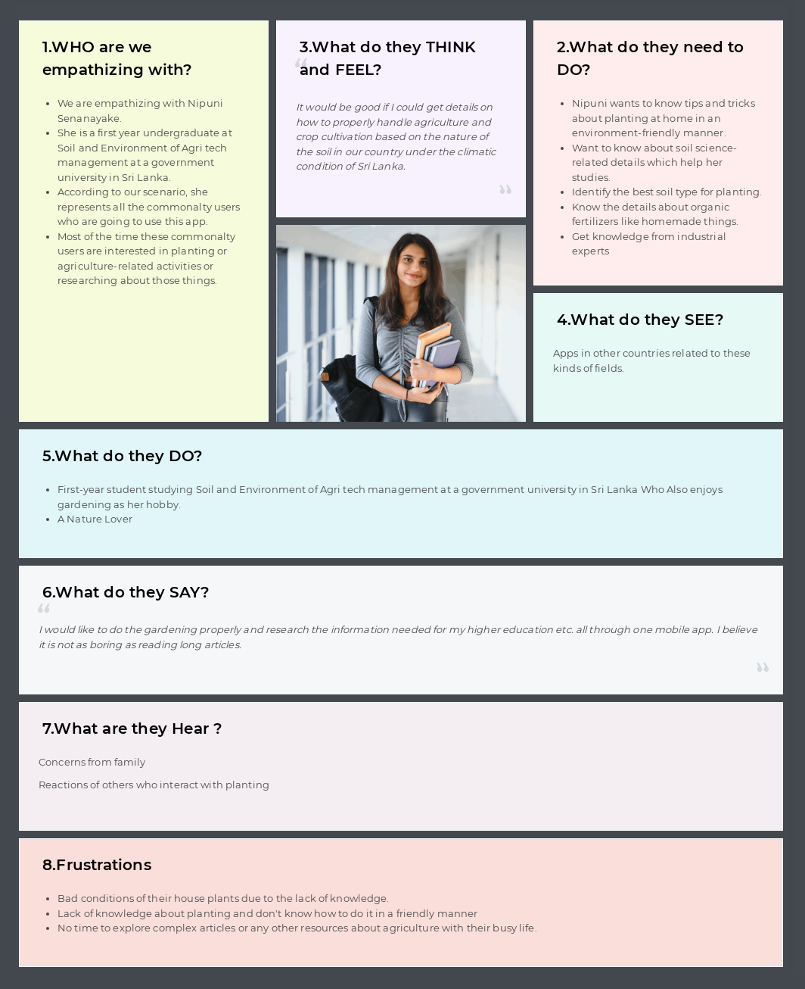

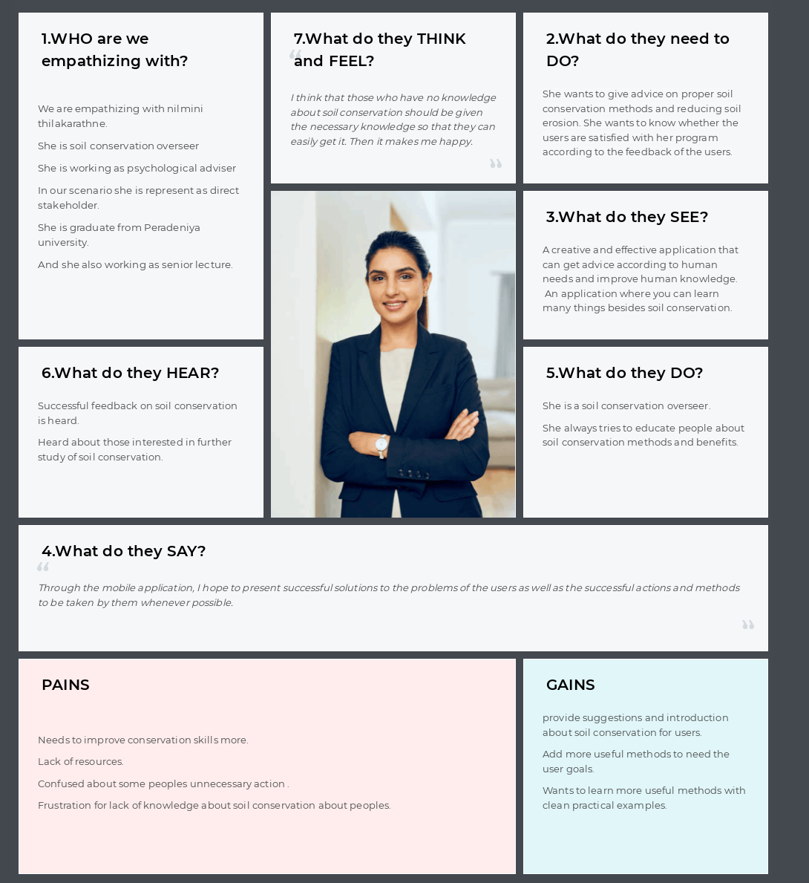

Figure 8-IT 20136710.Empathy map

## User stories – 04 User stories from a group

**Organic Farming trainer who providing advice and details**

As an Organic Farming Trainer, I would like to add organic farming methods and tips to the system so that I can lead users to an organic farming instead of agrochemical which we already know that unhealthy for human. So, I can Guide toward for a healthy society.

**Farmer who wants to get details about farming related things**

As a farmer, I would like to know about the soil around my farming area so I can get an idea about what kind of vegetables would grow easily in my farm. Also, I can have knowledge how to grow other vegetable plants in my farm by using various farming techniques given from the application.

**Commonalty User who interact with home planting and researching details**

As a Commonalty user, I would like to know about the effect of soil on the cultivation and related activities and details needed for my studies in daily life and the tips, tricks and how to properly engage with those activities in an environmentally friendly manner.

**Soil conservation overseer who interact with providing details**

As a soil conservation overseer I want to provide tips, methods and benefits of soil conservation so that I can build people's knowledge about soil conservation and increase soil conservation in the lands.

## User flow(s) - 04 User flows from a group

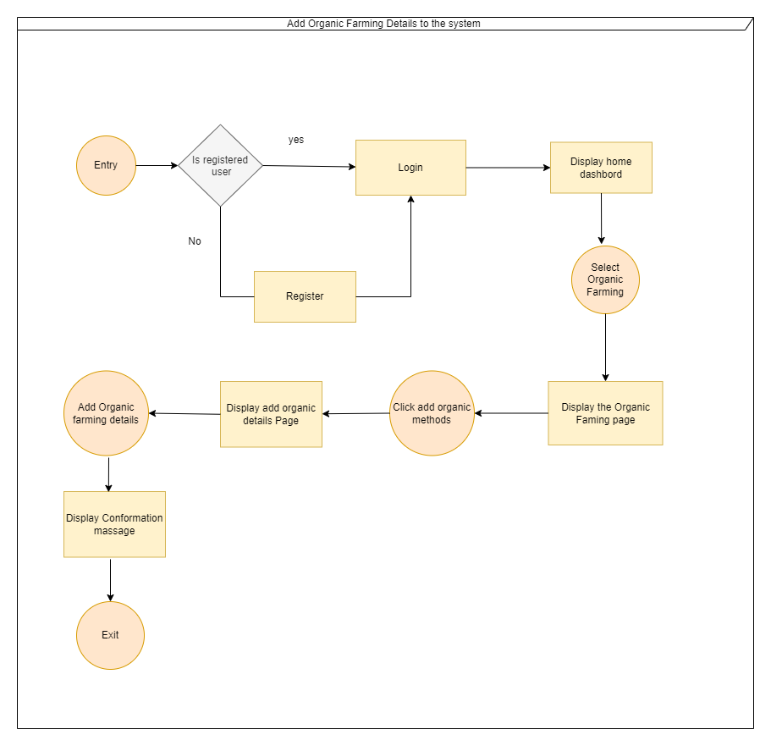

Figure 9-IT20125066.User Flow

Figure 10-IT20147082.User Flow

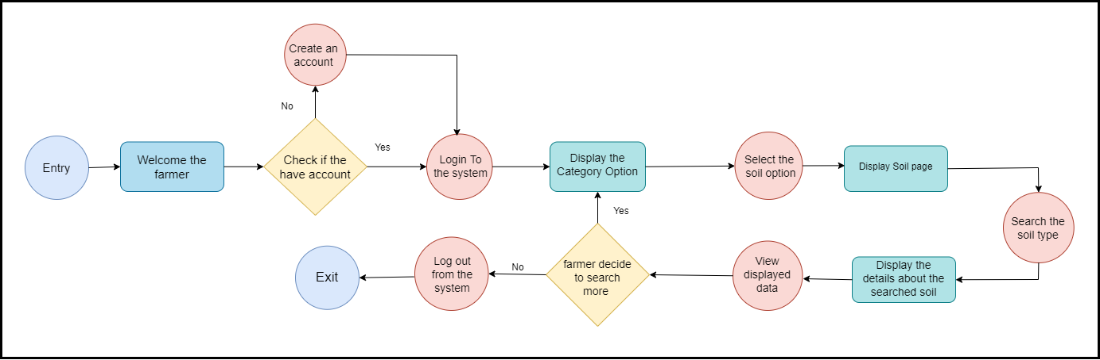

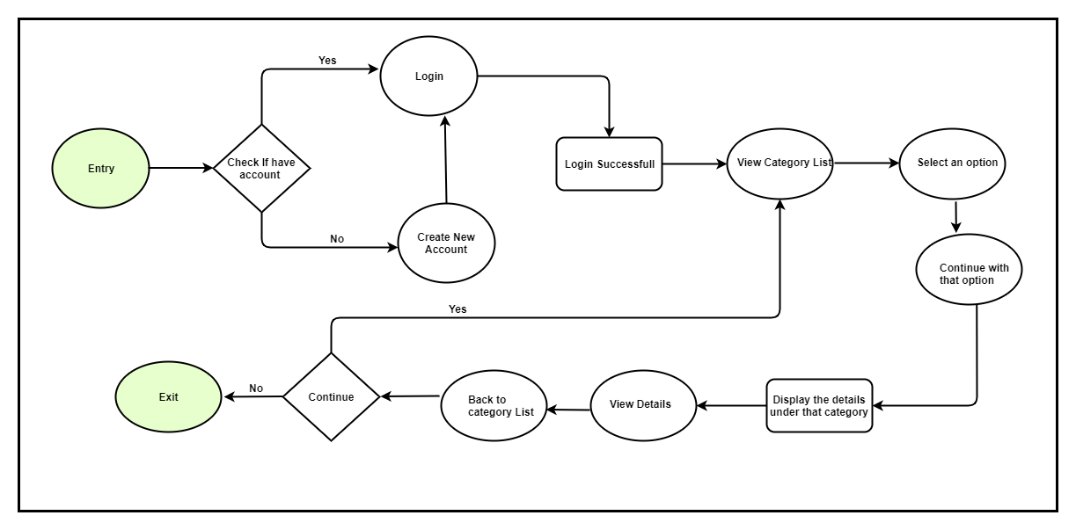

Figure 11-IT20258030.User Flow

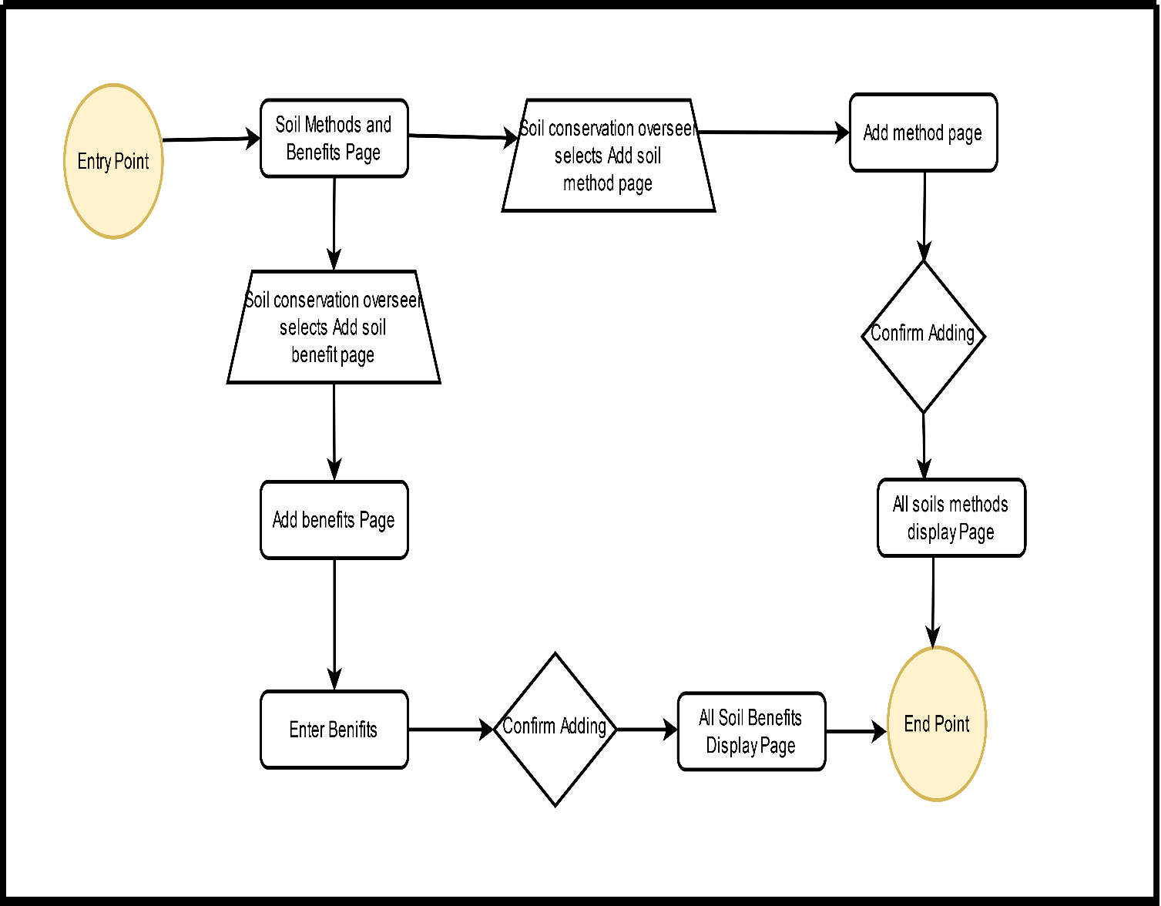

Figure 12-IT20136710.User Flow

## Service Blueprint(s) – 01 Service Blueprint from a group

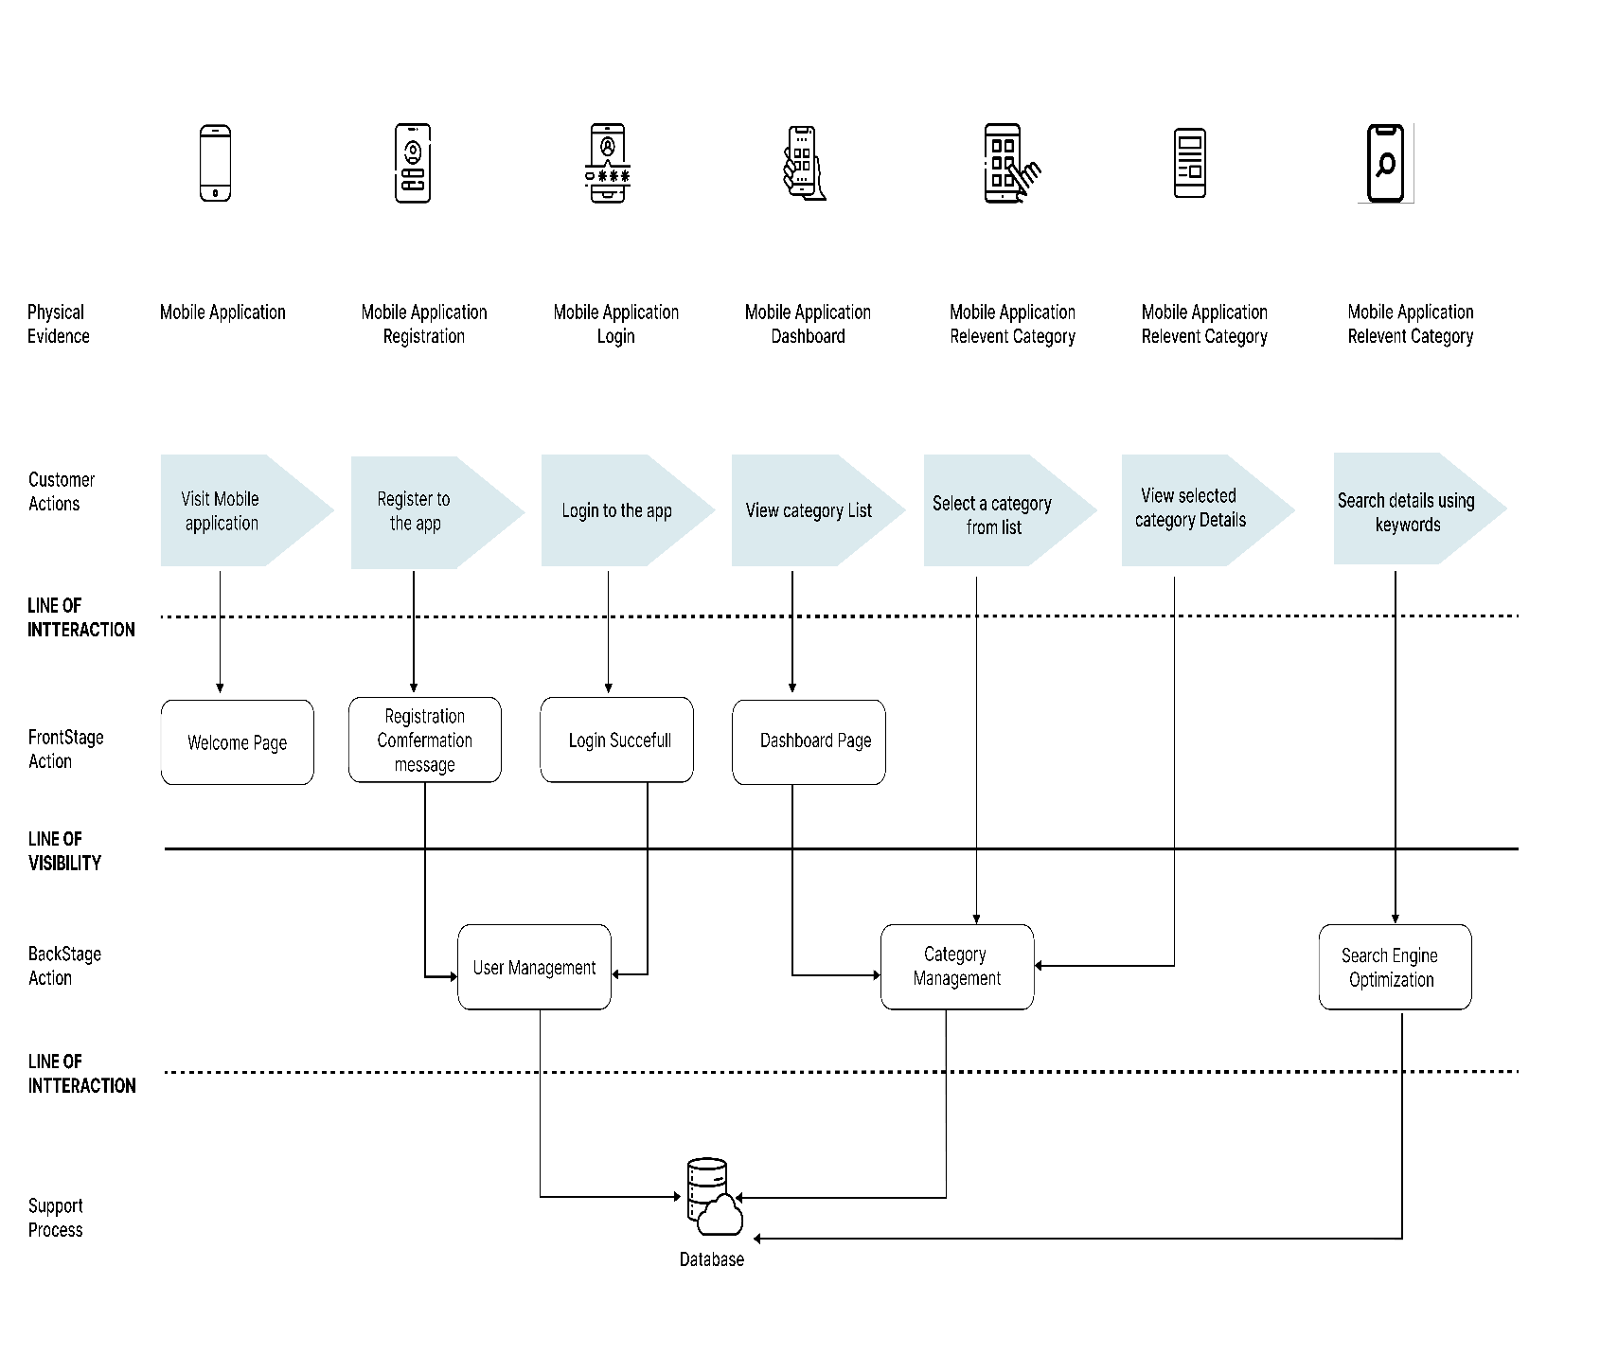

Figure 13-User Side Service blue print

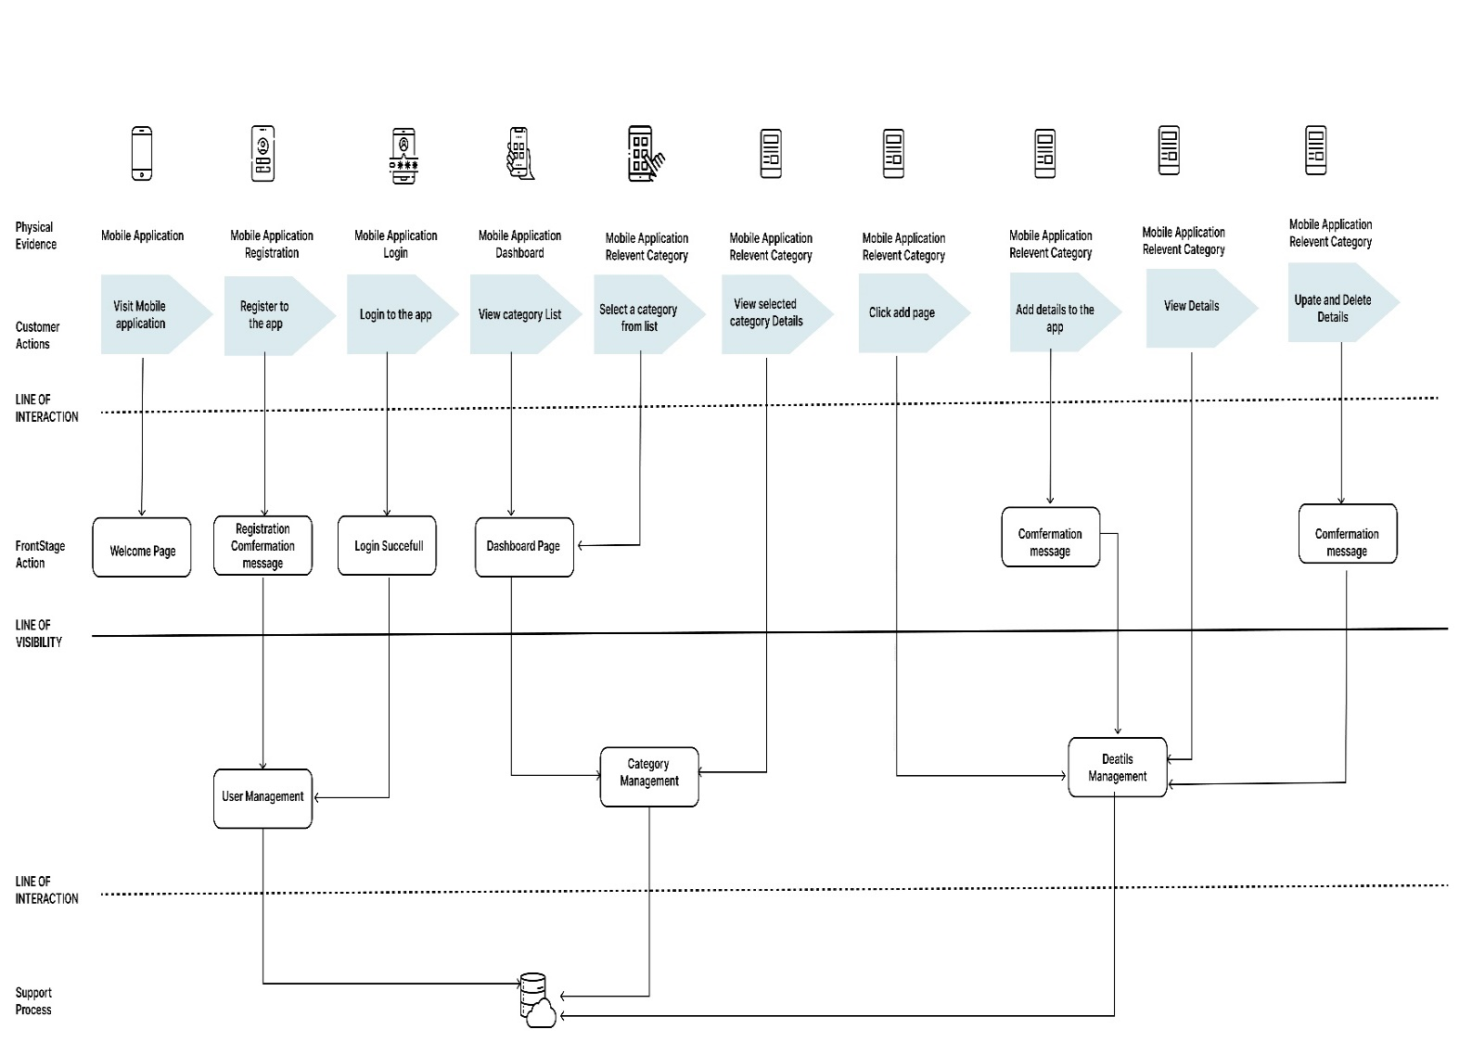

Figure 14-Admin Side service blue print

# Milestone 2: Plan and conduct user research

## IT 20125066

**Goal**

People in Sri Lanka are having such a difficult time due to the country's current economic disaster. To improve the relationship between the cost of living and the economy, actions can be implemented to direct people to organic crop cultivation seasons without toxins and to educate people about the success of organic crop cultivation. This is done to direct cultivation and clarify people's attitudes toward organic cultivation, as well as their current knowledge and specific demands.

The goal of the research is understood how people’s opinion towards organic farming and their common knowledge about it. Also, I wanted to know are they afraid to use organic farming instead of chemicals and what is they reason for that.

**Methodology**

In order to get a better understanding of the ongoing project, we have prepared two methods to gather user research data from people who are related to agriculture and other non-related people. We have conducted four interviews with four people who are in the persona. Also, we have prepared a Questioner to share with other people directly related to and non-related to farming to get more user research data for the project.

**Interview**

* Based on the information I provided in milestone 1, online interviewing of a suitable person was done here.
* Accordingly, the interview was conducted through an organic farming trainer.
* The interviews were recorded for further reference.
* To ensure that all aspects of the test objectives have been covered, a questionnaire was prepared before the interview.
* The questions that were asked in the interview directly focused on-point and simple

**Questioner**

A questionnaire was shared, which included mostly questions with quantitative answers

so that it was easier to analyze the data.

* The questionnaire was designed using google Forms within a one section.
* My questions are directly focusing on organic farming and tips functions.
* The questionnaire was shared using social media to get valuable responses.

Questionnaire

Questionnaire link -:

<https://forms.gle/1wb36DD4AYDTyRtZA>

**Questions and Purpose of the questions**

1. What is your opinion about organic farming?

This question is to understand the user’s knowledge about organic farming. As we are developing the application, we need to develop the application to understand even the users who have a lesser understanding of farming.

1. What are the positive effects of organic farming?

This question is to understand the user’s knowledge about the positive effect of organic farming. Here, we can gather feedback on the user’s positive knowledge of the organic farming.

1. What are the negative effects of organic farming?

This question is to understand the user’s knowledge about the negative effect of organic farming. Here, we can gather feedback on the user’s negative knowledge of organic about

1. How do you plan to control weeds while you farming?

The following question is to gather data on how to affect weeds in the framing and control the weeds.

1. In Sri Lanka, almost everyone uses chemical fertilizers. Do you think Sri Lankan farmers are interested in using organic methods?

The following question is to gather data on how Sri Lankans think about organic farming and how much knowledge they have about organic farming methods.

**How should the questionnaire be distributed and the data collection process**

* The questionnaire is planned to be distributed online since it was created using the google form
* The main method was distributed through WhatsApp groups and friends
* Also, other social media platforms such as Facebook and Instagram are used to share the questionnaire.

**Questions with user feedback details**

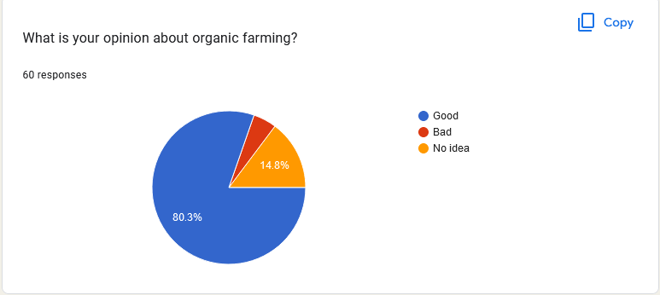

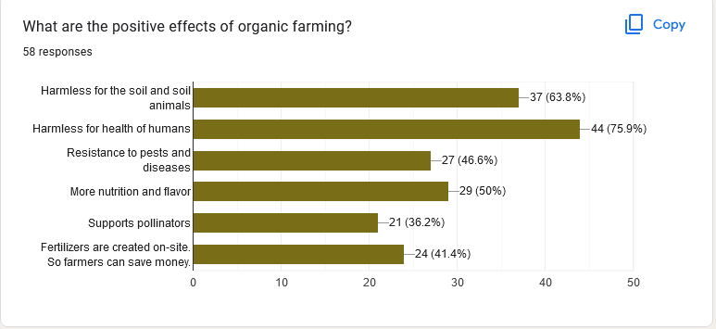

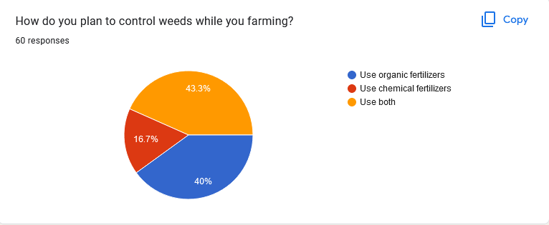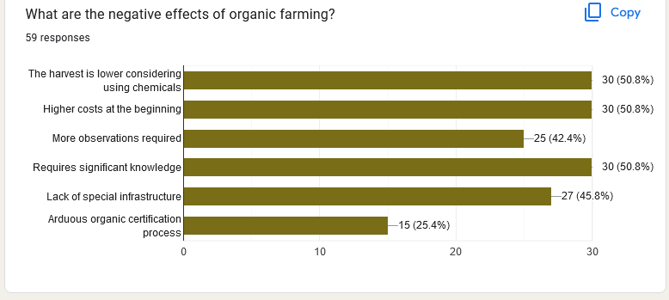

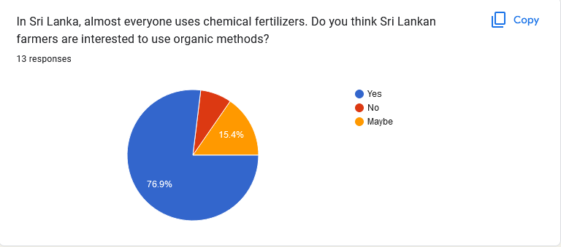

**Interviewing**

Interview 01

**Interviewer** **-:** Mr. Udara Gamage

**Conduct by -:** A.P.M. Chandrasena (IT20125066)

**LINK**

<https://drive.google.com/drive/folders/1Ra3fhaOmUi6Q50aGrNzHwgB9xi9oKAd6?usp=sharing>

**Procedure for the interview**

* The interview was conducted as a physical interview.
* The Interview was conducted from Kiribathgoda. So, I went from her place and conducted this interview as physical.
* I have prepared some questions before the interview because I won’t miss any details.
* Also, I have informed the interviewer about our project and the application that we hope to develop before the interview, so he won’t confuse.
* The interview was recorded as a video for future purposes after asking his permission to do so.

**Questions that we have prepared for the interview**

1. Hello, Madam, good morning, and welcome to the interview
2. Ok, can you say something about yourself?
3. As the first question, I would like to ask you about what organic farming is and the profits of using it.
4. In Sri Lanka, almost everyone uses chemical fertilizers. Do you think Sri Lankan farmers are interested in using organic methods?
5. It is such a good answer, I think. What is your thought about using chemical fertilizers?
6. Can you tell us how much effect you put on your work daily?
7. Can you show us some pictures or video of the organic farms that you visited?
8. Thank you, sir, for sharing your knowledge with us and allocating valuable time for this interview.

Have a good day Madam.!!

Participant Profiles

|  |  |  |
| --- | --- | --- |
| Name | Demography | Location & Date |
| Udara Gmage | 1. An Organic farming trainer 2. An unmarried young officer 3. Have organic farming 4. Engaging in research about organic farming | Physical Interview  25th September 2022 |

## IT20147082

**Goal**

The research is done with the ambition of gathering data from people who are related to farming and non-related. To complete the goal, we have prepared a questionnaire as a group, and I have personally interviewed a person how planned to start a farm as a part time work.

The goal of the questionnaire is to get a brief idea about the percentage of people who have the experience on farming and who haven’t. Also, I wanted to know each of the person’s knowledge of about farming so I can understand the overall idea about the Sri Lankans knowledge level about farming and soil. I wanted to get an overall idea about why people are farming for and do they only care about that purpose.

The goal of the Interview was how the people who are planning to start a farm and what kind of attitude they have toward farming. Also, I wanted to know their goals and their motivations toward their plan. Not only motivations but also frustrations toward his plan.

**Methodology**

In order to get a better understanding about the ongoing project we have prepared two methods to gather user research data from people who are related to agriculture and other non-related people. We have conduct four interviews with four people how are in the persona. Also, we have prepared a Questioner to share with other people who are directly related and non-related for the farming to get more user research data for the project.

**Interview**

* 4 people who are in the persona were interviewed online covering all the functionalities of the application.
* The 4 people are an organic farming trainer, a part time farmer, a Soil conservation overseer and a Commonalty User (Gardner).
* Each interview was conducted by each member of the team.
* The interviews were recorded for further reference.
* In order to make sure that all aspects of the test objectives were covered a questioner was

prepared before the interview.

* The questions that were asked in the interview directly focus on-point and simple.

**Questioner**

A questionnaire was distributed which included mostly questions with quantitative answers

so that it was easier to analyze the data.

* The questioner was designed using google form with a one section.
* It is contained question that are directly focus on each of our functions.
* The questioner was shared using social media to get user reference.

**Questionnaire & Response**

Questionnaire link -:

<https://forms.gle/1wb36DD4AYDTyRtZA>

**My Questions**

1. What is your knowledge level about Farming & soil?

This question is to understand the user’s knowledge about the farming and soil. As we are developing the application, we need to develop the application to understand even the users how have the lesser understanding about farming and soil.

1. Do you have any experience on farming?

We needed to understand how experienced and unexperienced people answer to the questioner and what kind of thing they expect from the application.

1. If you are farming or plan to farm, which of the following reason you are doing it for?

The question is to understand purpose of how each person is doing or plan to do the farming.

1. If you already have a farm about how much is your farm spread?

The question is to know that have large their farm.

1. What means do you use to get the agronomic and soil knowledge you need to farm?

This question is to get to know that what kind of means do they get knowledge about farming and what are the efficient ways

**Response to my Questions**

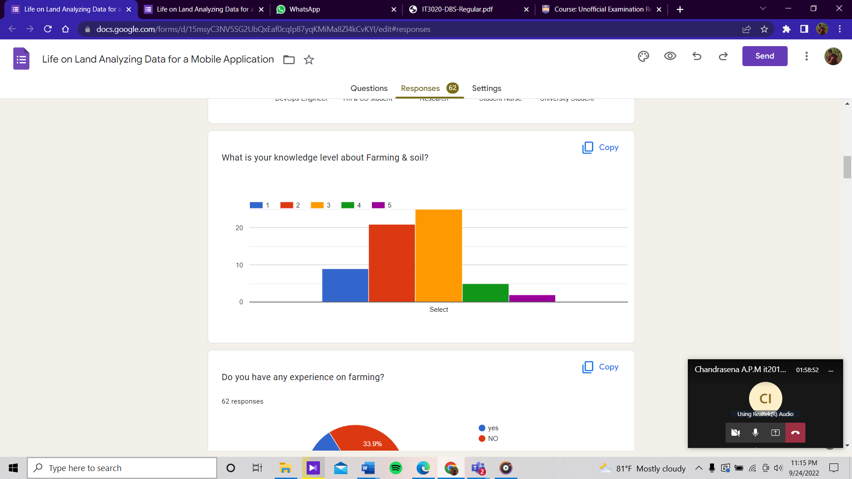

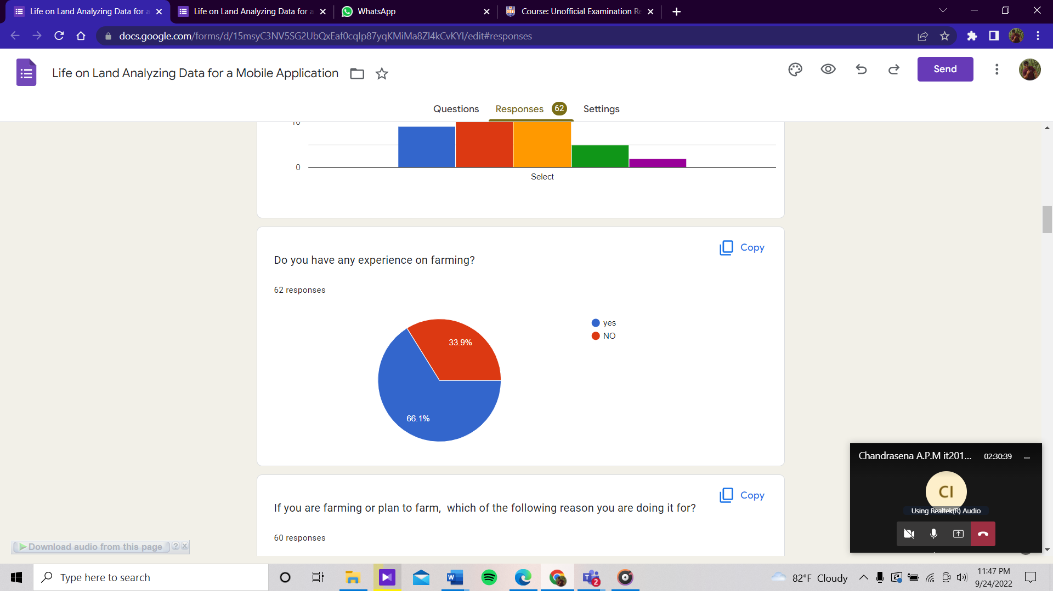

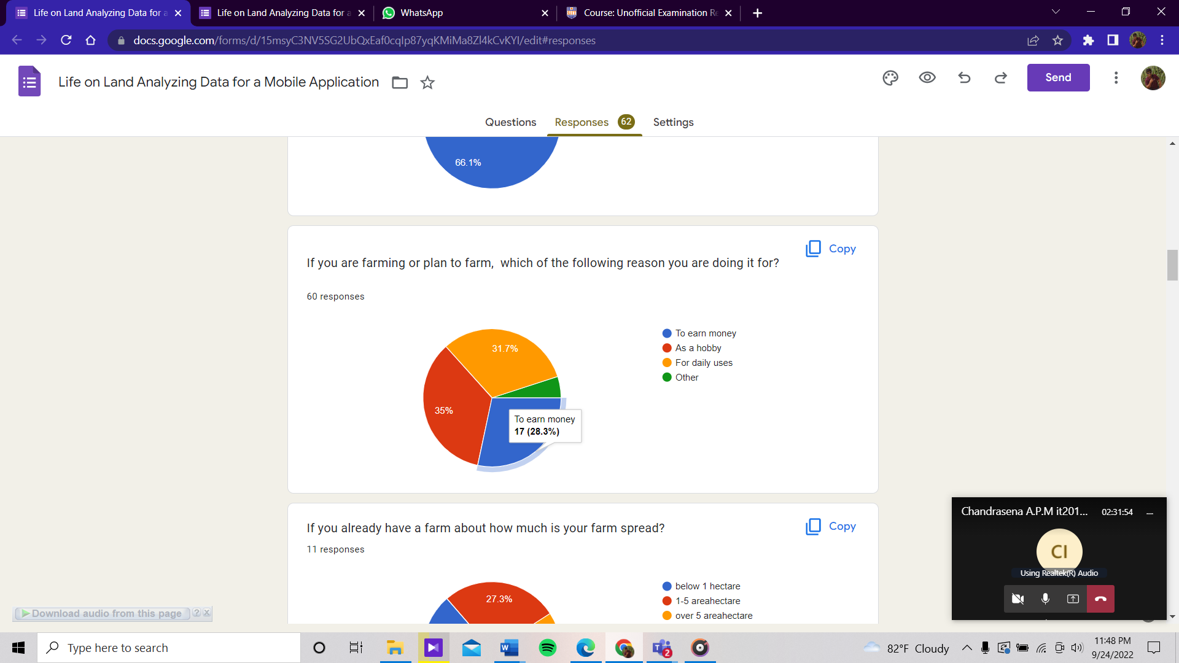

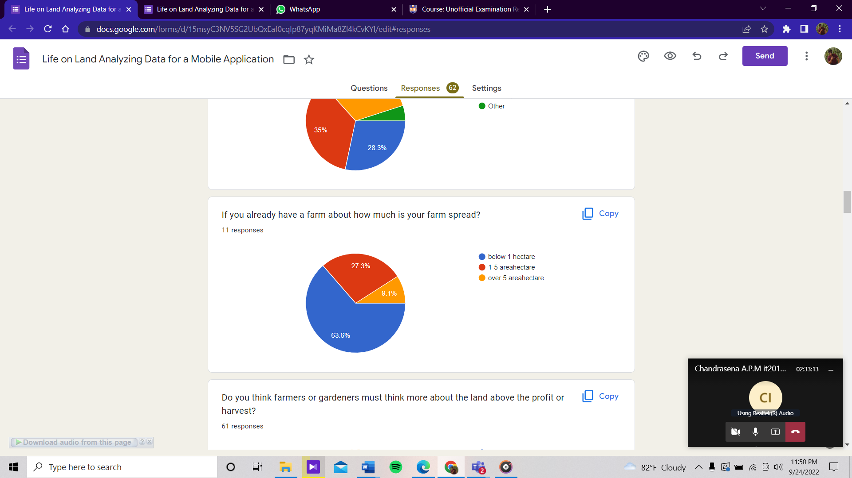

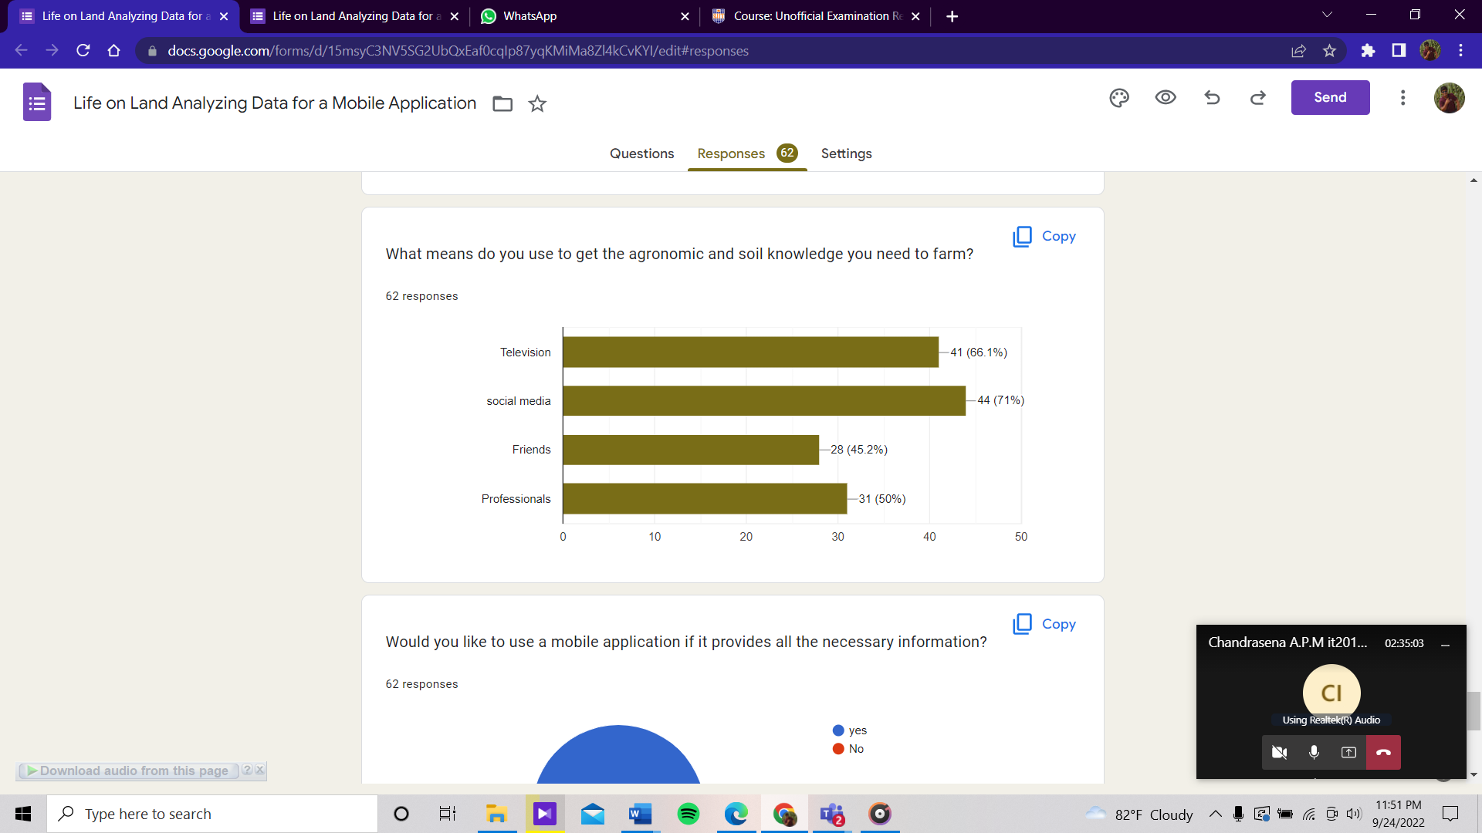

**How the questionnaire should be distributed and data collection process**

* The questionnaire was planned to be distributed online since it was created using google form
* The main method was distributed through WhatsApp groups and friends
* Also, other social media platforms such as Facebook and Instagram are used share the questionnaire.

**Interview**

**Interviewer** **-:** Mrs. Dilini Amanda

**Link -**:

<https://drive.google.com/drive/folders/1woSrfZInHe9bls4TEUPk1BQ7OdSceIb2?usp=sharing>

|  |  |  |
| --- | --- | --- |
| Name | Demography | Location & Date |
| U_0002 | 1. An accountant 2. A part time famer 3. Plan to build a farmer in garden 4. A married young woman 5. Unexperienced on farming | Physically  26th September 2022 |

**Procedure of the interview**

* The interview was conducted physically.
* The Interviewer was in Monaragala, and she has a busy schedule.
* I have prepared some questions before the interview because I won’t miss any details.
* Also, I have informed the interviewer about our project and the application that we hope to develop before the interview, so he won’t confuse.
* The interview was recorded for future purposes after asking his permission to do so.

**Interview sample questions**

1. Hello madam, good morning and welcome to the interview
2. First, can you tell your name.
3. Ok madam, can you say something about yourself?
4. Do you have any experience about farming or gardening?
5. Are you interesting to start a farm?
6. What do you plan to archive from your farm?
7. what will you plan to do with your harvest? will you sell them?
8. Ok, then what will you do the extra vegetables?
9. Earlier you mention that you hope to do the farm just organic materials. What is the purpose of that?
10. How do you plan to get information about farming?
11. what will be your frustrations about the plan to build a farm?
12. what do you think about an application which consist of details about the soil each area in Sri Lanka and organic methods?
13. Ok madam, thank you for spending your valuable time for this interview. Hope you will be able to build a good farm soon and have a nice day.

## IT 20258030

**Goal**

The main goal here is to engage in agricultural activities in an environmentally friendly manner without damaging the soil. Through that, according to my persona, the main targets are commonalty users who are engaged in daily gardening and planting. According to that, my goal is to find out whether they have enough knowledge about those actions through things like how to care for house plants, environmentally friendly gardening skills like soil conservation, and whether they already follow them or not. And to provide the information they need to get proper knowledge for those things.

**Methodology**

In order to get a better understanding of the ongoing project, we have prepared two methods to gather user research data from people who are related to agriculture and other non-related people. We have conducted four interviews with four people who are in the persona. Also, we have prepared a Questioner to share with other people directly related to and non-related to farming to get more user research data for the project.

**Interview**

* Based on the information I provided in milestone 1, online interviewing of a suitable person was done here.
* Accordingly, the interview was conducted through an organic farming trainer.
* The interviews were recorded for further reference.
* To ensure that all aspects of the test objectives have been covered, a questionnaire was prepared before the interview.
* The questions that were asked in the interview directly focused on-point and simple.

**Questioner**

A questionnaire was distributed, which included mostly questions with quantitative answers

so that it was easier to analyze the data.

* The questionnaire was designed using google Forms with one section.
* It is contained questions that are directly focused on organic farming and tips functions.
* The questionnaire was shared using social media to get valuable references.

**Questionnaire**

Questionnaire link -:

<https://forms.gle/1wb36DD4AYDTyRtZA>

**Questions and Purpose of the questions**

1. Do you think farmers or gardeners must think more about the land above the profit or harvest?

Through this question we mainly hope to know to what extent people give priority to environmental friendliness.

1. Do you engage in gardening?

What we wanted to know about this question was to get a rough understanding of the percentage about people are currently engaged in gardening.

1. If so, under which of the following reasons is it done?

Through this question, we want to get an understanding of what is the reason the people who are currently engaged in gardening are doing it through the above question.

1. Do you think a proper understanding of soil nature is essential for gardening?

Through this question, we wanted to know whether people engage in gardening with having knowledge about soil or not. And want to know that they know if it is essential for gardening or not

1. Are you concerned about the nature of the soil when you are engaged in gardening?

What is needed to be known through this question is whether people are concerned about the nature of the soil and its various forms when engaged in gardening or not.

**How should the questionnaire be distributed and the data collection process**

* The questionnaire is planned to be distributed online since it was created using the google form
* The main method was distributed through WhatsApp groups and friends
* Also, other social media platforms such as Facebook and Instagram are used to share the questionnaire.

**Questions with user research feed back details**

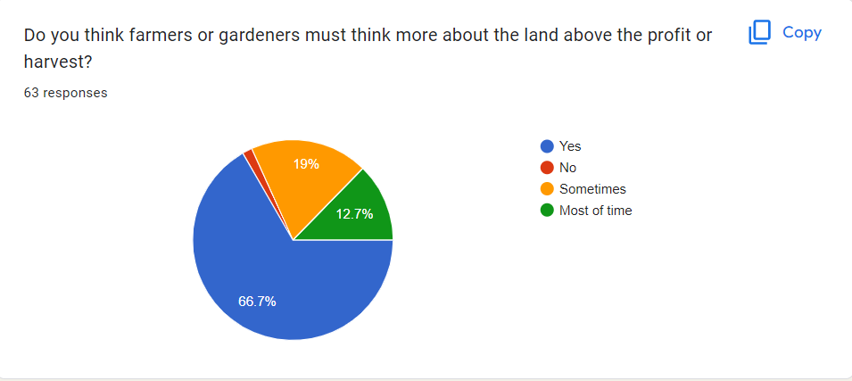

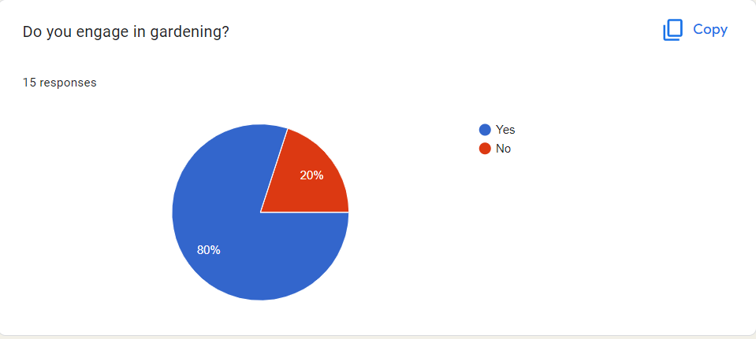

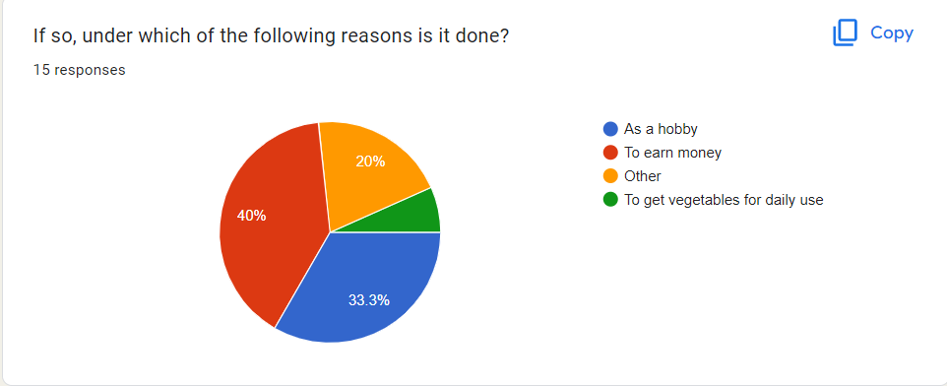

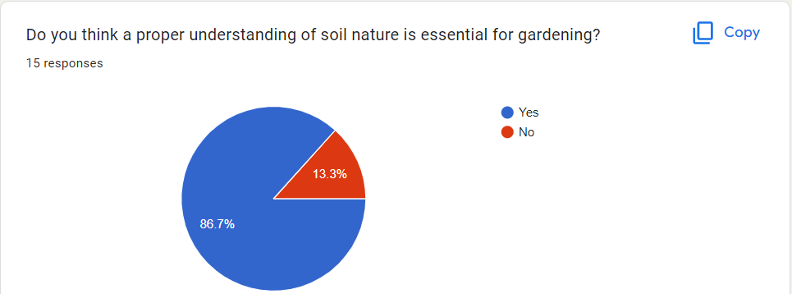

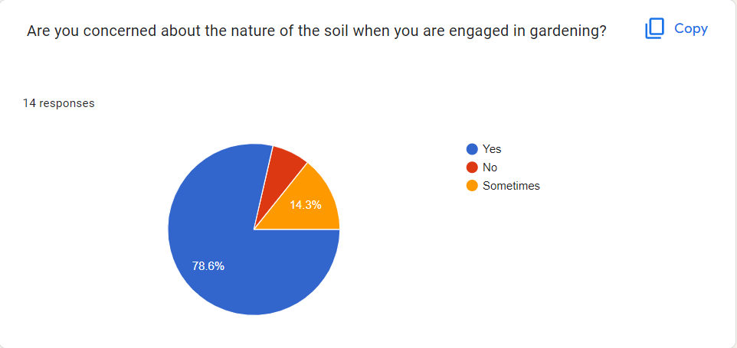

**Procedure for the interview**

* The interview was conducted using Microsoft team’s application.
* The Interviewer from Anuradhapura , But currently she in her university boarding place . So I am not able to contact her physically now. So, we conduct the interview through online.
* I have prepared some questions before the interview because I won’t miss any details.
* Also, I have given a brief idea to the interviewer about our project and the application that we hope to develop before the interview, so she won’t confuse. And during the interview also I am going to explain further more.
* The interview was recorded for future purposes after asking her permission to do so.

**Interviewing**

**Interview 01**

**Interviewer** **-:** Ms. Nipuni Senanayake

**Conduct by -:** Gunawardhana H.P.M.N

**LINK**

[https://drive.google.com/file/d/1yxCcznUbUiXe5zvXEPBv9swuI-1nBdTC/view?usp=sharing](%20%20%20https:/drive.google.com/file/d/1yxCcznUbUiXe5zvXEPBv9swuI-1nBdTC/view?usp=sharing)

**Questions that we have prepared for the interview**

1. Hello, Nipuni Good Afternoon
2. Gave an introduction and thanked for having with us.
3. First can I know do you engaging in gardening?
4. Can I know why you are into gardening?
5. Do you think it is necessary to have a knowledge while doing gardening?
6. So I want to know if you who are engaged in gardening are doing it with the right knowledge and by using environmentally friendly strategies?
7. Are you concerned about soil moisture and related conditions while gardening?
8. Have you faced any problems while engaged in gardening?
9. Can I know what are those problems?
10. Do you use online resources to find solutions for them?
11. Explain the relevant process of application to her using my user flow.
12. Do you think it would help you if there was an app that included solutions to these problems, tips, and tricks on how to do agriculture and gardening in an environmentally friendly way, the nature of the soil, and soil conservation methods?
13. Thank you nipuni for your valuable information. And Have a nice day.

Participant Profiles

|  |  |  |
| --- | --- | --- |
| Name | Demography | Location & Date |
| Nipuni Senanayake | 1. University Student 2. Who already doing gardening 3. Young lady who is love nature 4. Following a degree related to agriculture field . | Microsoft Teams  25th September 2022 |

## IT20136710

**Goal**

Life on land is extraordinary. Our magnificent ecosystems allow us all to eat, breathe and live. It's not just humans who live on land. All humans, animals, and quadrupeds live on land. Before everyone else, we should think about the earth we live in. But with minimal knowledge about soil conservation, we are slowly killing our planet and its inhabitants.

Indeed, there are people with knowledge about soil conservation in the society. Accordingly, those people have experience. Accordingly, my goal is to learn about a person with such experience and knowledge, ask them that information and spread that information among the people through this app. The purpose of this app is to find out information about soil conservation and the difficulties they face and solve those problems through this app. Accordingly, the goal is to increase people's knowledge for soil conservation and restoration. The purpose of this is to determine what results should be given to the people by analyzing the knowledge of the people about soil conservation. Then, we can stop the damage and loss caused by not conserving the soil.

**Methodology**

In order to get a better understanding about the ongoing project we have prepared two methods to gather user research data from people who are related to agriculture and other non-related people. We have conduct four interviews with four people how are in the persona. Also, we have prepared a Questioner to share with other people who are directly related and non-related for the farming to get more user research data for the project.

**Interview**

* 4 people who are in the persona were interviewed online covering all the functionalities of the application.
* The 4 people are an organic farming trainer, a part time farmer, a Soil conservation overseer and a Commonalty User (Gardner).
* Each interview was conducted by each member of the team.
* The interviews were recorded for further reference.
* In order to make sure that all aspects of the test objectives were covered a questioner was

prepared before the interview.

* The questions that were asked in the interview directly focus on-point and simple.

**Questioner**

A questionnaire was distributed which included mostly questions with quantitative answers

so that it was easier to analyze the data.

* The questioner was designed using google form with a one section.
* It is contained question that are directly focus on each of our functions.
* The questioner was shared using social media to get user refe

**Questionnaire & Response**

Questionnaire link -:

**Questions**

1. Do you think a proper understanding about the nature of the soil is essential for farming?

* The main objective of this question is how much people are interested in soil while in farming. According to the responses given here, people's understanding can be analyzed.

1. If yes, what are the reasons?

* using this question, we can analyses why people use soil knowledge for farming. Accordingly, you can get an idea of ​​what things people pay more attention to, which should be included in this application.

1. Do you have any familiar methods in soil conservation?

* In this question, a response can be obtained about whether people use the soil conservation method inherent in the grant or not.

1. Are you concern about soil conservation while agriculture?

* This question aims to analyze whether people engaged in agriculture use soil conservation or not. Then, according to this app, we can know how many people can be informed about soil conservation.

1. Which of the following do you see as the most acute problem caused by poor soil conservation?

* Due to the poor soil conservation, there are many bad results that have happened in the land. Through this, people can ask about the ones they experience the most.

**Response**

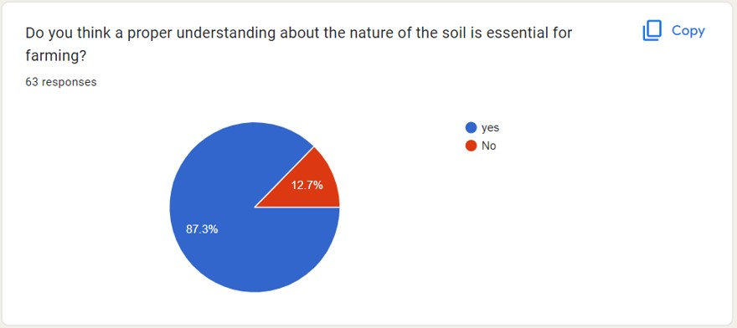

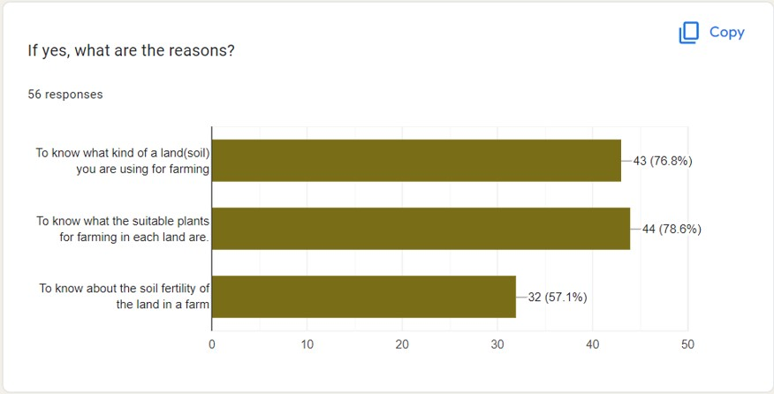

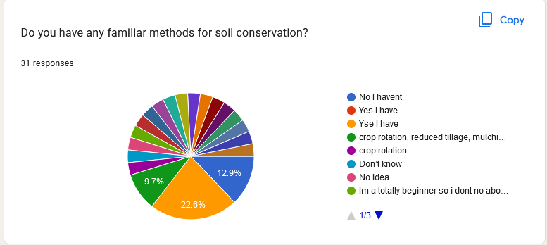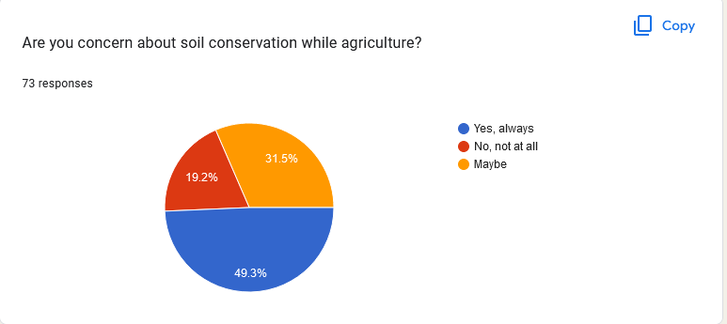

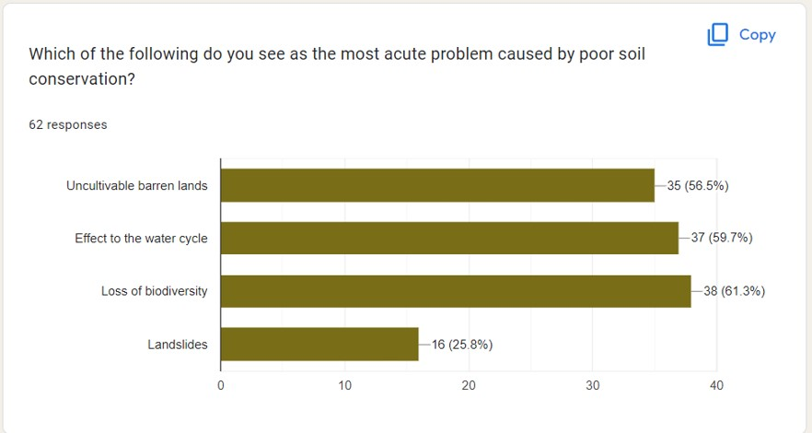

How the questionnaire should be distributed and data collection process

* The questionnaire is planned to be distributed online since it was created using google form
* The main method was distributed through WhatsApp groups and friends
* Also, other social media platforms such as Facebook and Instagram are used share the questionnaire.

**Interview**

**Interviewer** **-:** Miss Nilmini Thilakarathne

**Link -**

|  |  |  |
| --- | --- | --- |
| Name | Demography | Location & Date |
| U_0004 | 1. A soil conservation researcher 2. Young Officer. 3. Have Better knowledge about soil conservation 4. Engaging in research about soil conservation | Physical Interview  25th September 2022 |

Procedure of the interview

* The interview was conducted in physically.
* The Interviewer was in Kurunegala.
* I have prepared some questions before the interview because I won’t miss any details.
* Also, I have informed the interviewer about our project and the application that we hope to develop before the interview, so he won’t confuse.
* The interview was recorded for future purposes after asking his permission to do so.

**Interview sample questions**

1) Hello Miss Nilmini, nice to talk to you.  
  
2) Well, what are you think about soil conservation knowledge people  
have? Do you think they have enough knowledge?  
  
3) What do you see as the most acute problem caused by poor soil  
conservation?  
  
  
4) So miss I need some information regarding your projects? Are youworked any projects?

5) What are the most important factors to consider you when planning soil  
conservation projects?  
  
  
6) Can you explain how you get feedback from peoples about your  
methods?  
  
7) So, miss Nilmini can you explain what is the most important thing that  
farmers can do to protect their soil?  
  
8) Which soil conservation methods are you most familiar with?  
  
9) So can you please tell me what are the difficulties that you faced in this  
process?  
  
10) Miss Nilmini, we develop app for including soil conservation,  
you can give suggestion for us.  
11) Well finally thank you very much Miss joining with us and thank  
you for sharing your experience and kn

# Milestone 3: Verify the key-user flow(s)

## **IT 20125066**

|  |  |
| --- | --- |
|  | 01  Fail-points/blocking |
| Fail-  points/blocking | The organic farming instructor can be able to add the organic framing method he or he want to display adding details information page and want two option for the select organic farming and healthy range chemical fertilizer. |
| Evidence | 1  1      1  1      2  2 |

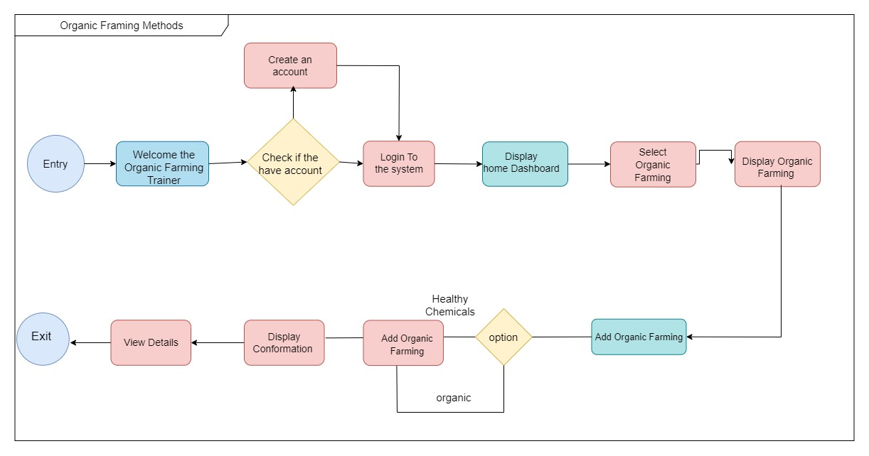

|  |  |
| --- | --- |
|  | 02  Fail-points/blocking |
| Fail-points/blocking | The organic farming instructor wants to update the option to the given user flow show he wants to update the given details we add to the new user flow to update the given organic details. |



|  |  |
| --- | --- |
|  | 03  Fail-points/blocking |
| Fail-points/blocking | The organic farming instructor wants to delete adding details then here added new user flow to delete user details |

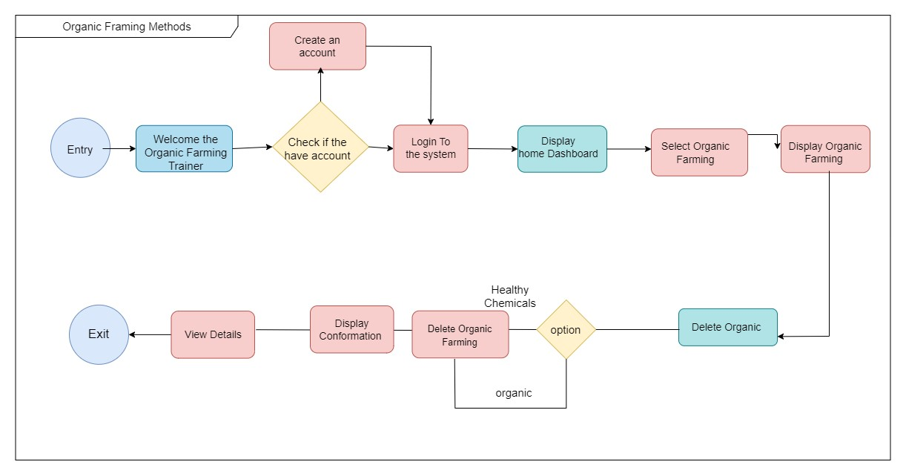

## **IT20147082**

**Evidence**

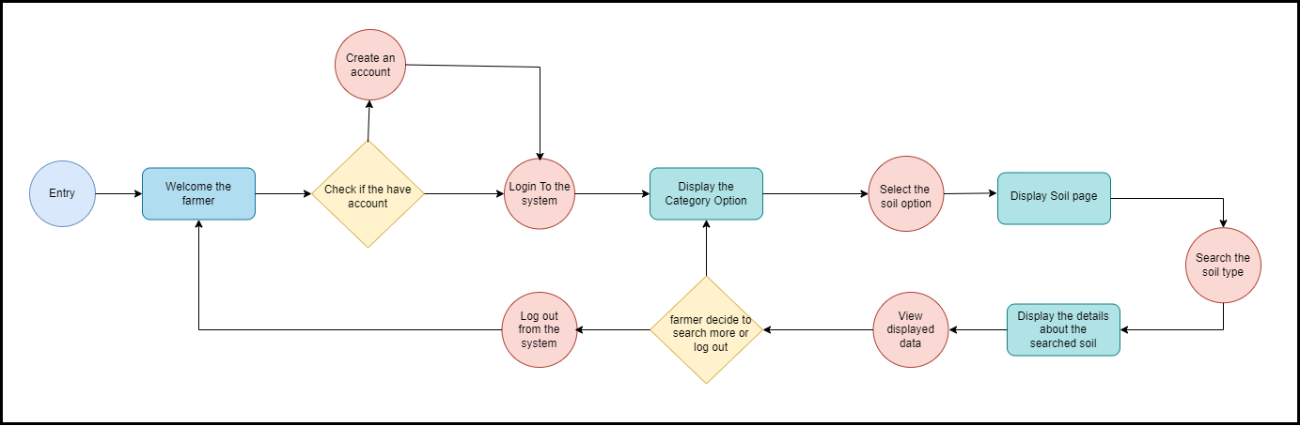

**Fail point 01**

|  |  |
| --- | --- |
|  | 01  Fail-points/blocking |
| Fail-points/blocking | As the interviewer’s thoughts he needed to know not just only know about the soil before started the farm but also, he needed to have a better knowledge about organic methods and tricks. So, I prefer to update user flow diagram how the user would search and go through organic farming method details. |

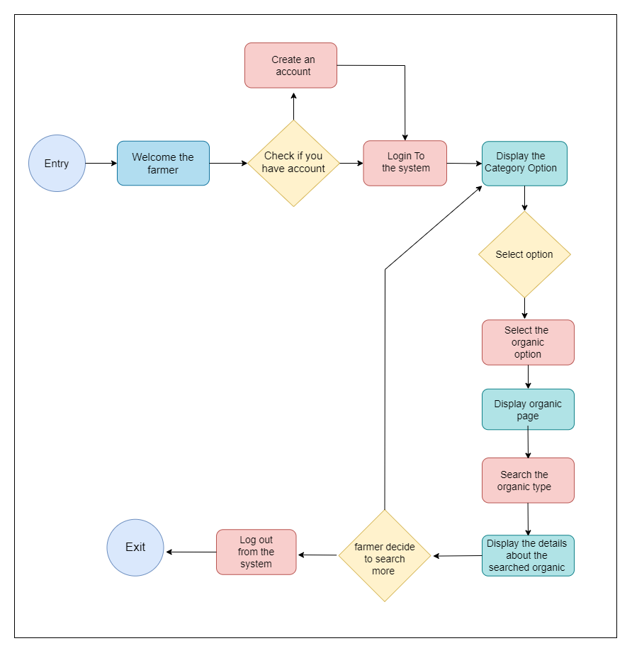

**Fail point 02**

|  |  |
| --- | --- |
|  | 02  Fail-points/blocking |
| Fail-points/blocking | As when a user wanted to reset a password, he could be able to update it or if he forgets the password, he can be able to reset it. I have updated the user flow by adding the password reset process. |

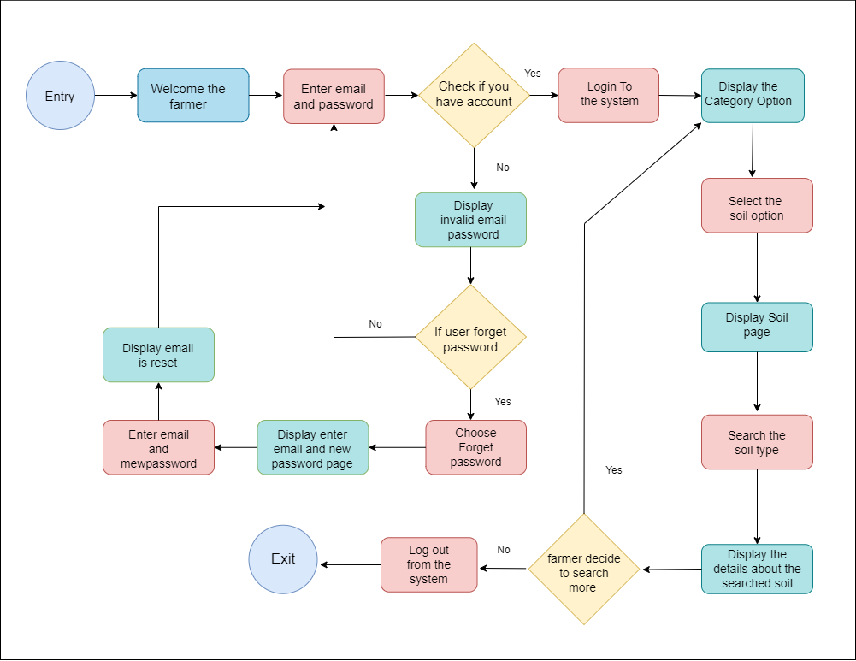

**Fail point 03**

|  |  |
| --- | --- |
|  | 03  Fail-points/blocking |
| Fail-points/blocking | According to the interviewer I realize that she did not have much idea about the soil. So, I it is hard to think that she exactly knows the names of soil that she wanted to know the information. So, I it is not enough to think that she should search exactly a correct name without any invalid searches. Therefore, I updated the 1st milestone user flow by adding error massage. |

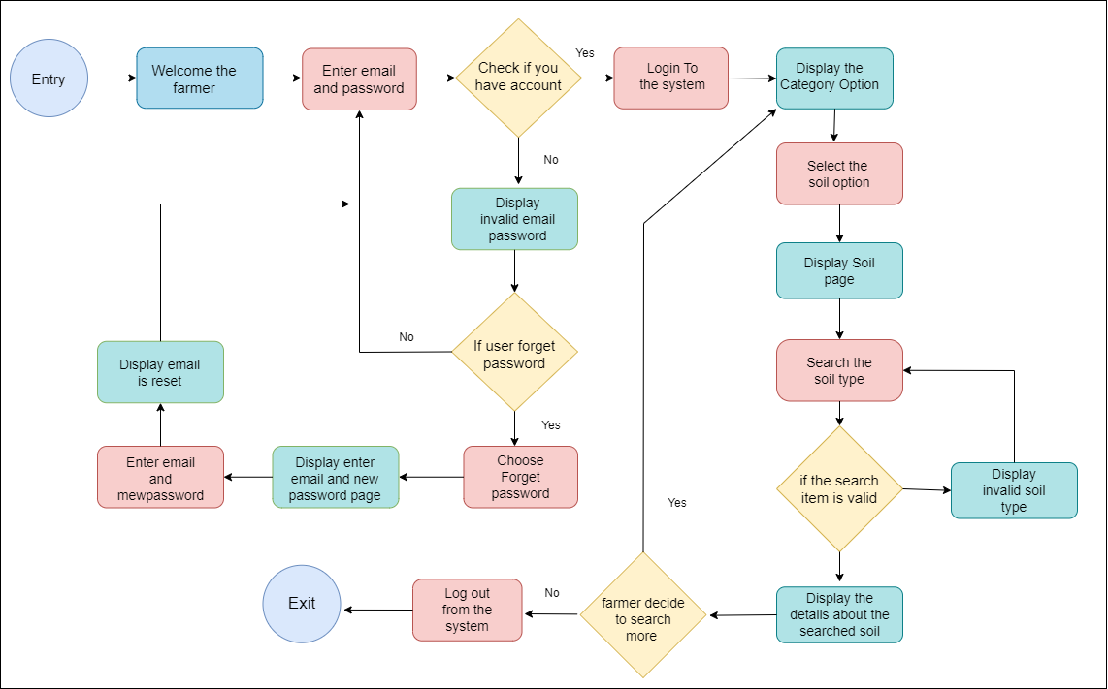

## **IT 20258030**

**Fail Point 01**

According to the persona's comments in the previous interview, as a fail point that I understood, before displaying the category list to the user, an About Us page should be included so that they can see a description page with a brief introduction about the App.

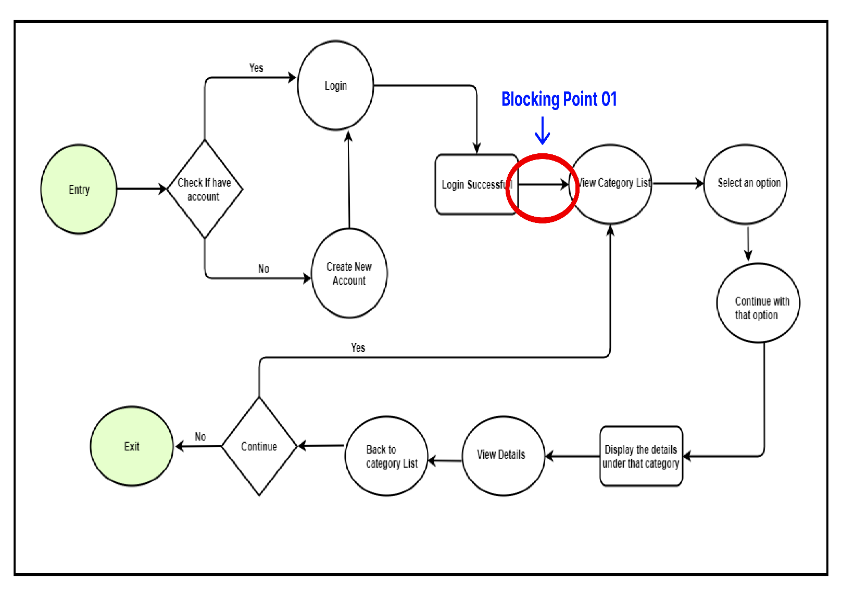**Fail Point 01 – User Flow with**

**Fail Point 01 –Updated User Flow**

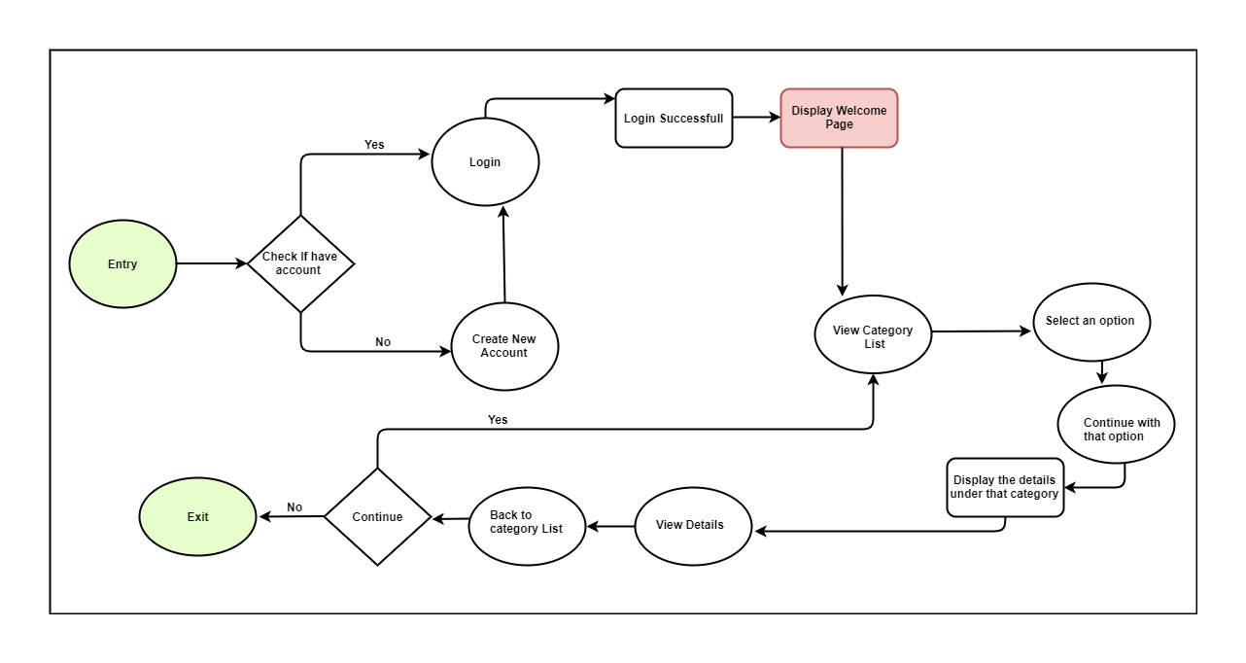

**Fail Point 02**

Apart from that, the other thing understood through the interview is that this can be used even by a person with technical knowledge as well as a person without technical knowledge, so the user should include a guideline page on how to use the app.

**Fail Point 02 – User Flow with blocking point**

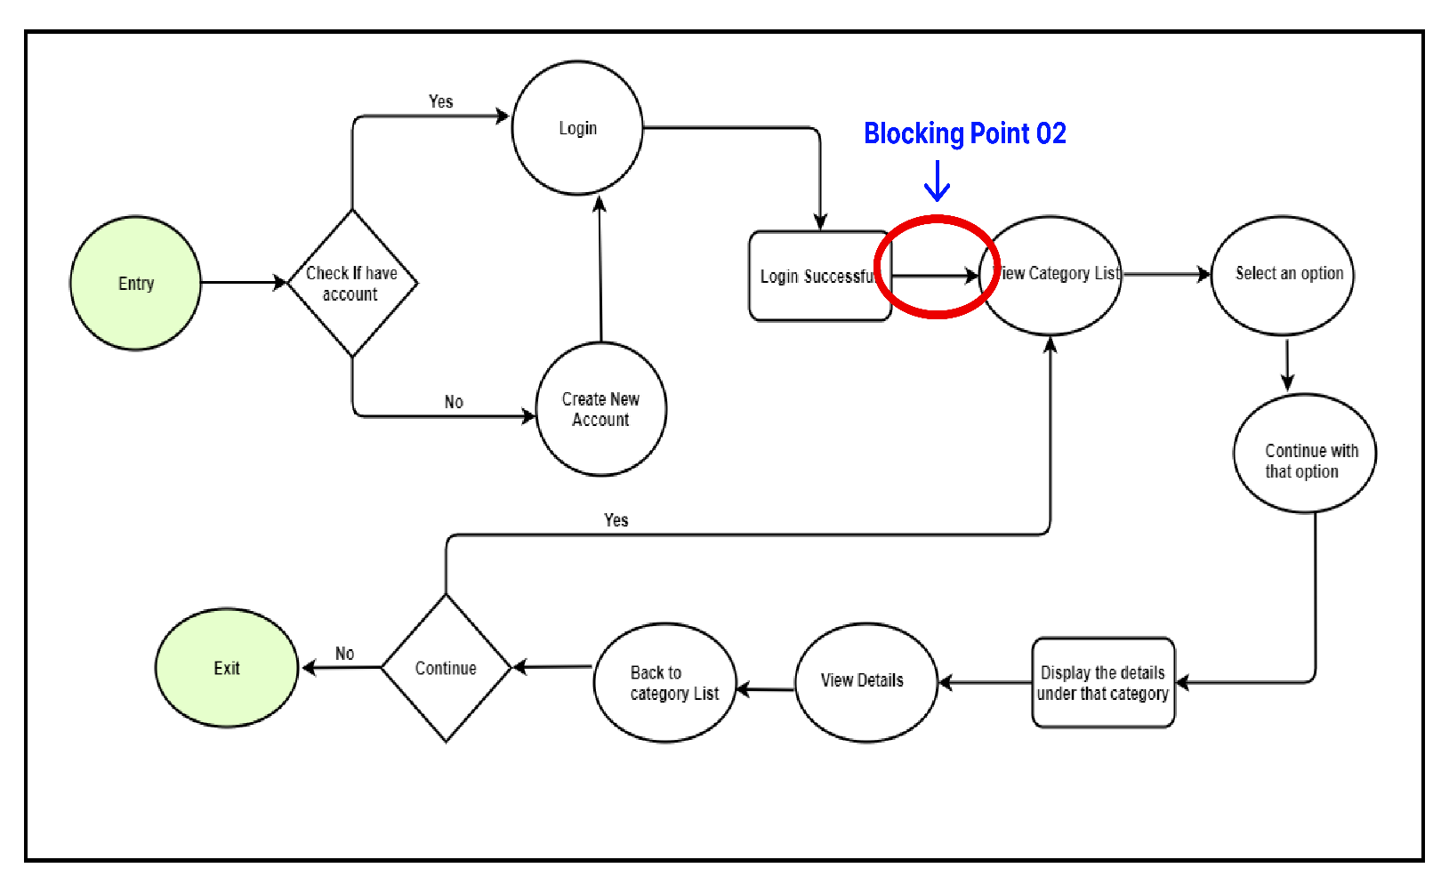

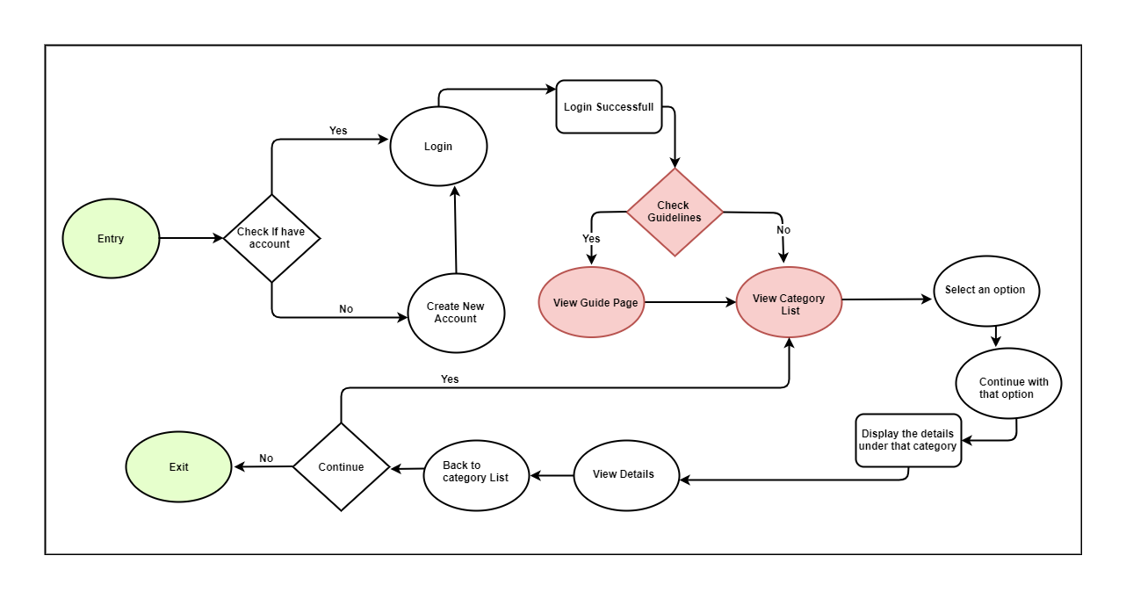**Fail Point 02 – Updated User Flow**

**Fail Point 03**

In addition to this, the other identified fail point is to display the details related to a certain category, and then instead of searching for the details one by one, insert a search box so that the information you want can be easily found with the help of a keyword.

**Fail Point 03 – User Flow with blocking point**

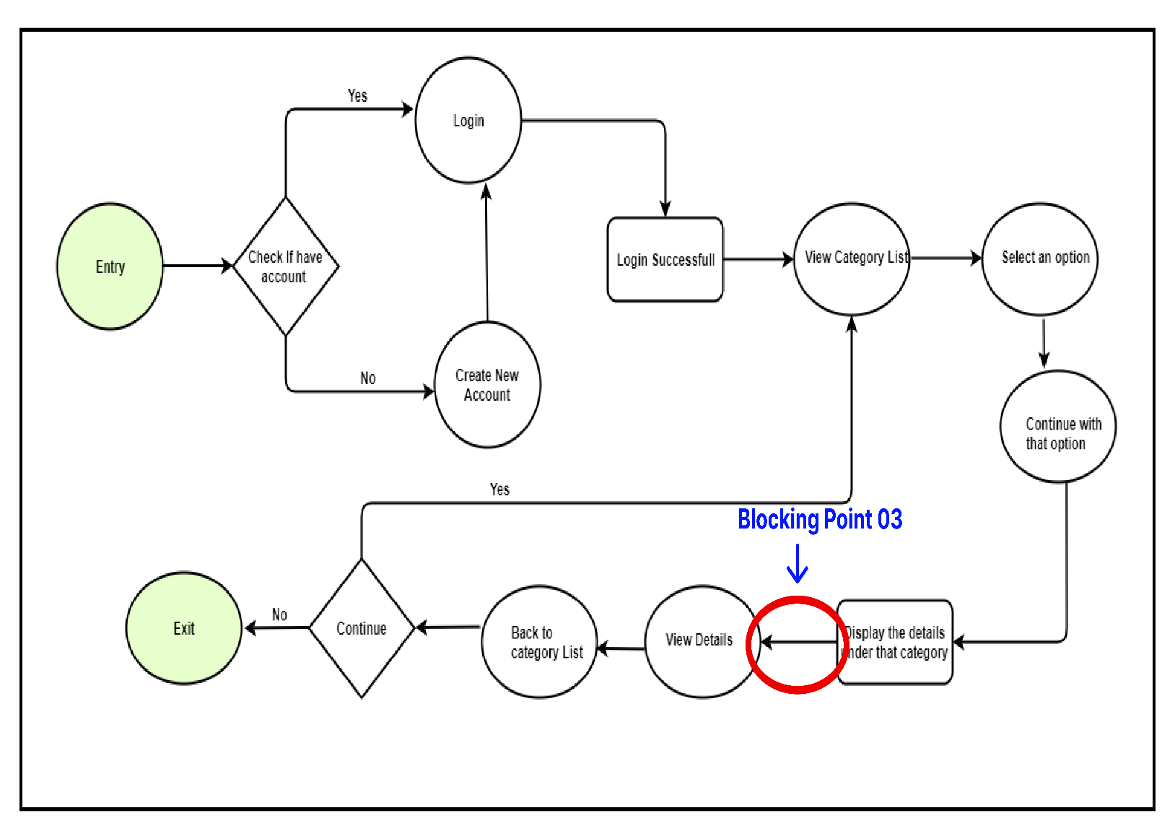

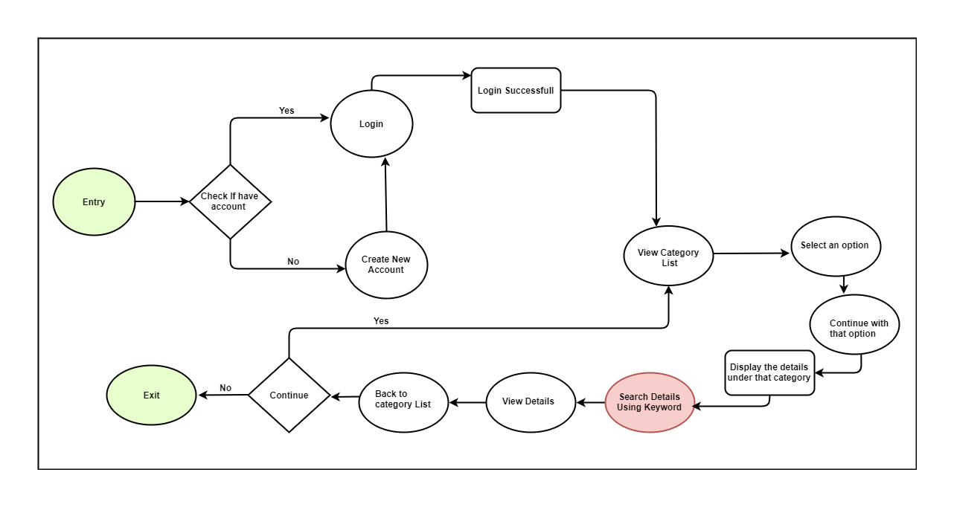**Fail Point 03 – Updated User Flow**

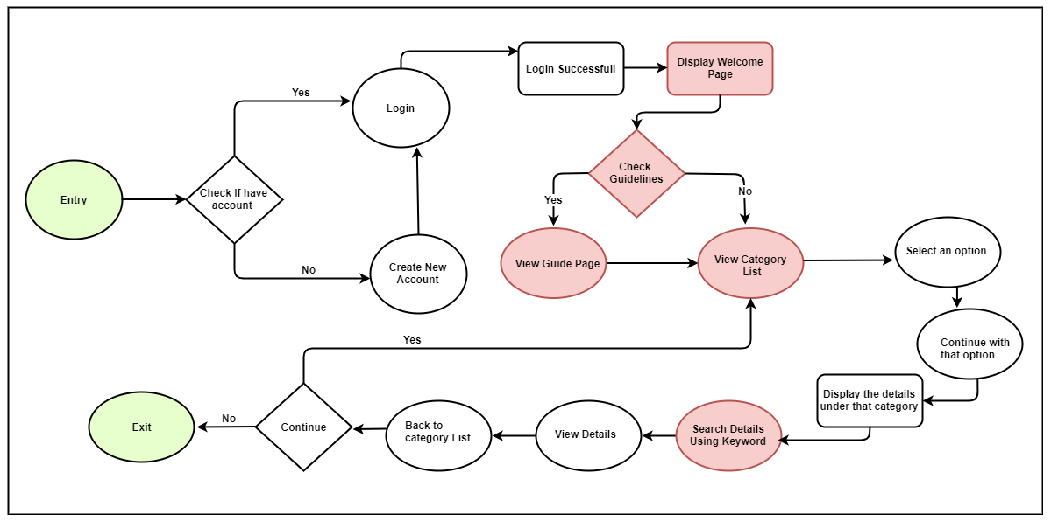

## IT 20136710

Fail Point 01

According to the comments received from the interviewed persona, I realized that the absence of a search field is a fail point. Accordingly, it is good to be able to create a search field and search for soil conservation methods.

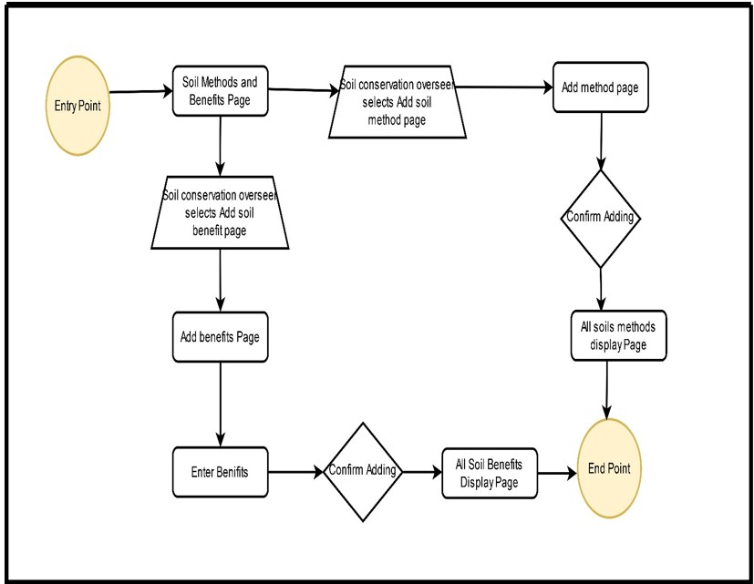

Fail Point 02

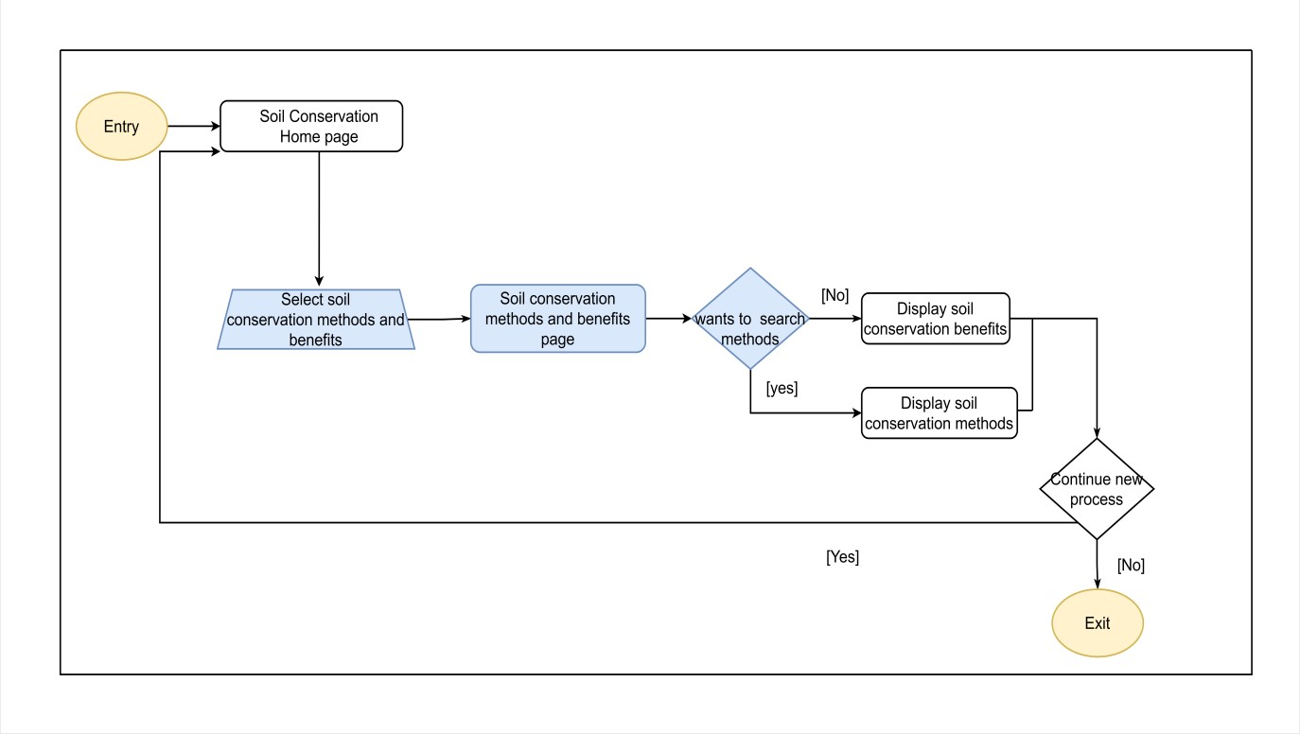Regarding the person, the person said that feedback is a very valuable element. It can know the opinion of the people about the advice and services received. So, I figured it would be good to add a section to provide feedback on users' experiences.



# **Block Point 2**

# **Block Point 2**

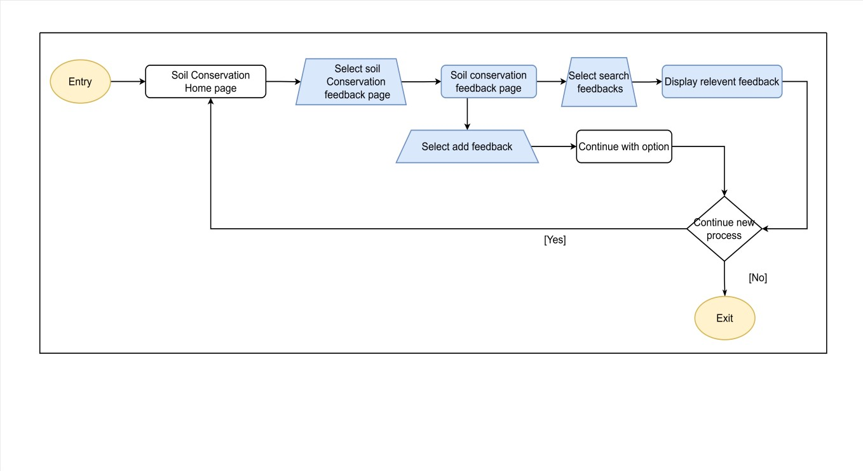

Fail Point 03

The person related persona said that he is experimenting with different methods. Accordingly, it was understood that not adding such a part is a fail point. So it is good to add a section to collect the problems of different users and the solutions and experience they have applied to those problems.



# **Block Point 3**

# **Block Point 2Block Point 3**

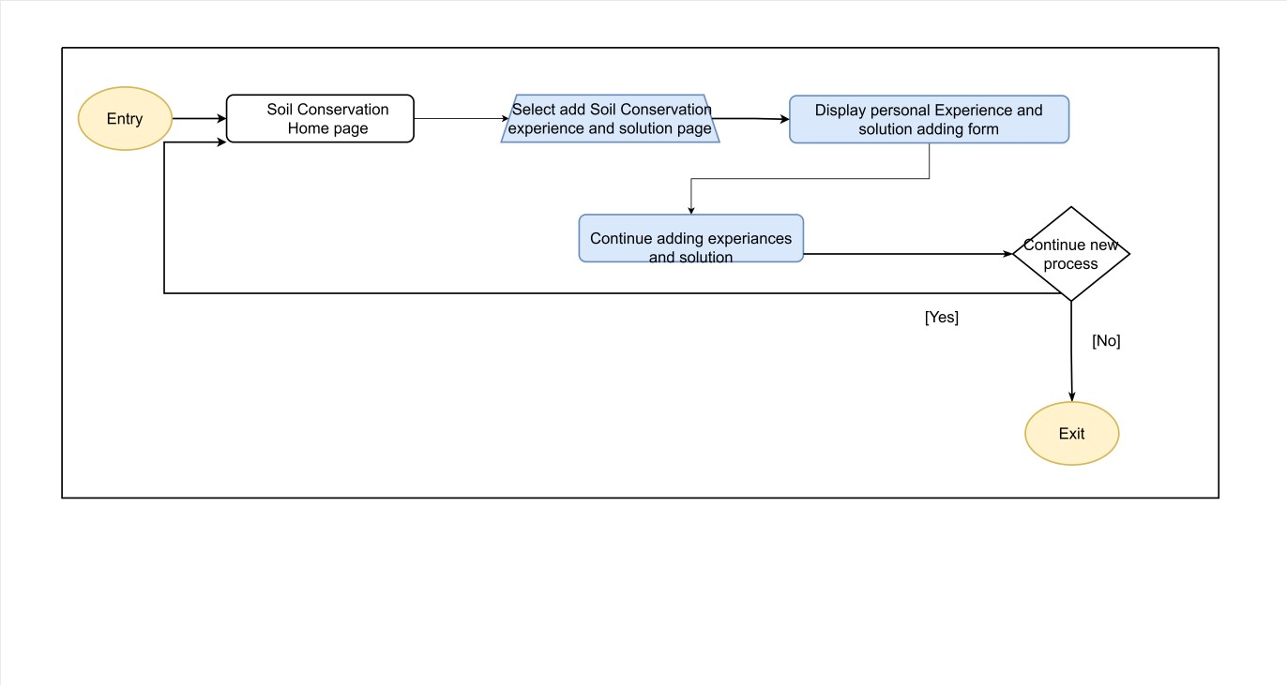

Final User Flow

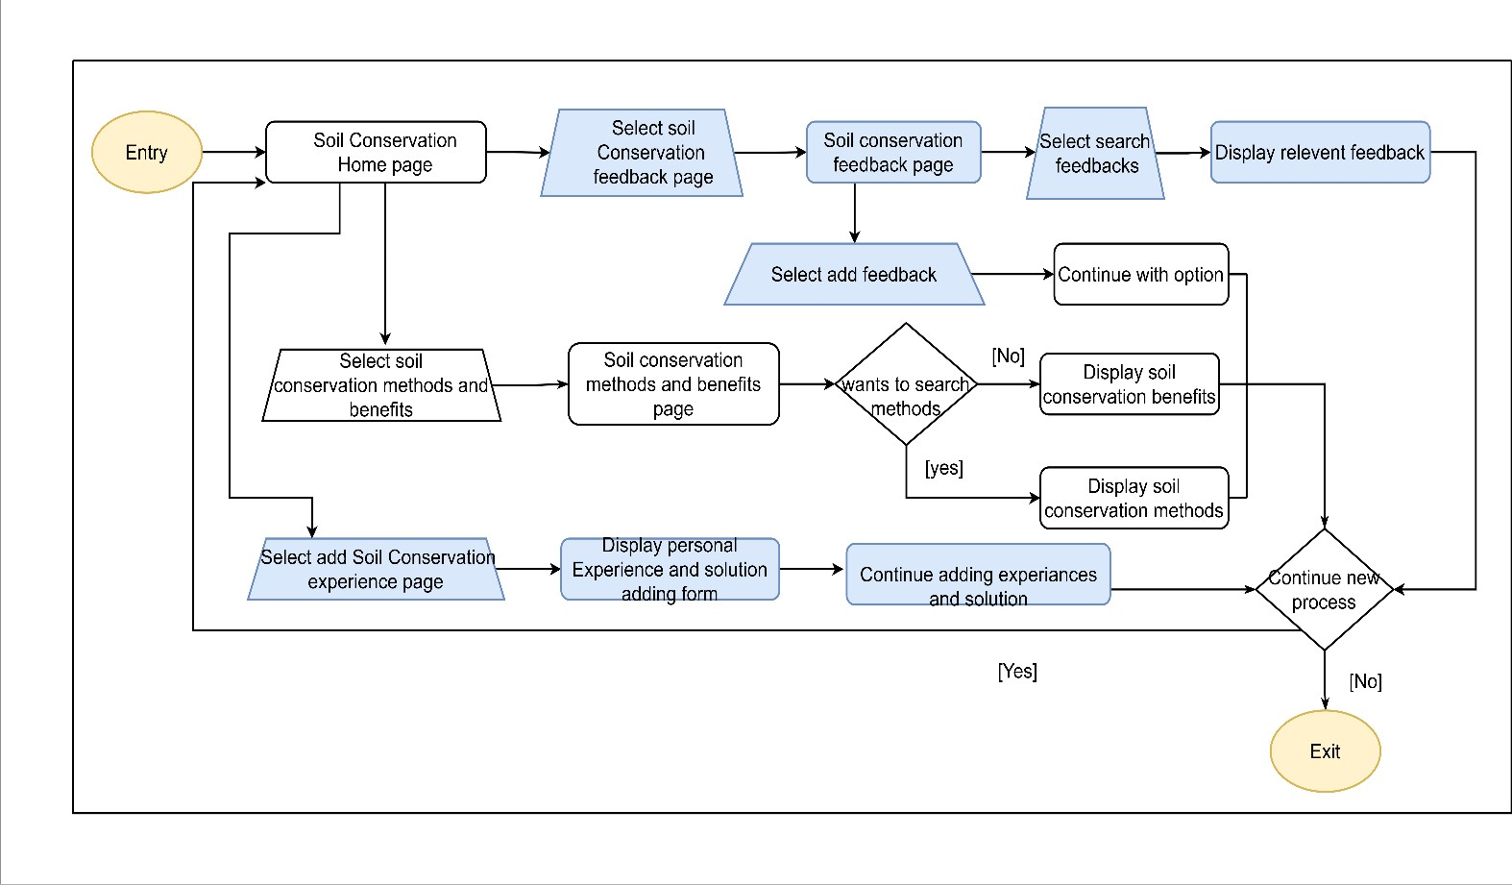

# Competitor Analysis

**ගොවි මිතුරු**

**Advantages**

• The ගොවි මිතුරු app contains information related to many categories.

**Disadvantages**

• In the ගොවි මිතුරැ app, there is no subcategory page which is a disadvantage. There was more color, view more feathers didn't work. It is a disadvantage.

Comparison with our app

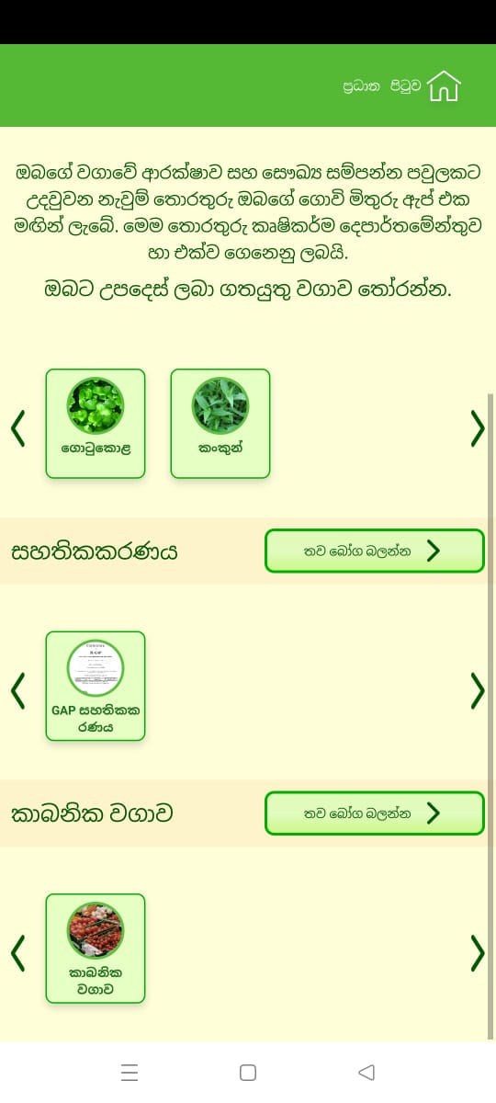ගොවි මිතුරු- This is an app that provides fresh information about crop safety and healthy family. A shortcoming seen in it is that the view page related to all the existing categories is shown only on one page. We don't do that in our app. Mainly the sections are separated very lightly into sub-category pages. User can easily proceed to the issues by clicking on his desired category.

Figure 15-Competitor 01 sample screenshot

**වවමු දිනමු**

**Advantages**

• You can search a category in වවමු දිනමු app.

**Disadvantages**

• In the වවමු දිනමු app, there is no sub-category page, which is a disadvantage. The ui is less attractive. Having to scroll down a lot to select the category.

**Comparison with our app**

වවමු දිනමු- This is also an app that has been created to give advice on farming activities. A shortcoming seen there is that the view page related to all the existing categories is shown only on one page. Also, there was a lack of attractiveness. Not user friendly. Color combination is not creative. We have designed our app with good quality and it is really attractive to look at.

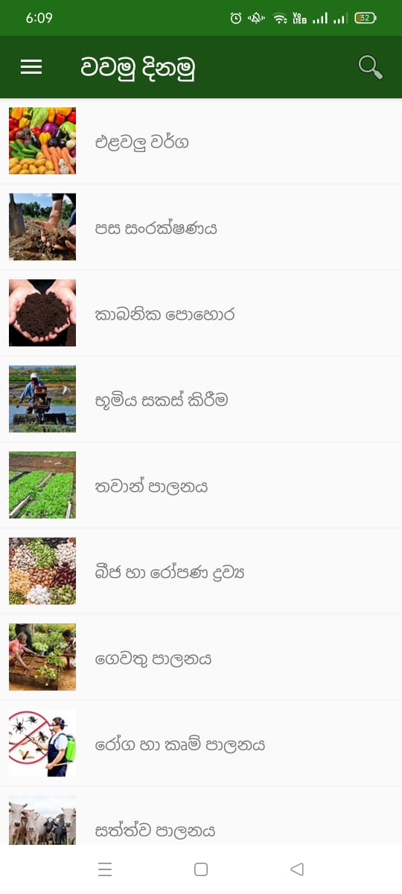

Figure 16-Competitor 2 sample screenshot

**Soil type**

**Advantages**

• Soil type app's user interface is attractive. Creative.

• Adding real-world images is a plus. Adding green color is good. white color is very good combination with green color

**Disadvantages**

• soil type app - missing a home page. lack of information and feathers.

**Comparison with our app**

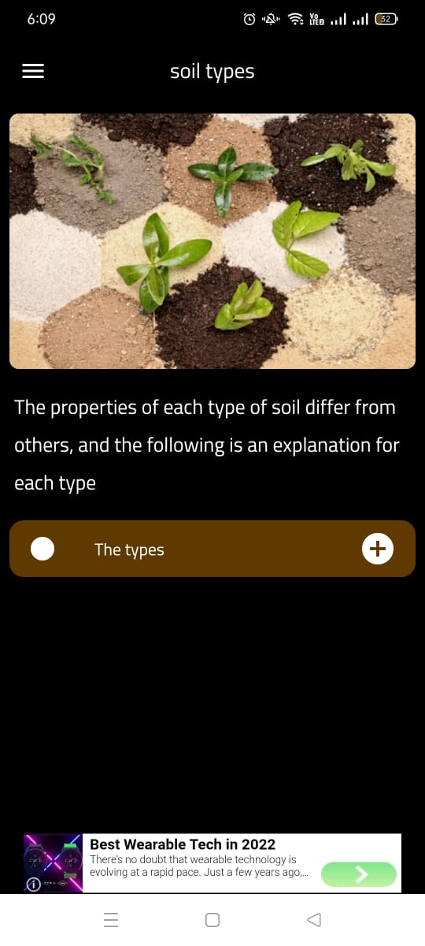 soil type - There was no major drawback in this app. But it lacked a home page. There was a lack of information. I saw it as a deficiency. And the attractiveness of some pages was low. Our app has been designed by combining all these good advantages . Our app has been designed to be user friendly, attractive and effective.

Figure 17-Competitor 3 sample screenshot

# Milestone 4: Sketching

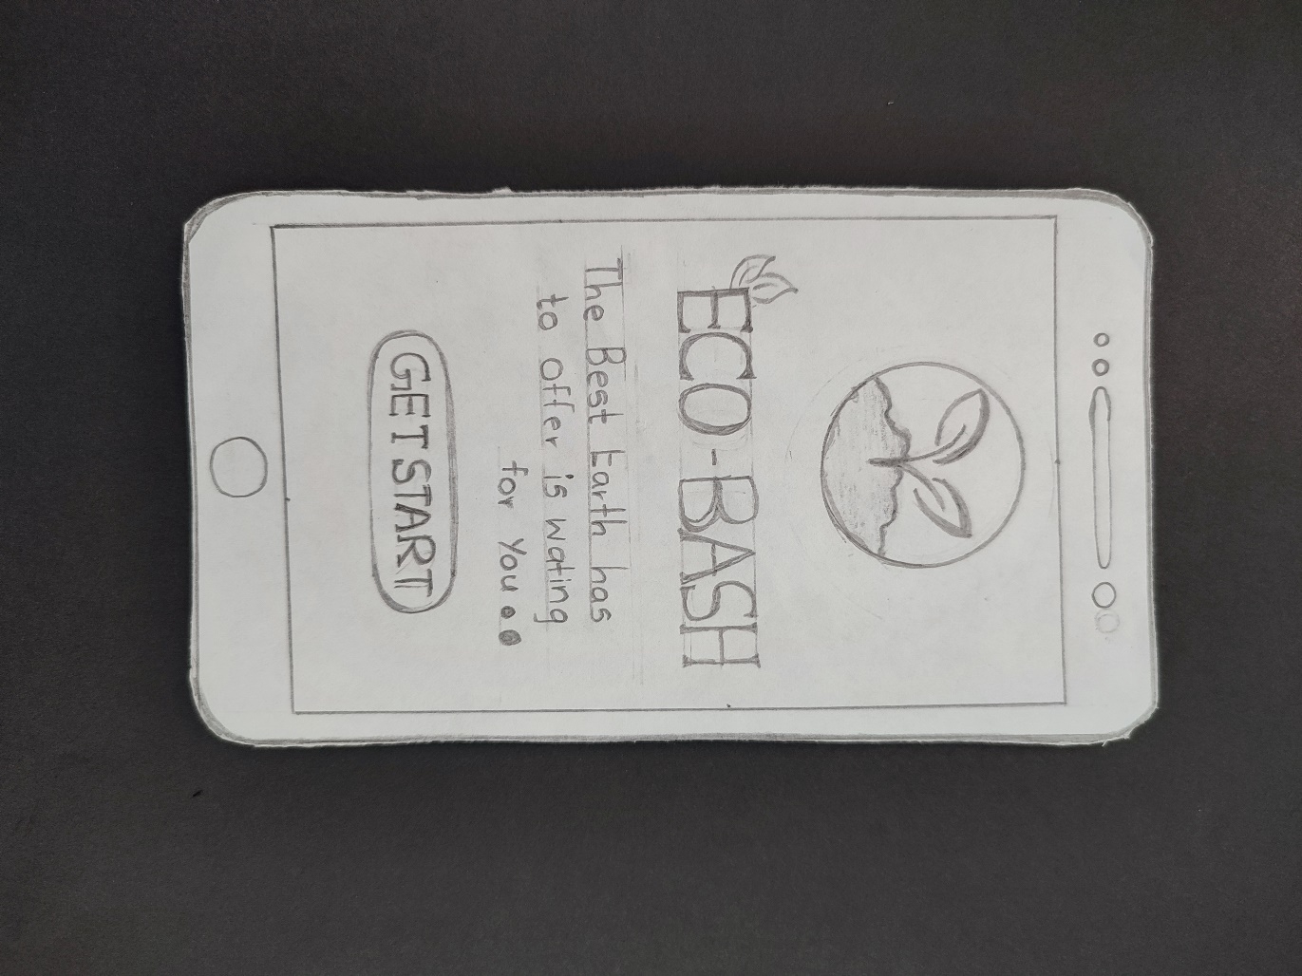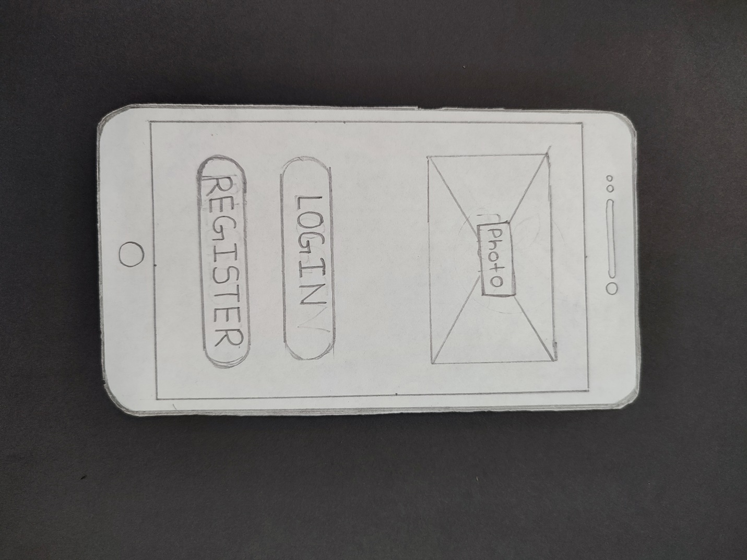

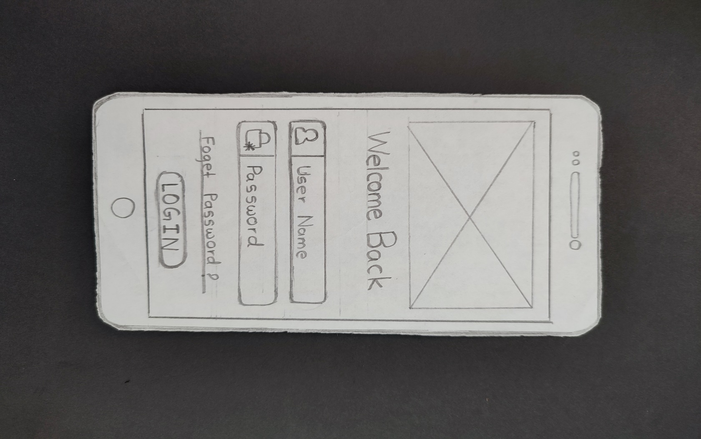

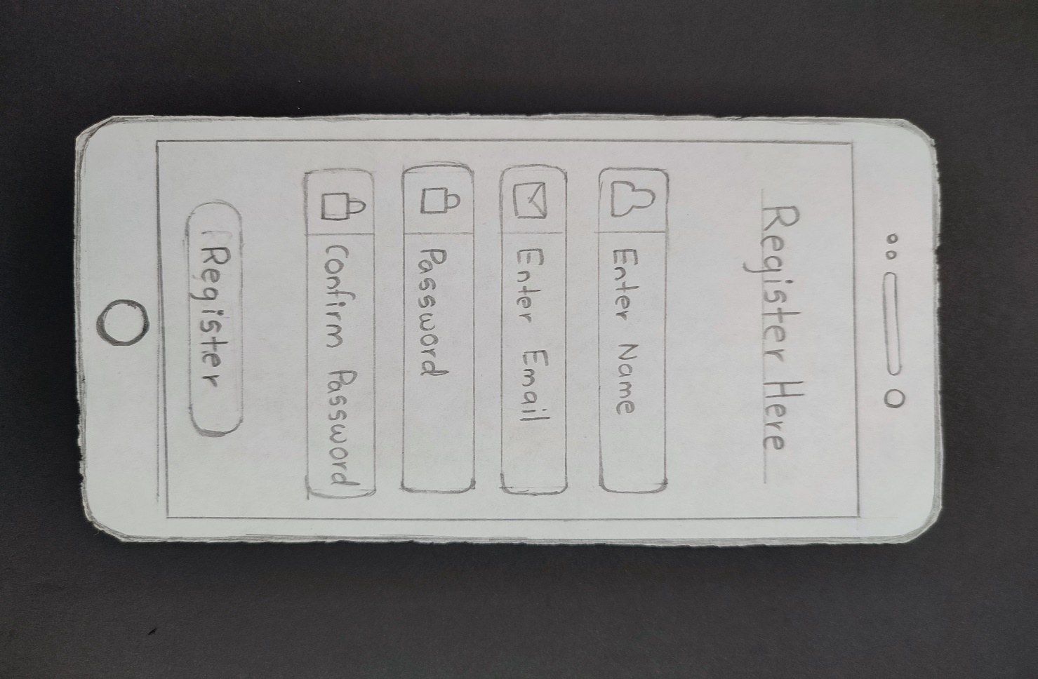

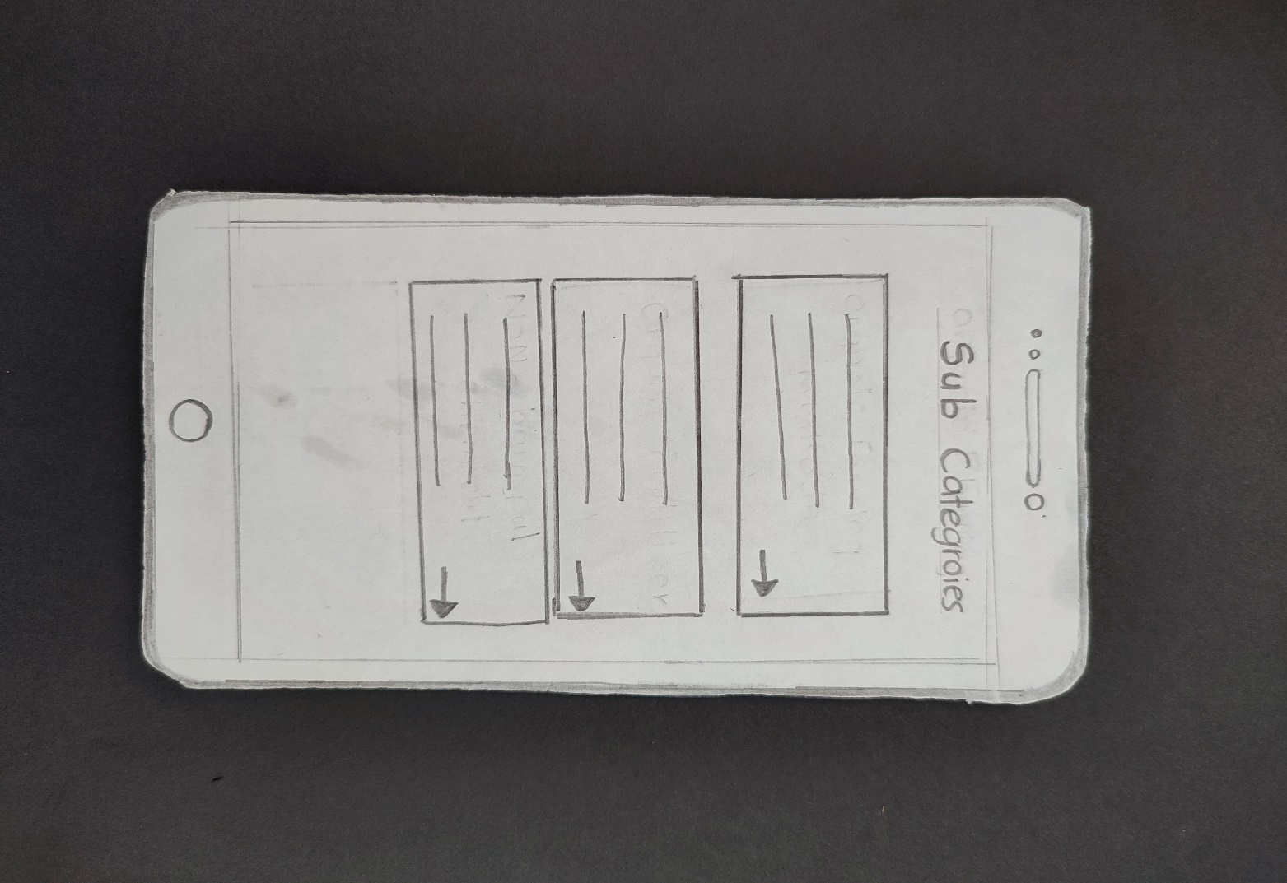

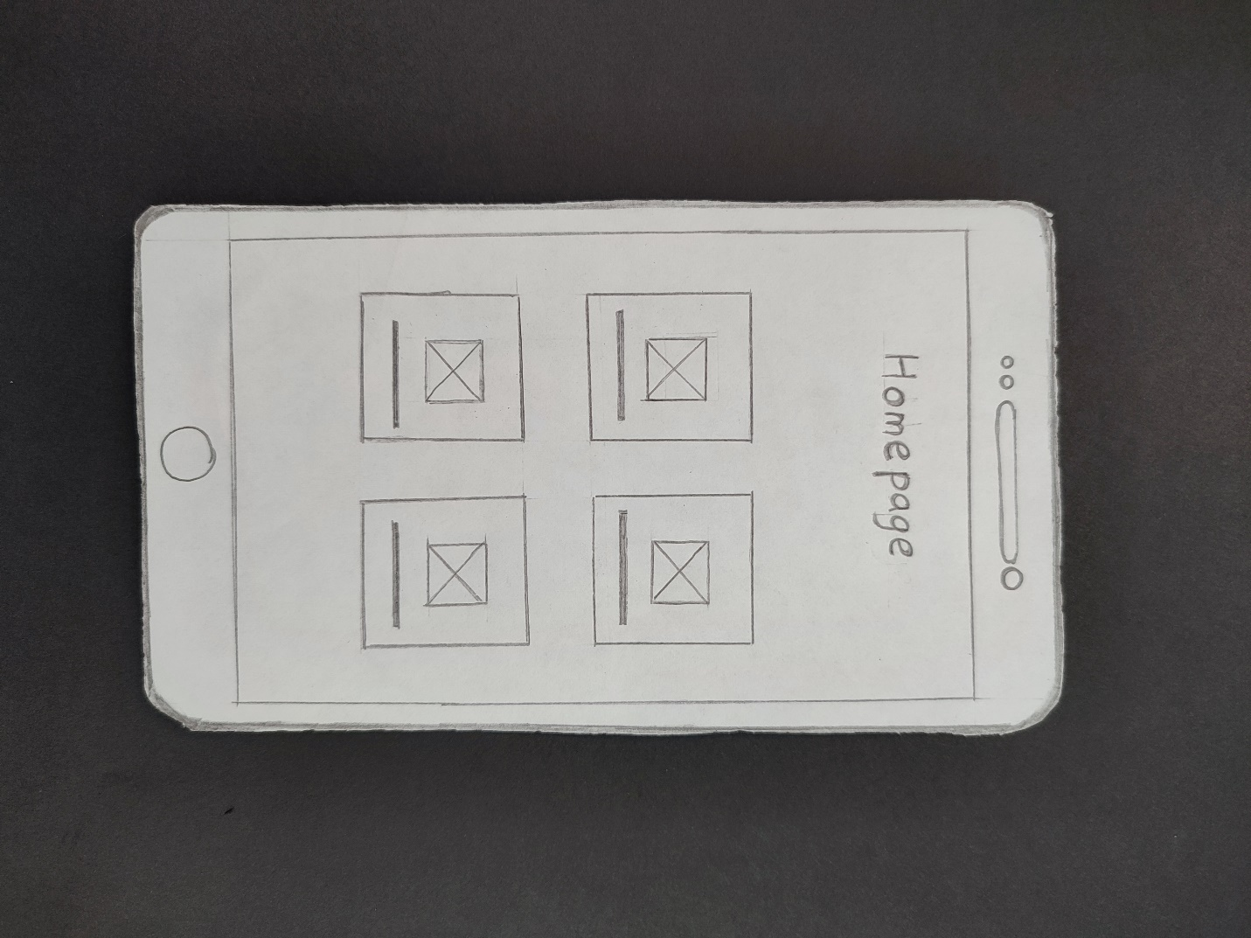

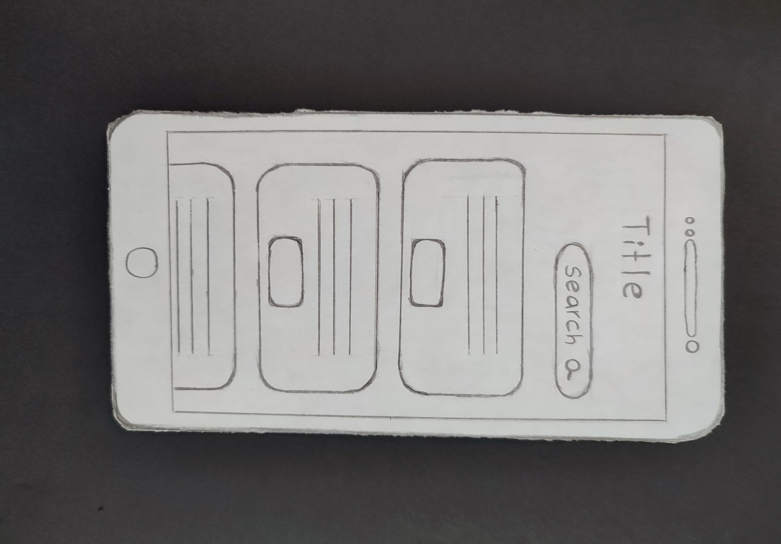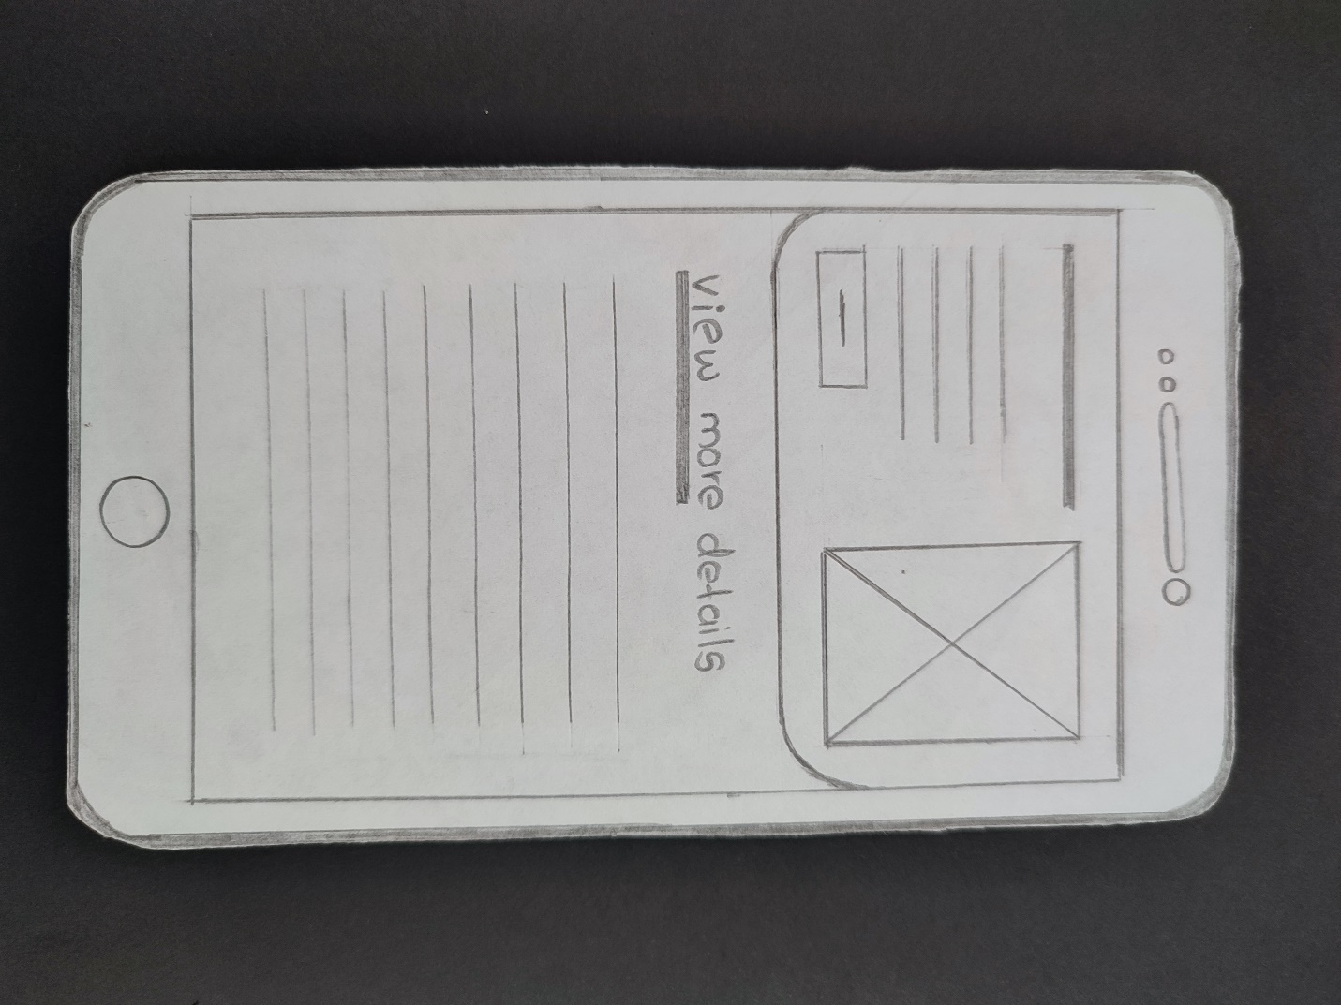

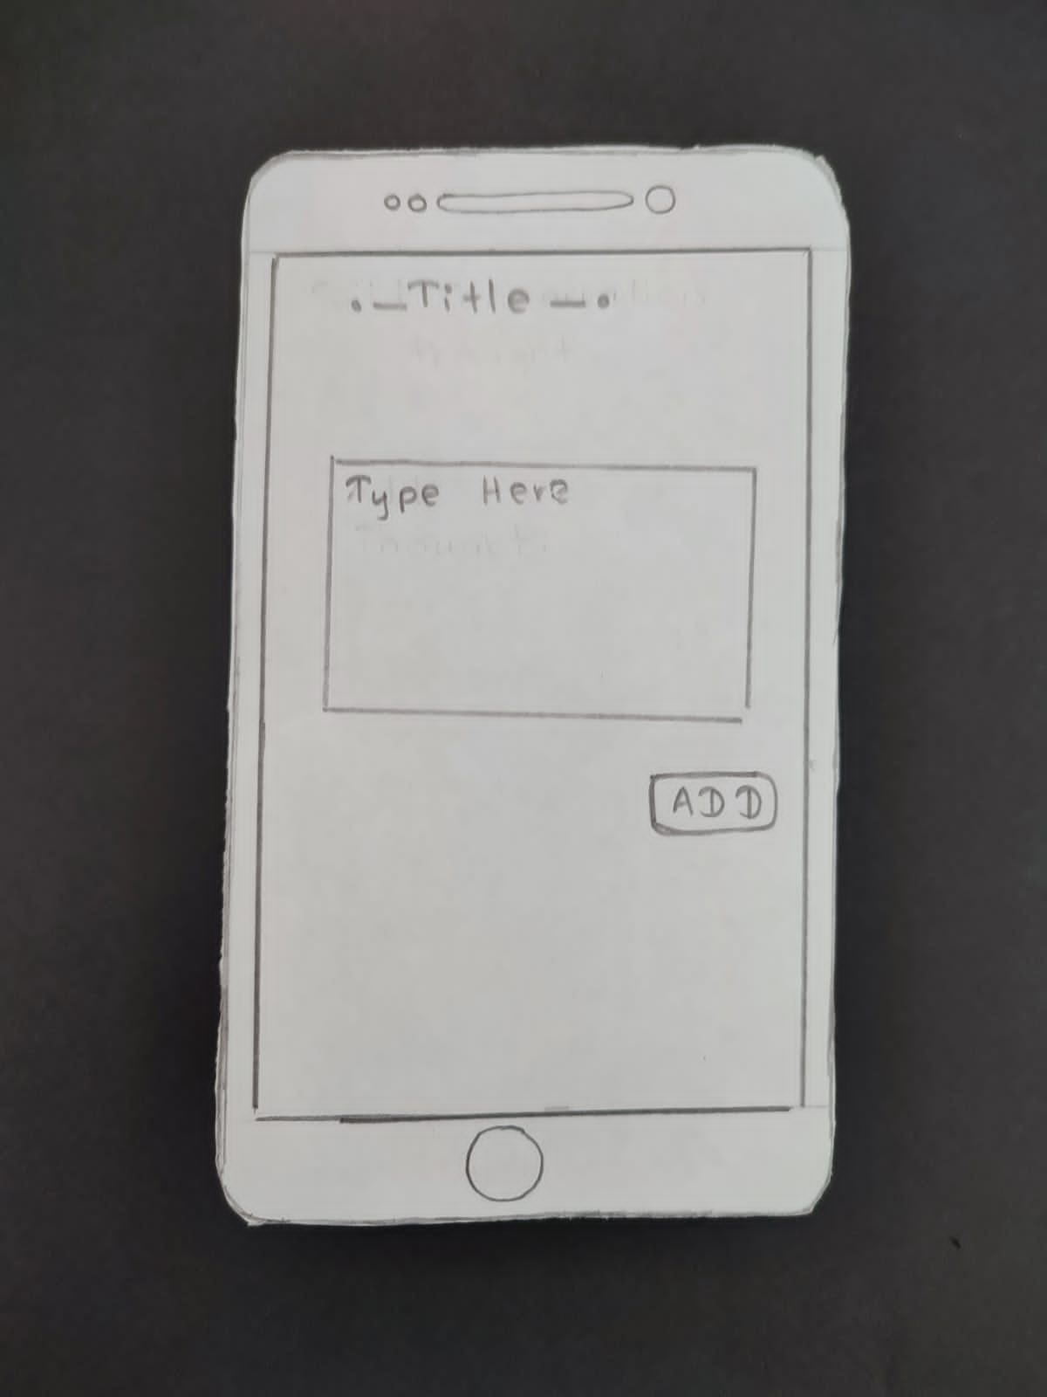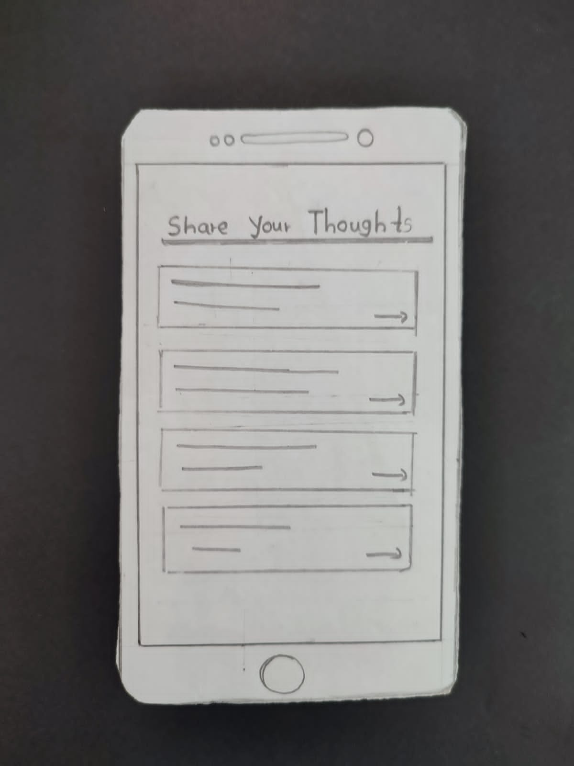

## **Admin Side Sketches**

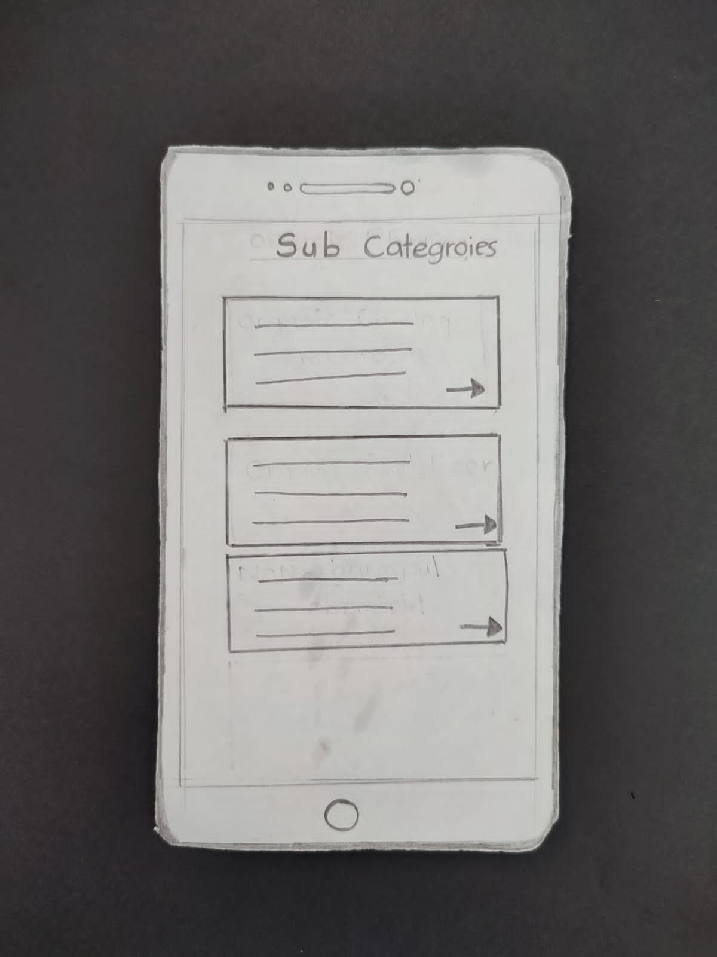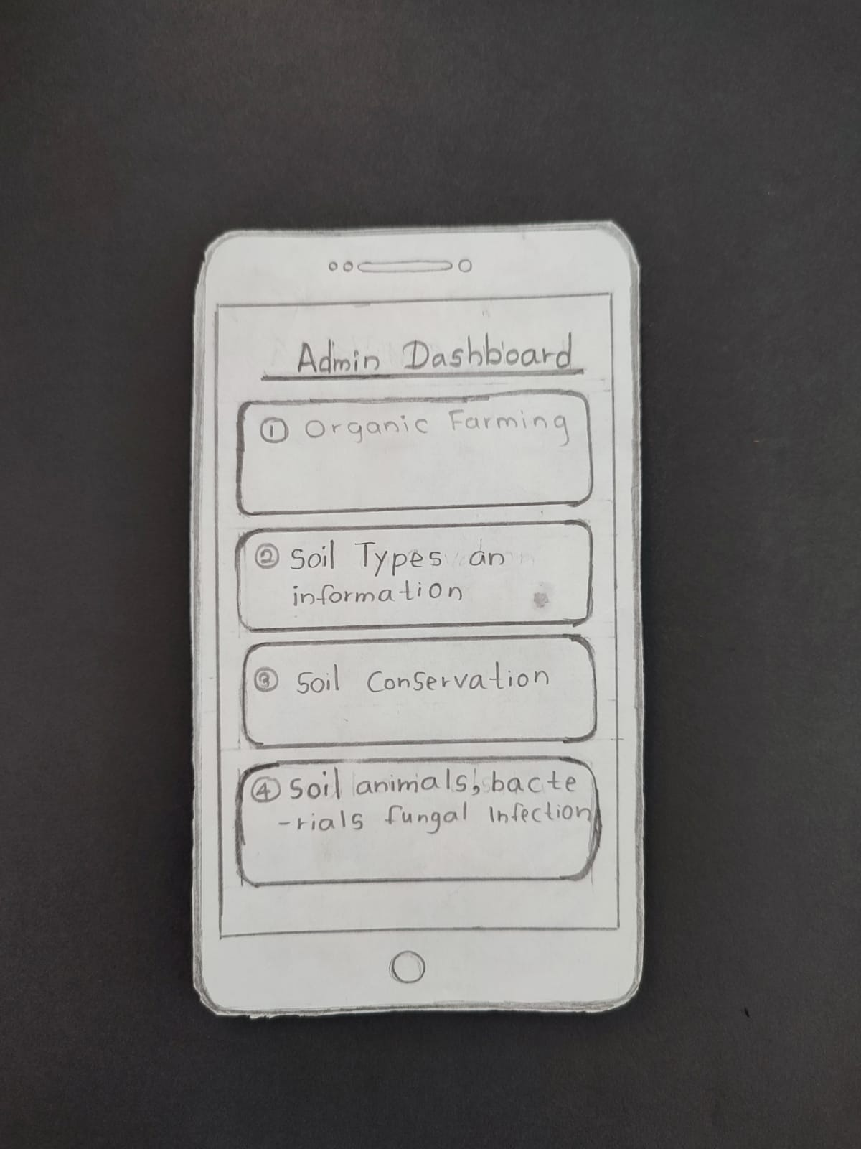

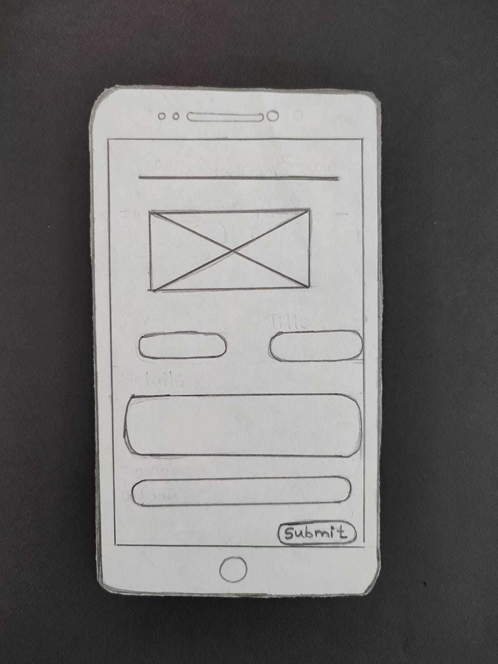

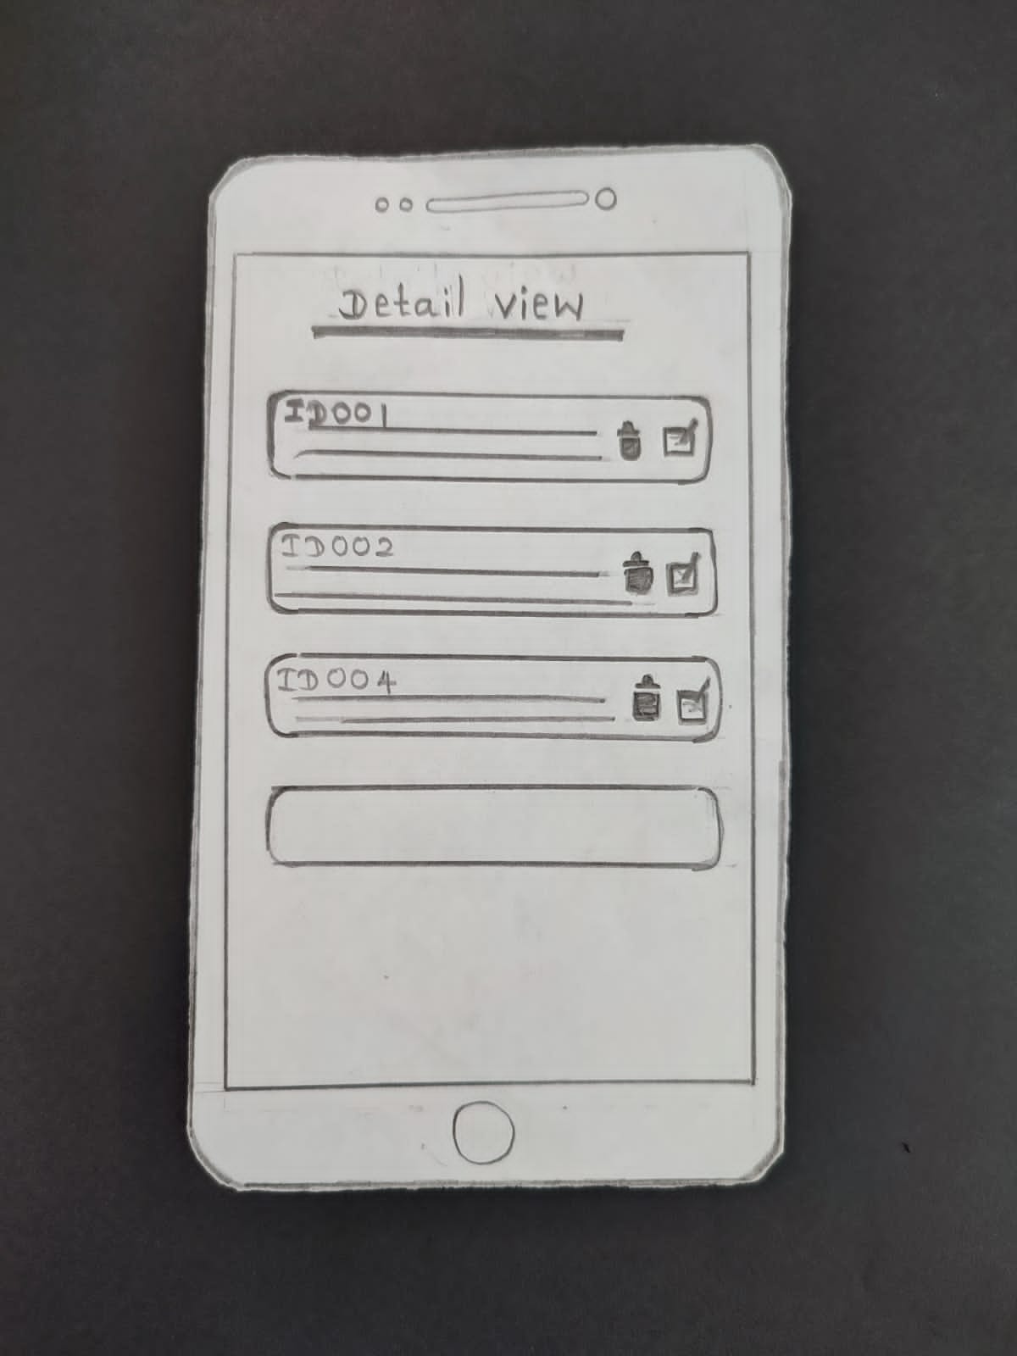

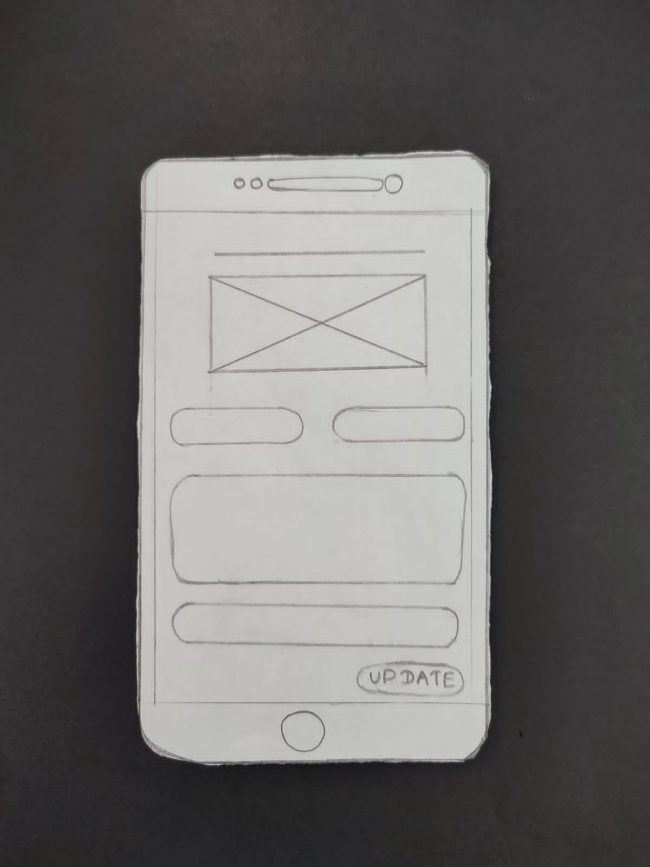

## IT20125066

### Low fidelity wireframe

### Function: Organic Farming Management

#### User part wireframes

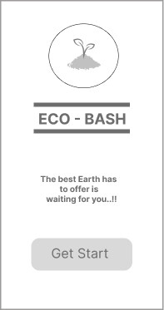

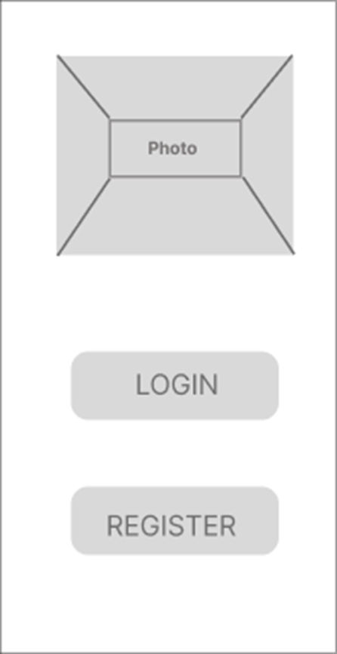

Splash page

Start page

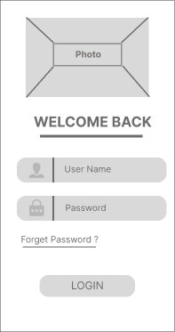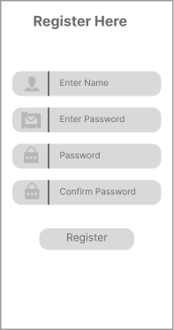

Registration page

Registration page

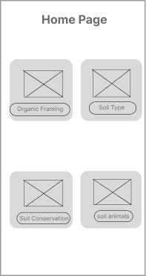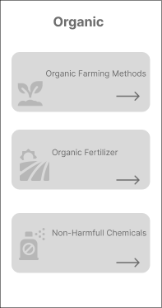

Home Page for user side

Organic Framing Dashboard

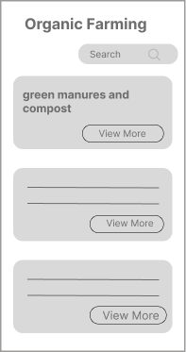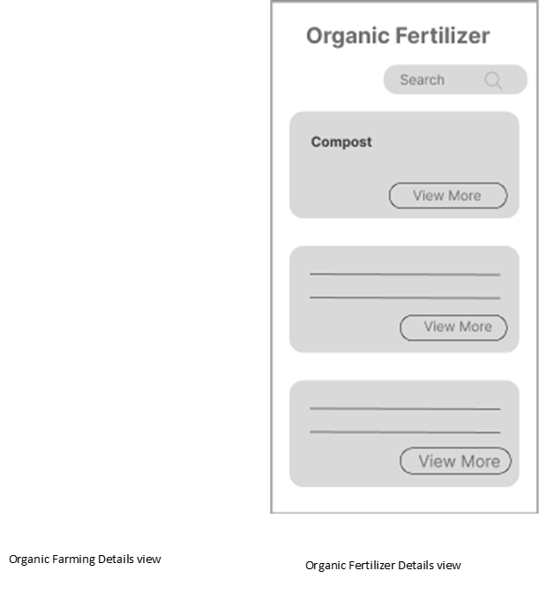

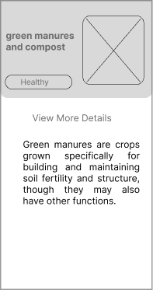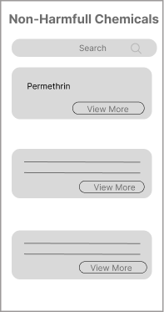

View more details for organic Farming

Non- Harmful chemicals View

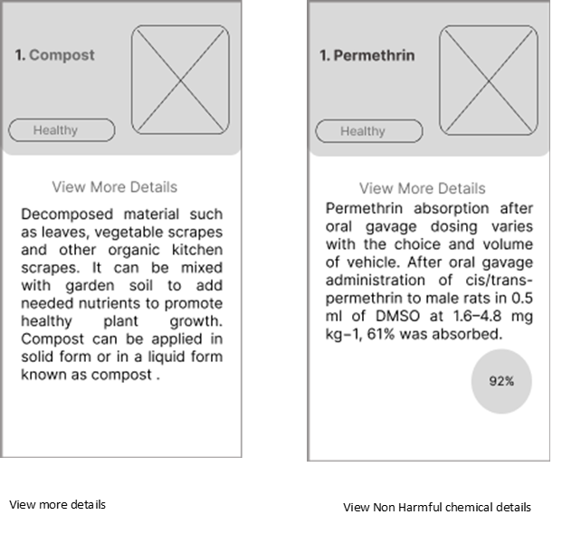

### Function: Organic Farming Management

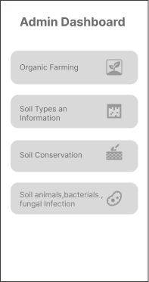Admin part wireframes

Admin Dashboard

Organic Farming dashboard

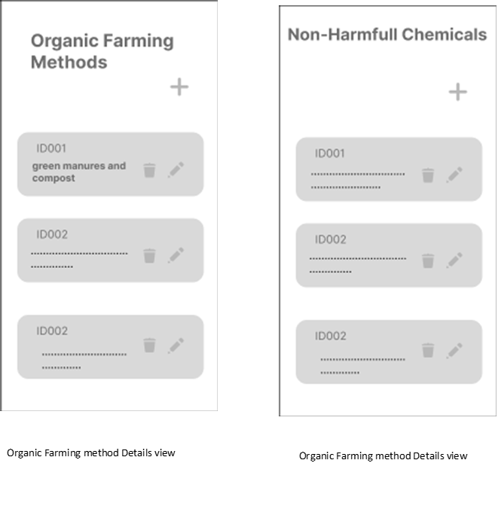

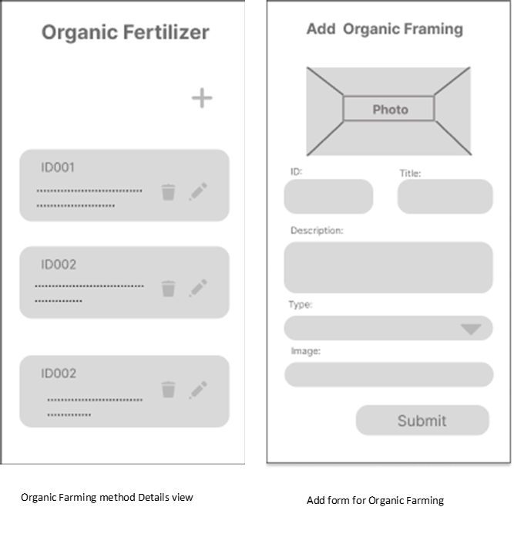

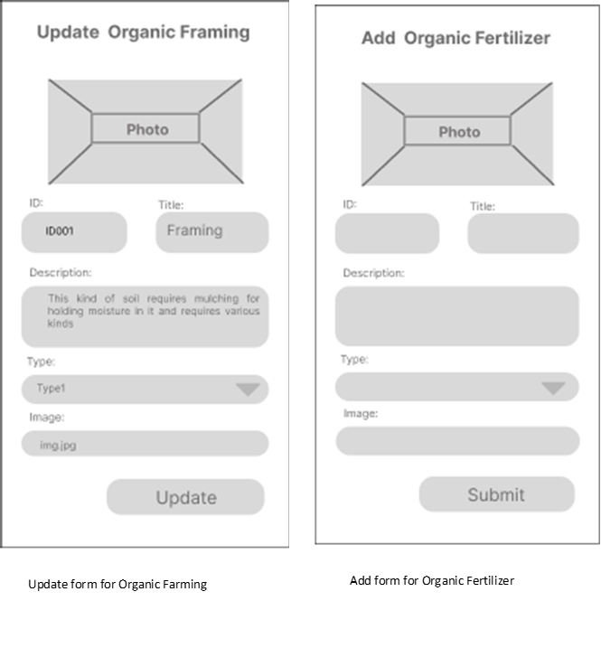

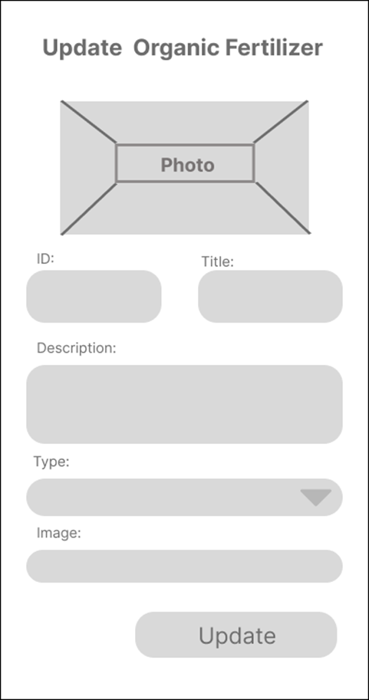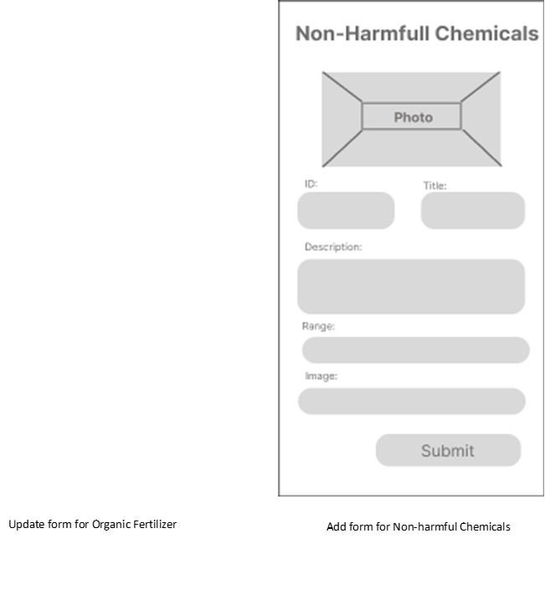

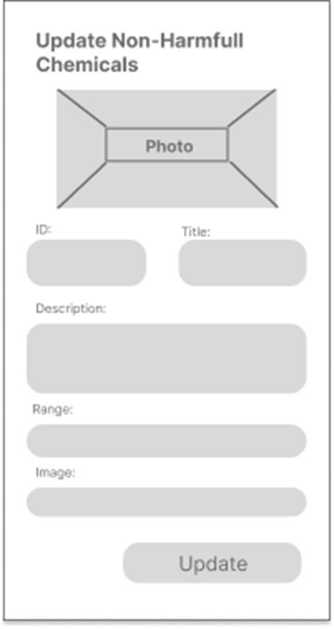



## Prototype Links

Admin Part:

<https://www.figma.com/proto/kRSnFRlmFwYCDNBPT0kaV1/Untitled?node-id=1%3A44&scaling=min-zoom&page-id=0%3A1&starting-point-node-id=1%3A44>

User Part:

<https://www.figma.com/proto/kRSnFRlmFwYCDNBPT0kaV1/Untitled?node-id=34%3A2&scaling=min-zoom&page-id=0%3A1&starting-point-node-id=1%3A44>

## User Feedback Gathering

Questionnaire

Questionnaire link -: <https://forms.gle/XNir1NjGe2kXjqb29>

Questions with user feedback details

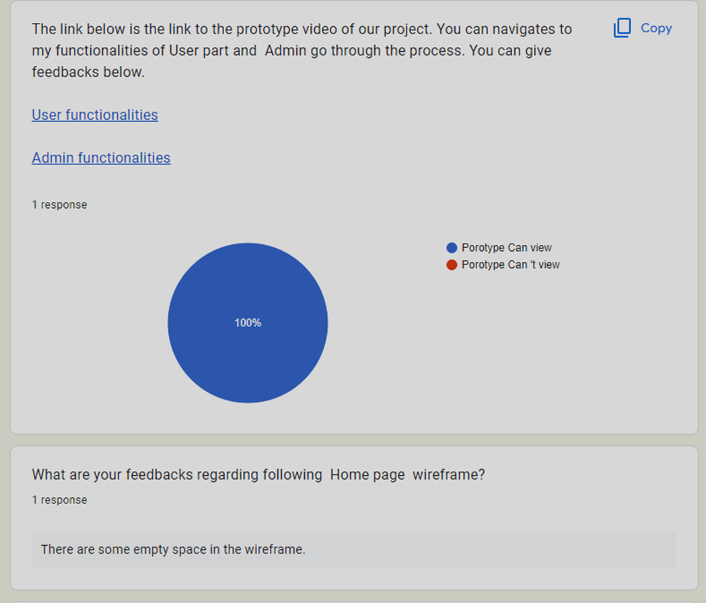

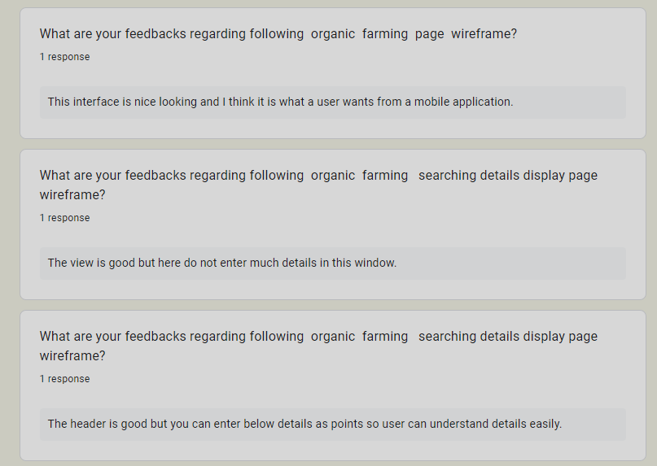

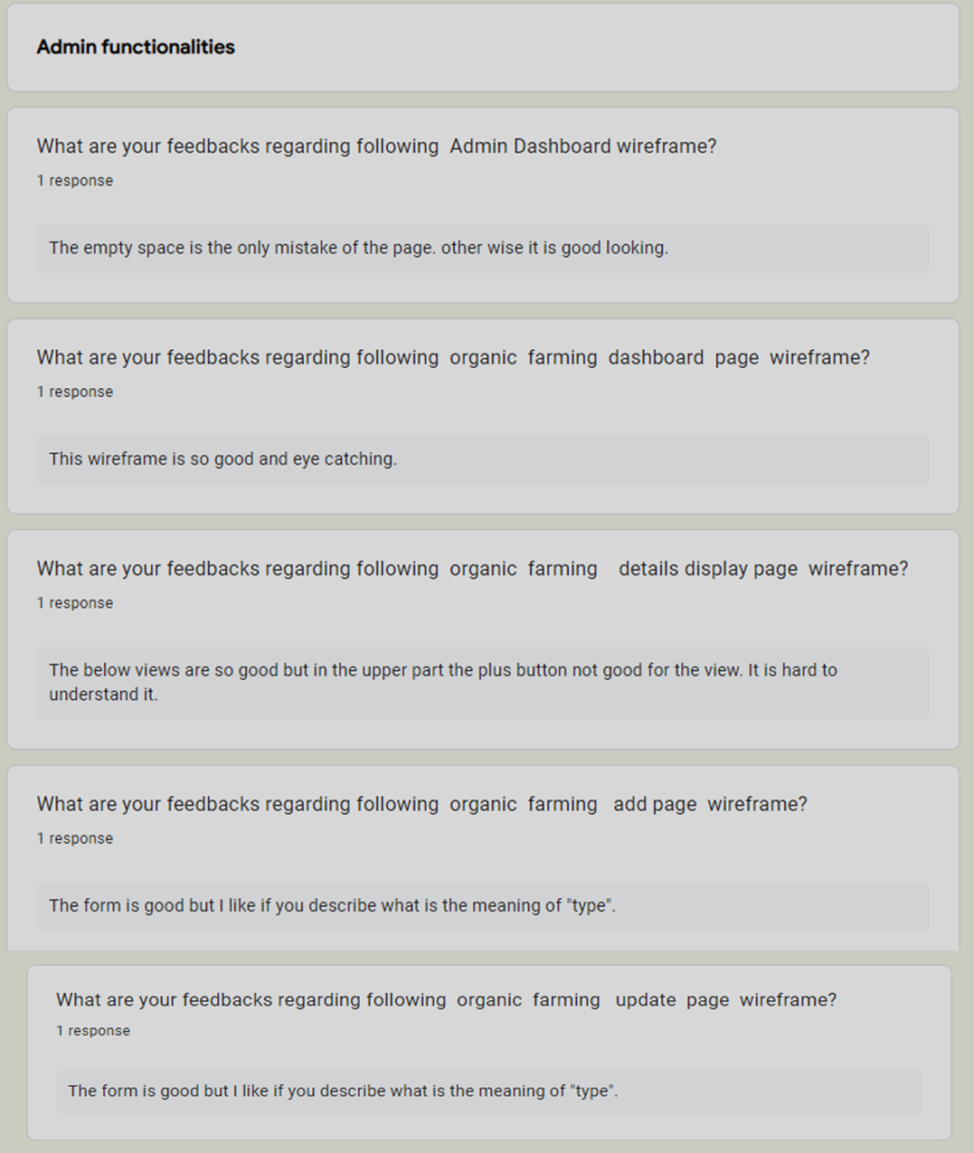

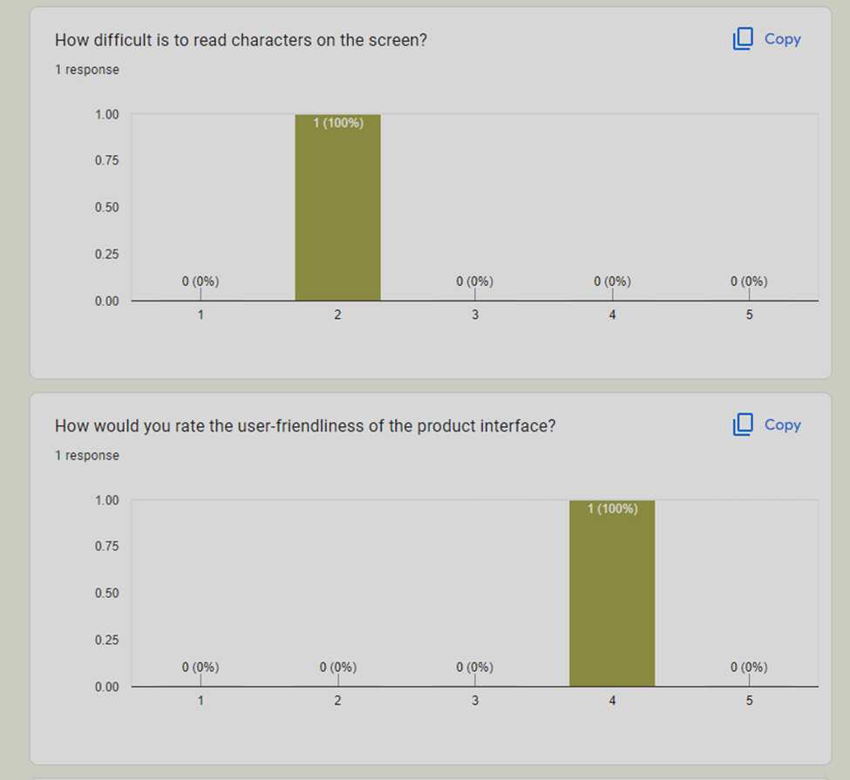



IT20258030

## **User Side Wireframes**

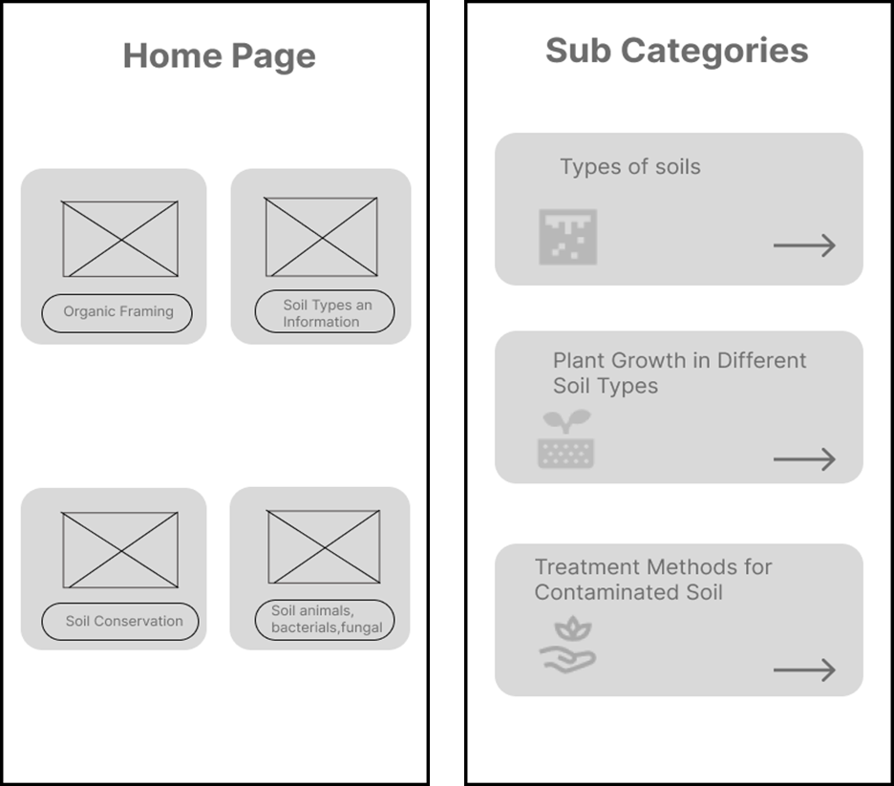**User Side prototype:** [**https://www.figma.com/proto/OgwqJ4HOC6DyBGxkoVpAjl/Untitled?node-id=33%3A17&scaling=min-zoom&page-id=21%3A2&starting-point-node-id=33%3A17&show-proto-sidebar=1Untitled Title**](https://www.figma.com/proto/OgwqJ4HOC6DyBGxkoVpAjl/Untitled?node-id=33%3A17&scaling=min-zoom&page-id=21%3A2&starting-point-node-id=33%3A17&show-proto-sidebar=1Untitled%20Title)

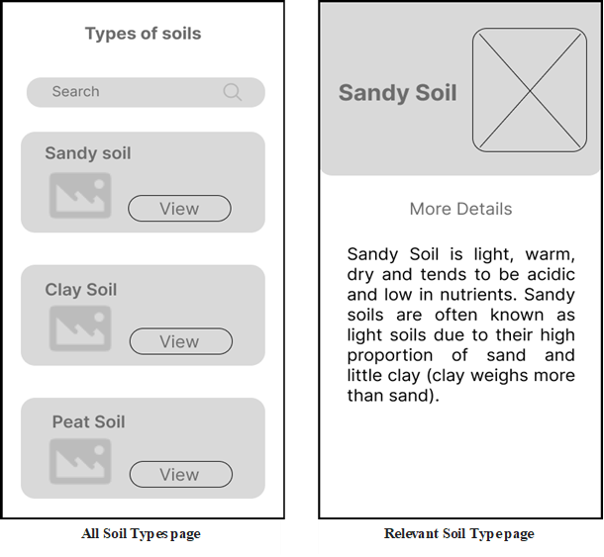

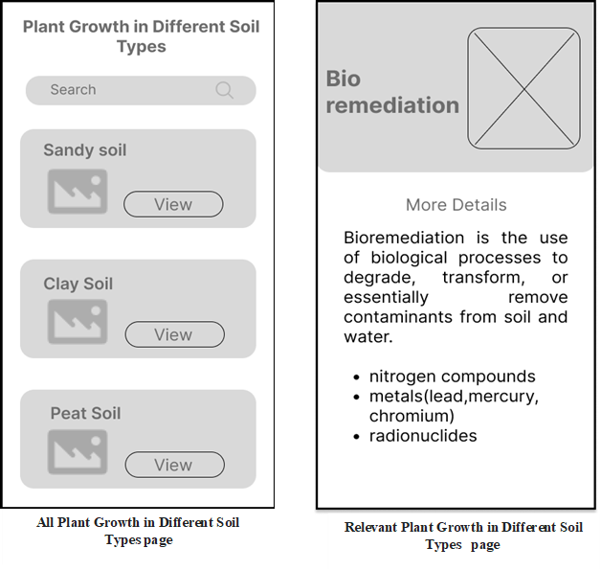

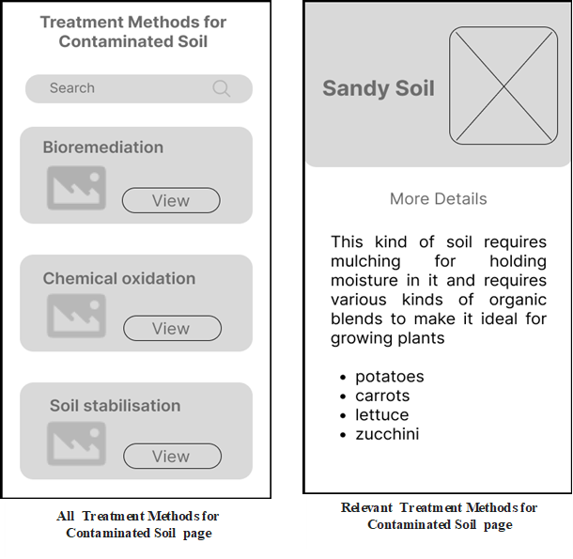

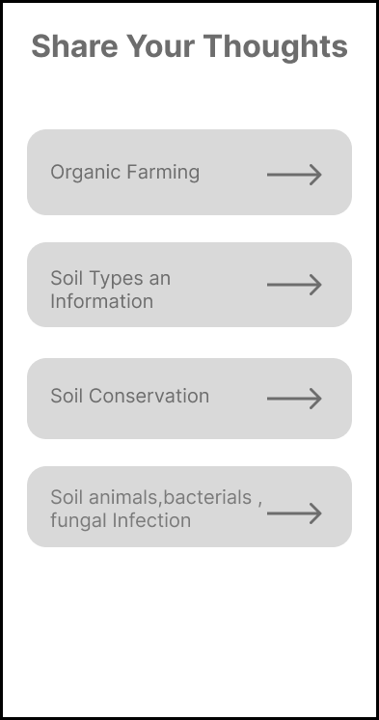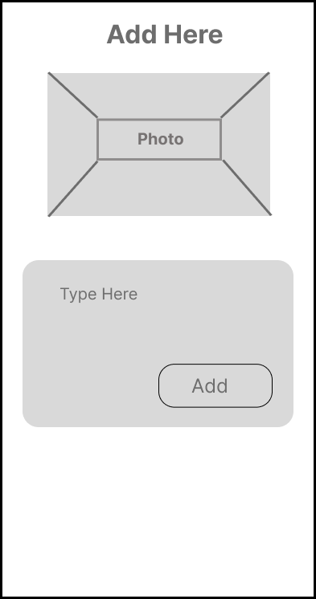

**User Experience/Feedback adding**  **page**

## **Admin Side Wireframes**

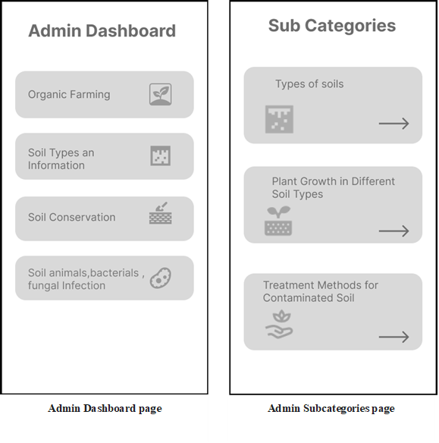**User Side prototype:** [**https://www.figma.com/proto/OgwqJ4HOC6DyBGxkoVpAjl/Untitled?node-id=50%3A682&scaling=min-zoom&page-id=21%3A2&starting-point-node-id=50%3A682&show-proto-sidebar=1**](https://www.figma.com/proto/OgwqJ4HOC6DyBGxkoVpAjl/Untitled?node-id=50%3A682&scaling=min-zoom&page-id=21%3A2&starting-point-node-id=50%3A682&show-proto-sidebar=1)

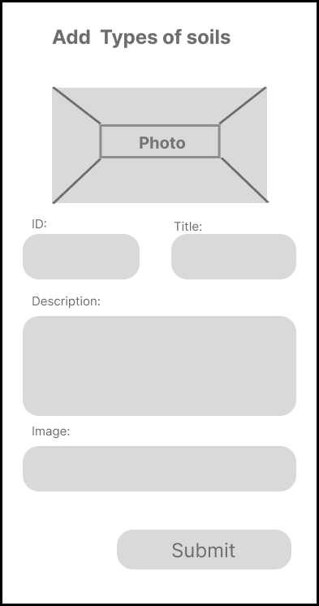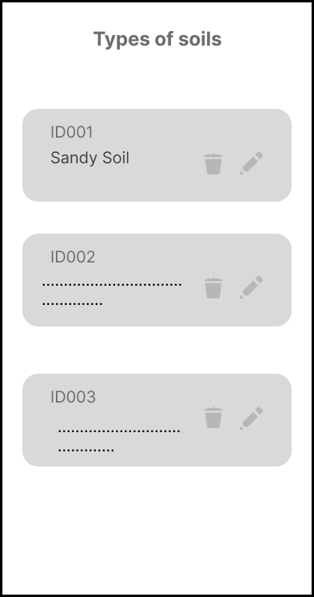

**All Added Details page with update /Delete options**

**Details adding page**

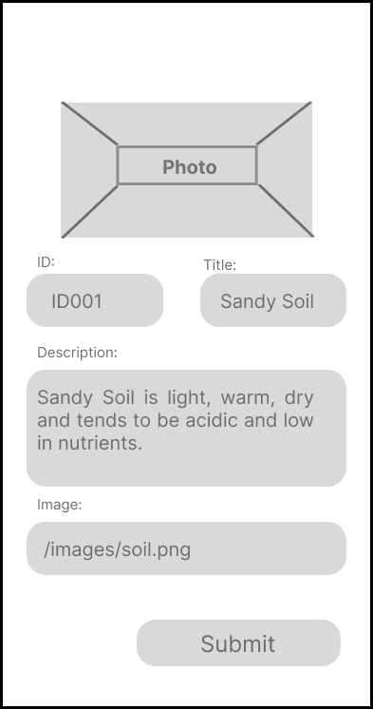

**Update Details Page**

# **User Responses**

**Google Form Link :** [**https://docs.google.com/forms/d/e/1FAIpQLSczUjHS_ETwRDxoJVunate07LGbbLtr9qB3_-ERRm8MJgkQgw/viewform**](https://docs.google.com/forms/d/e/1FAIpQLSczUjHS_ETwRDxoJVunate07LGbbLtr9qB3_-ERRm8MJgkQgw/viewform)

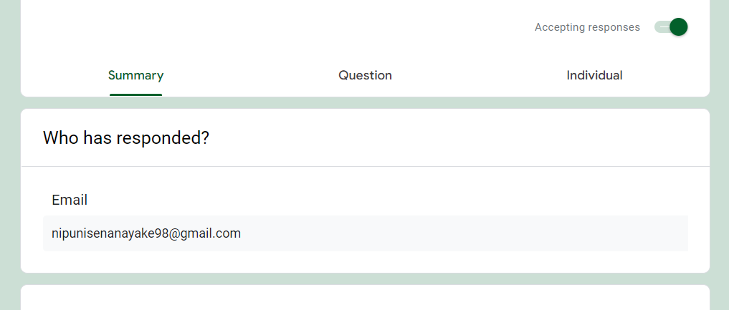

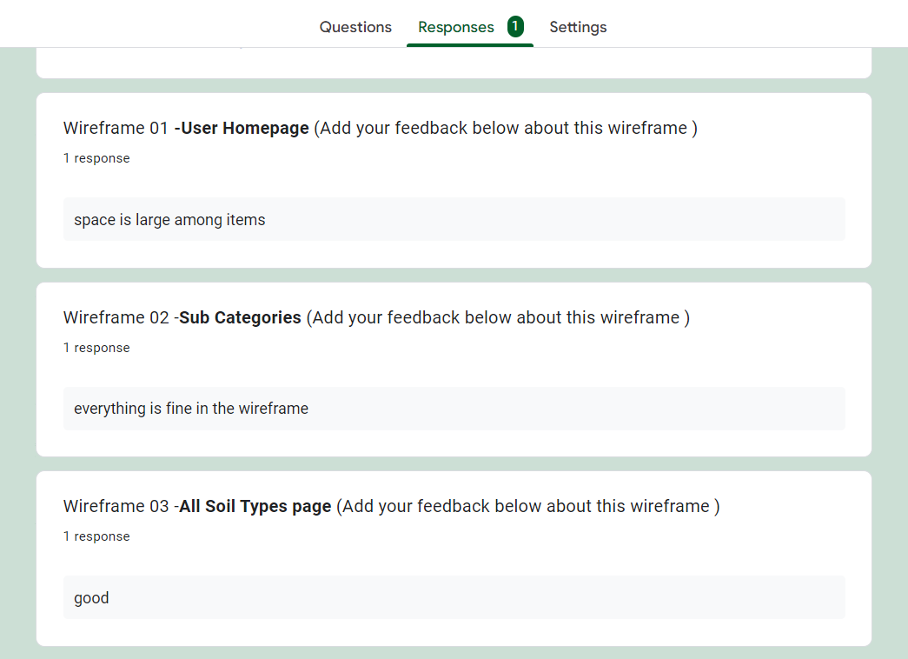

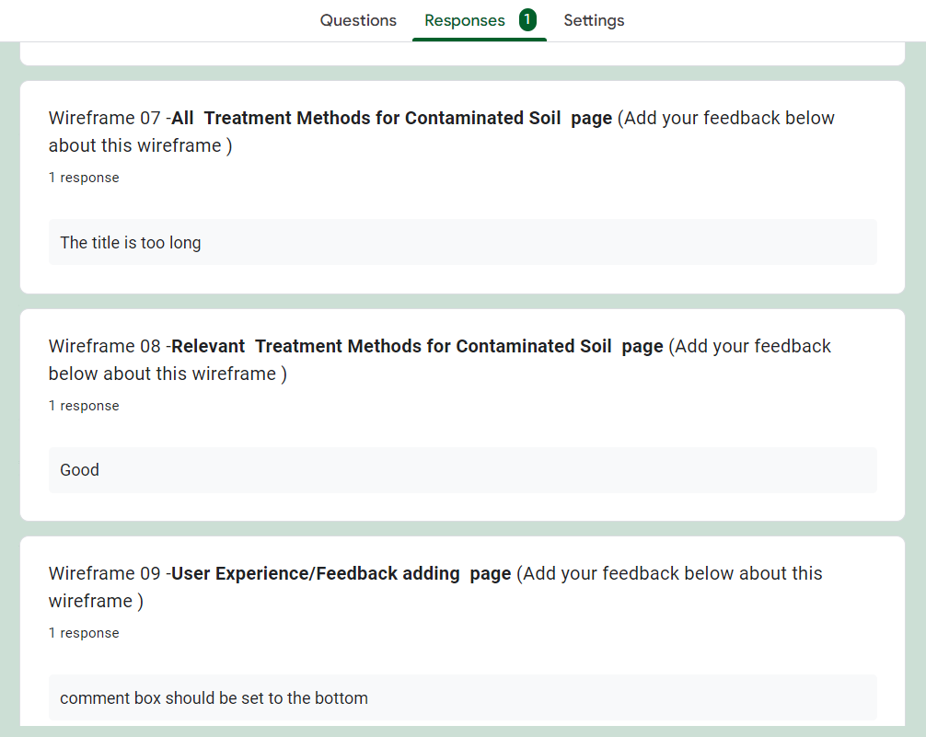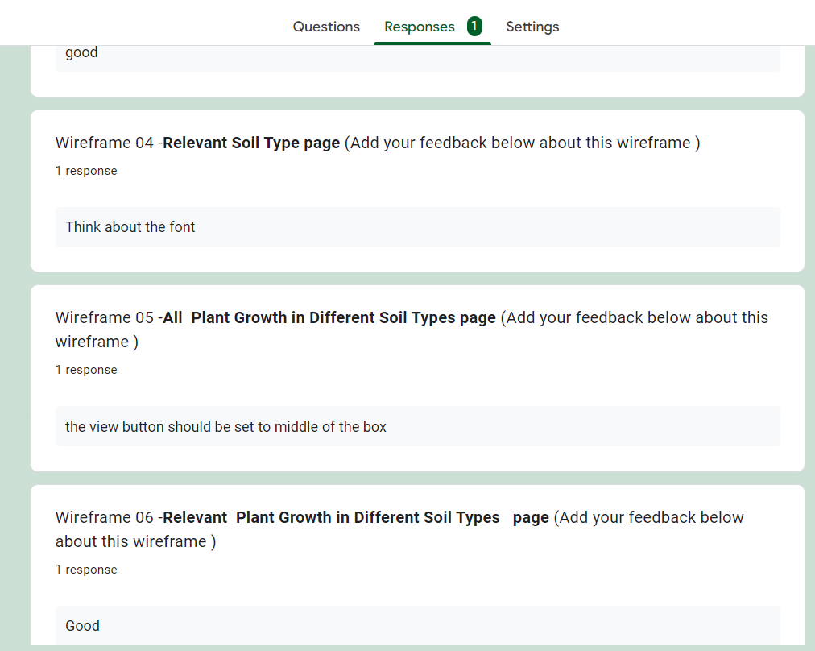

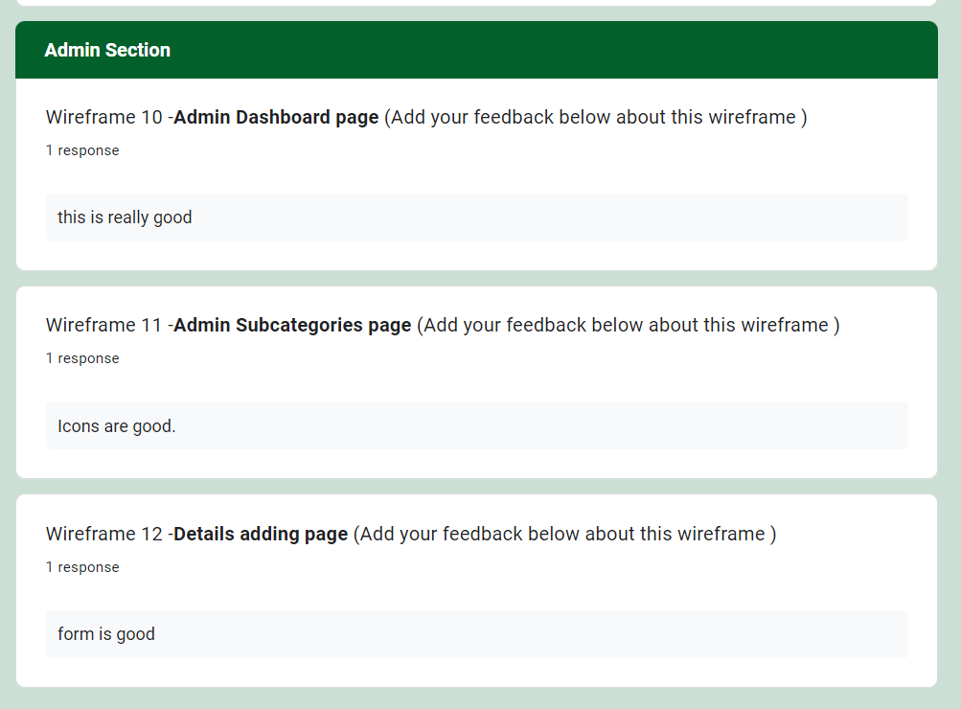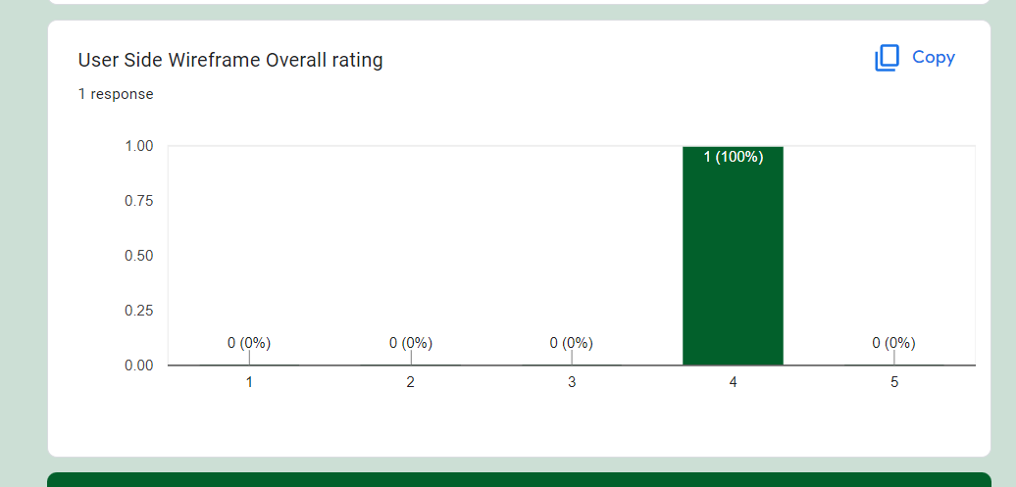

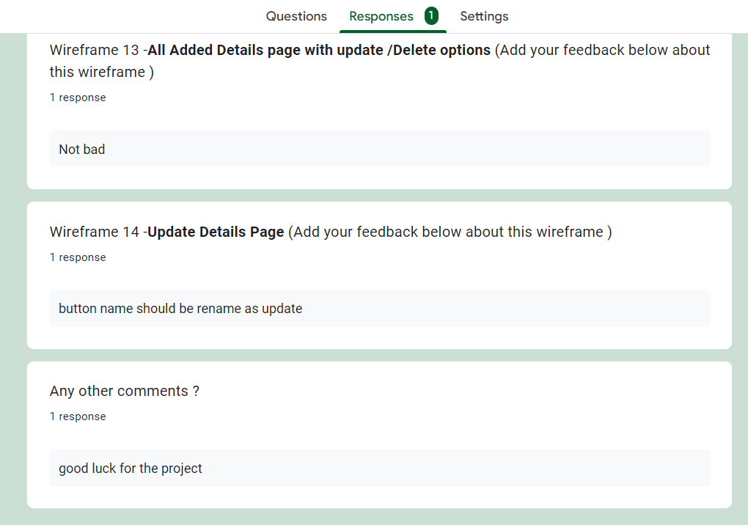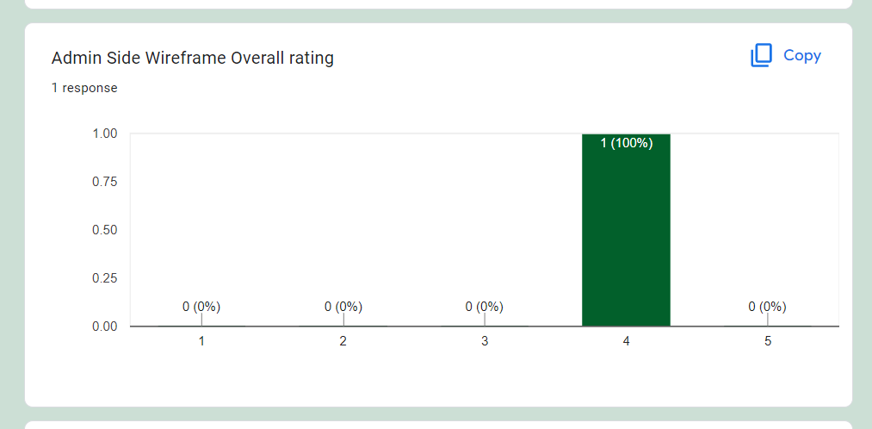

IT20136710

# **Prototypes Links**

**The link below is the link to the prototype video of our project. You can navigates to my functionalities and go through the process and give feedbacks.**

## **User Side prototype**

https://www.figma.com/proto/SmC1k3Ay8HRlqHOVpFhnd3/Untitled?node-id=10%3A170&scaling=min-zoom&page-id=0%3A1&starting-point-node-id=16%3A375

## **Admin Side prototype**

https://www.figma.com/proto/SmC1k3Ay8HRlqHOVpFhnd3/Untitled?node-id=16%3A807&scaling=min-zoom&page-id=16%3A693&starting-point-node-id=16%3A932&show-proto-sidebar=1

### User Side Wireframes





**User side: Soil conservation method page.**



**User side: soil conservation benefit page.**

**User side: various ways of soil conservation page.**

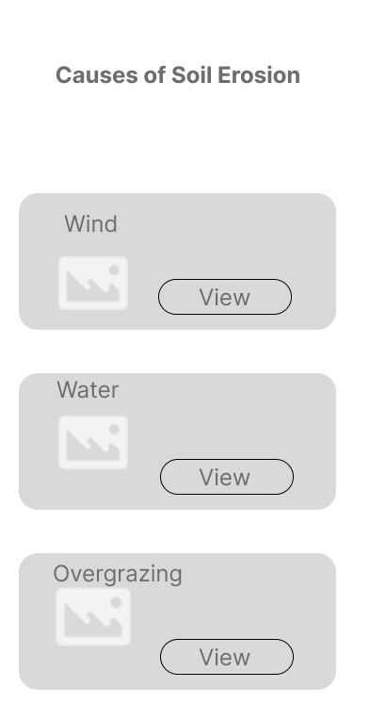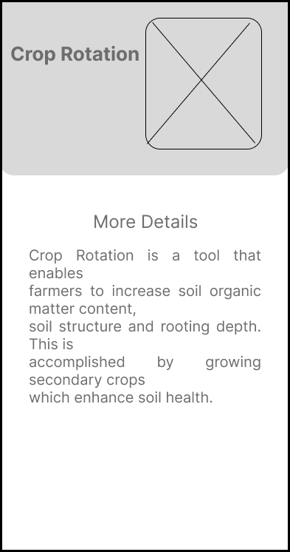

**User side: Causes of soil erosion page**

**User side: Soil conservation methods viewing page.**

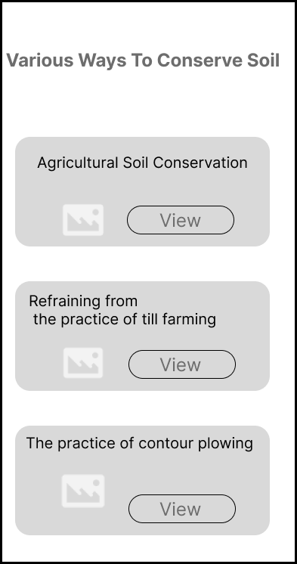

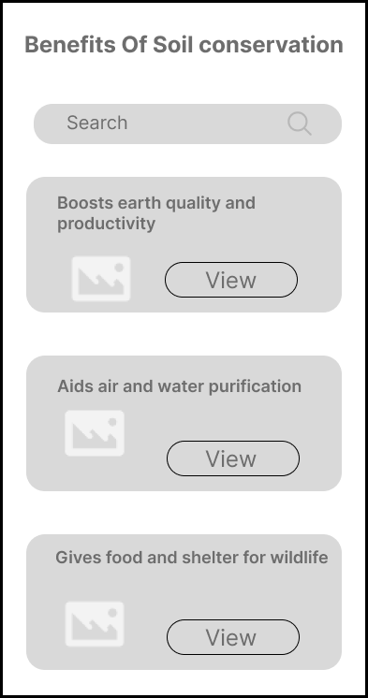

**User side: various ways of soil conservation page.**

**User side: soil conservation benefit page.**



### Admin Wire Frames





**User side: Share your thought page** .

**User side:** **Soil conservation feedback and  experience add page**.







### Feedback Google form Link

Google form Link-

<https://docs.google.com/forms/d/e/1FAIpQLSeuopPC-82Sk1_2JcIF_nAAZKE72GiU__RkDbZu5R1zttN57w/viewform>

# **Feedback Google form Responses**

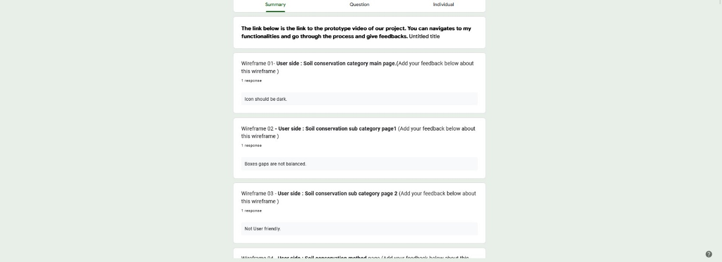

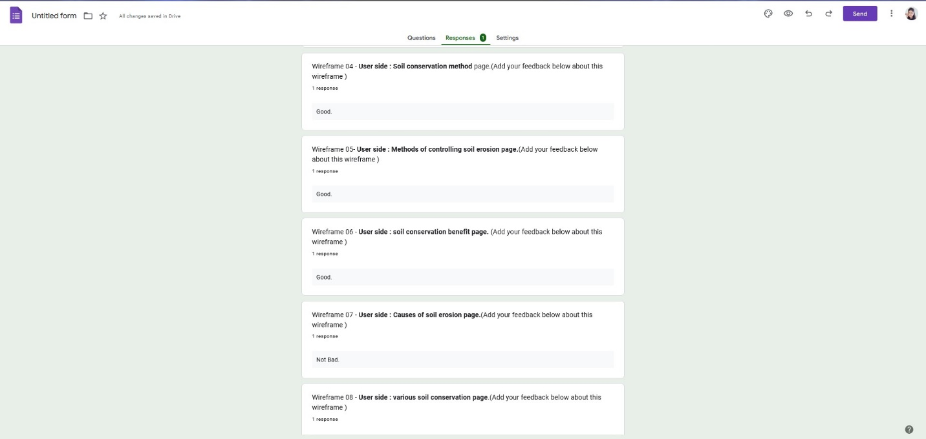

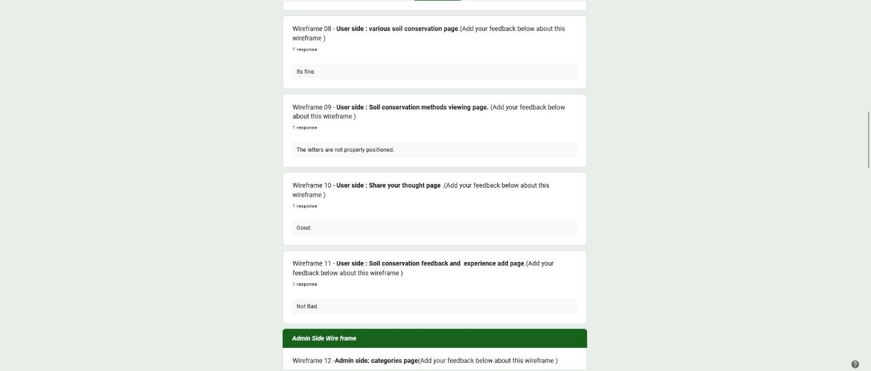

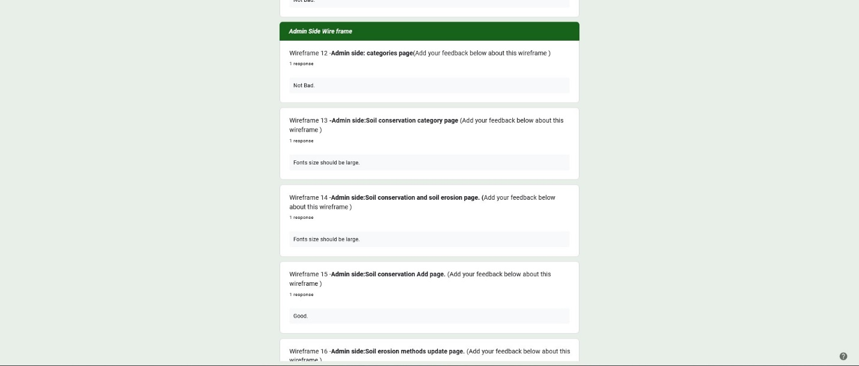

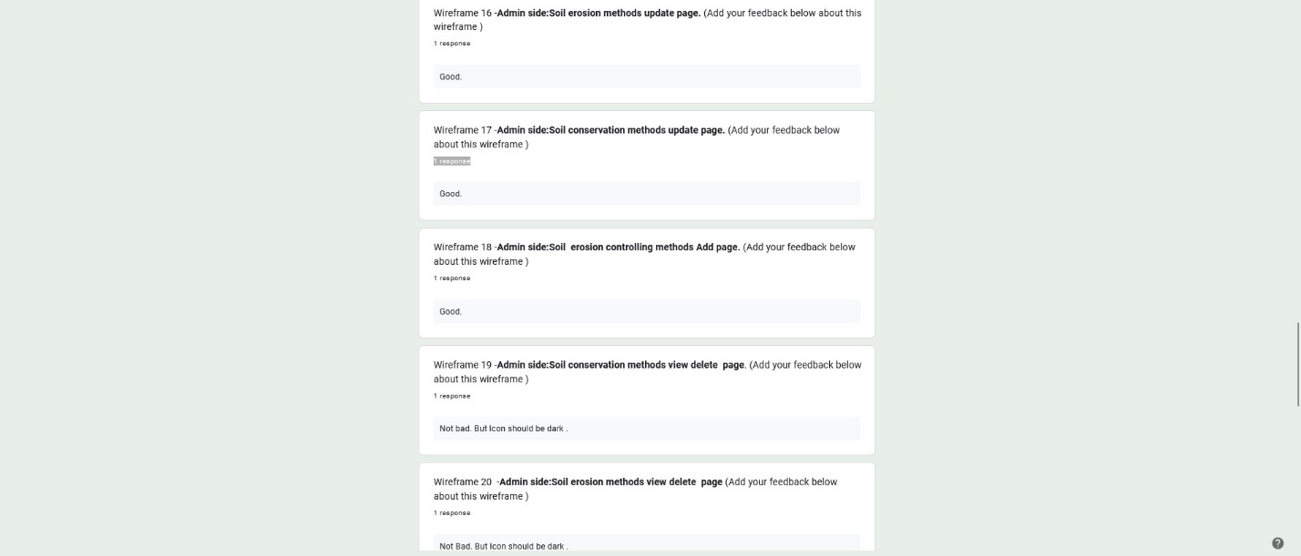

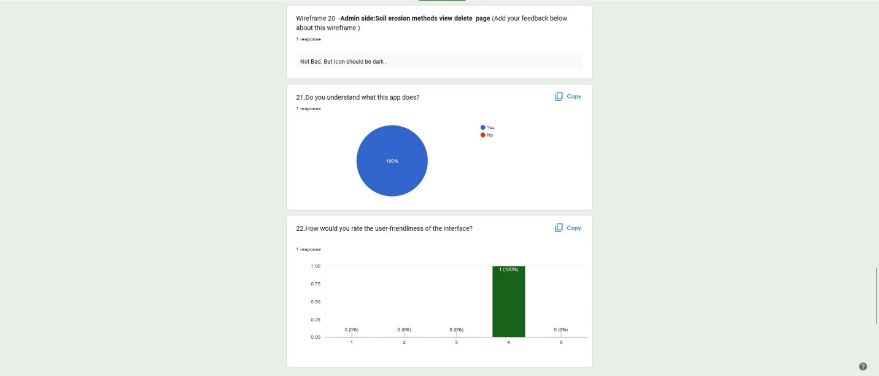

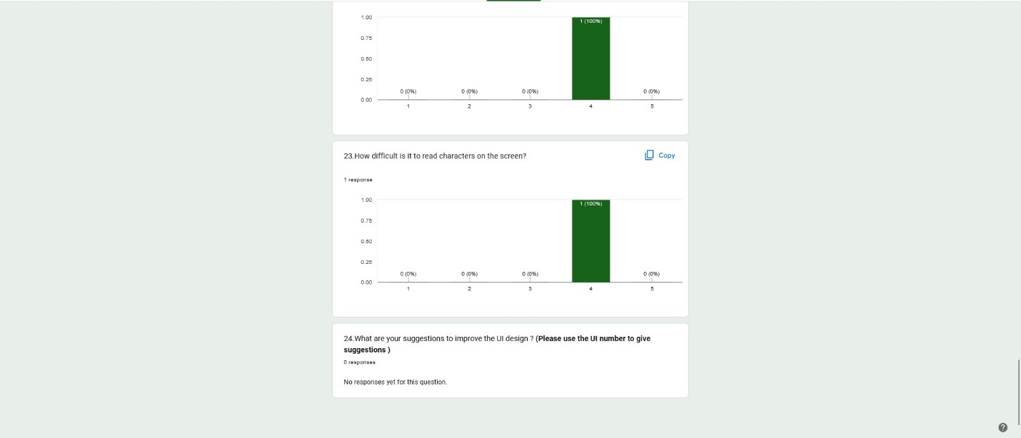

## IT20147082

### Low fidelity wireframe

### Function: Organic Farming Management

#### User part wireframes





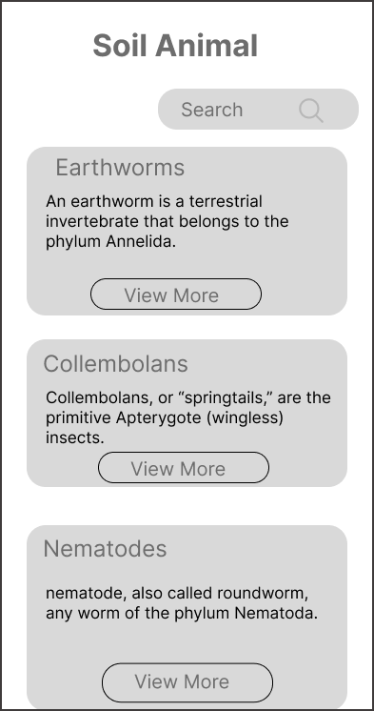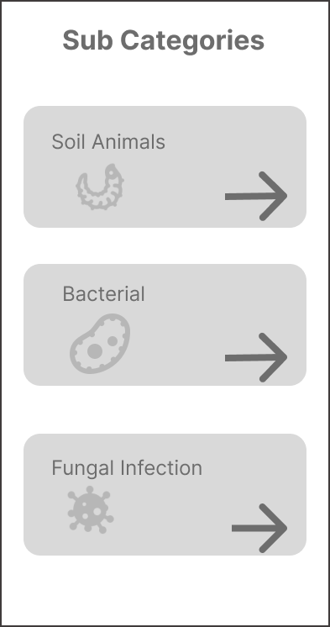

View Soil animals view Page

View Subcategories Page





#### Admin Wireframes

















### Prototype Links

Admin Part : [Click Here](https://www.figma.com/proto/doAxc3kRxJxwM0lgw49l1g/My-function-UEE?node-id=1%3A2&scaling=min-zoom&page-id=0%3A1&starting-point-node-id=1%3A2)

User Part : [Click Here](https://www.figma.com/proto/doAxc3kRxJxwM0lgw49l1g/My-function-UEE?node-id=12%3A230&scaling=min-zoom&page-id=0%3A1&starting-point-node-id=1%3A2)

### Questionnaire

Questionnaire link -: [Click Here](https://forms.gle/qs7AJ6yHGUanD34P9)

#### Questions with user feedback details

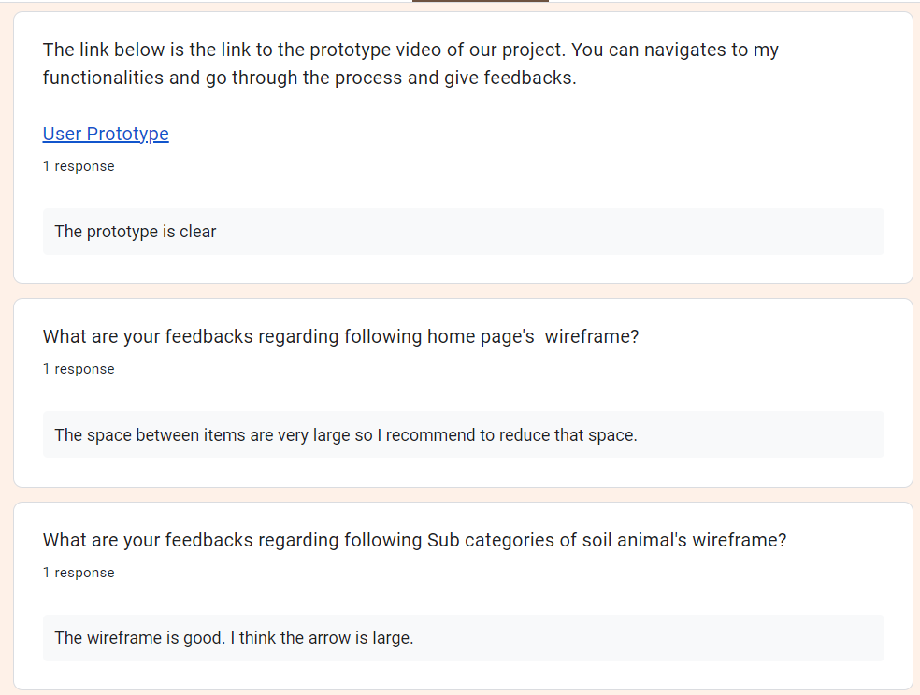

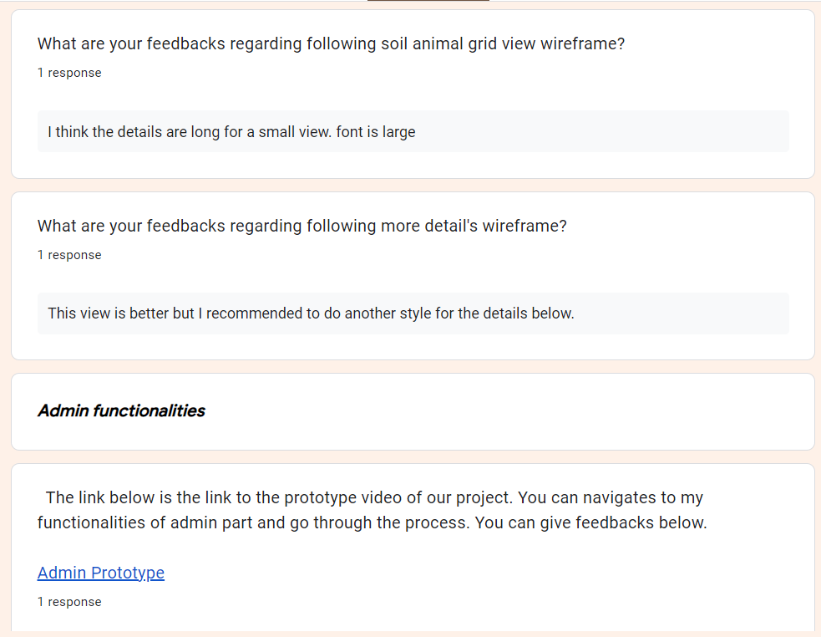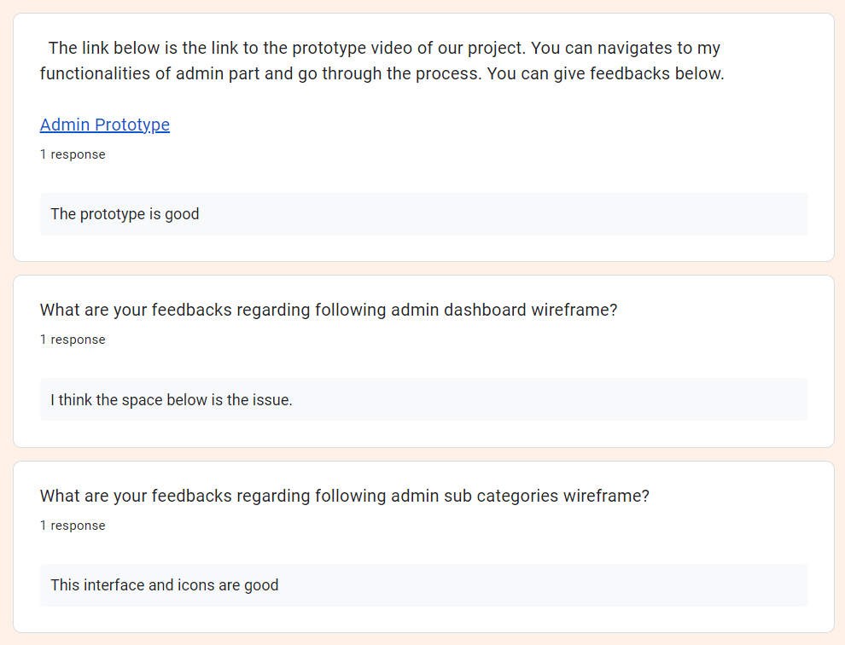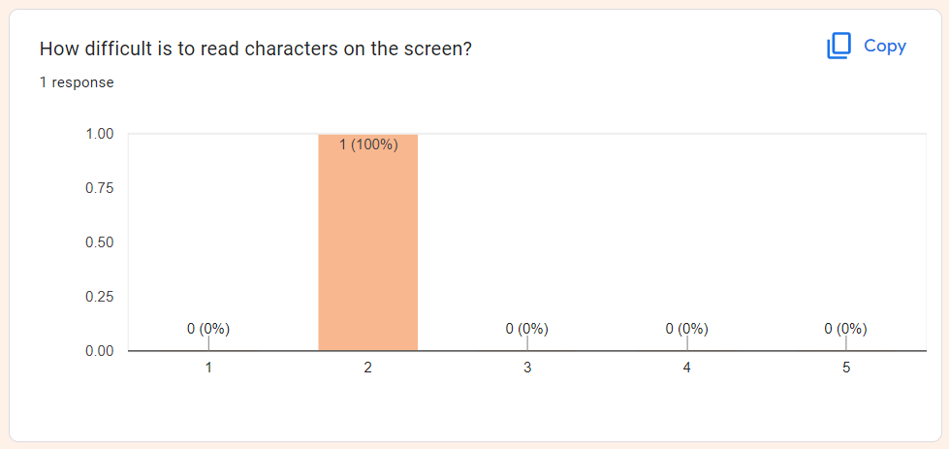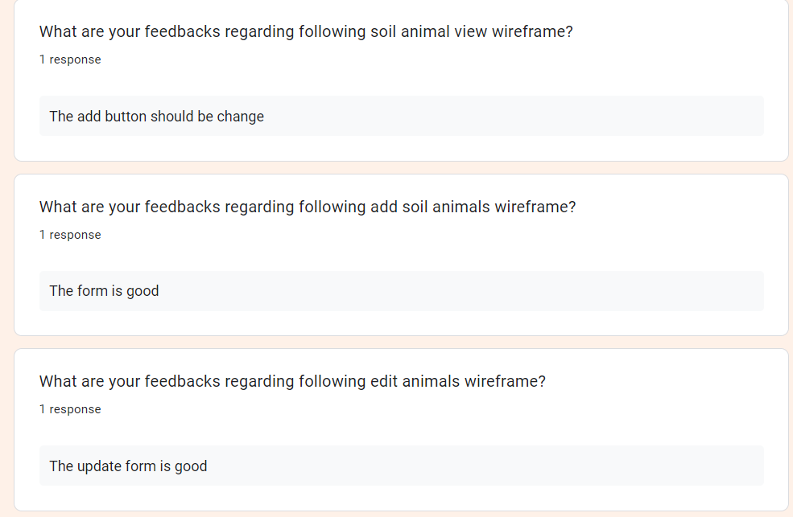

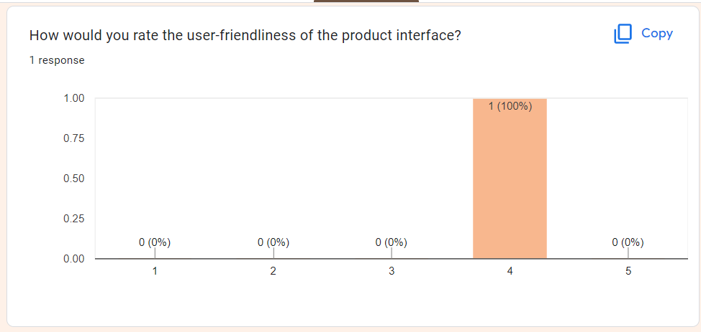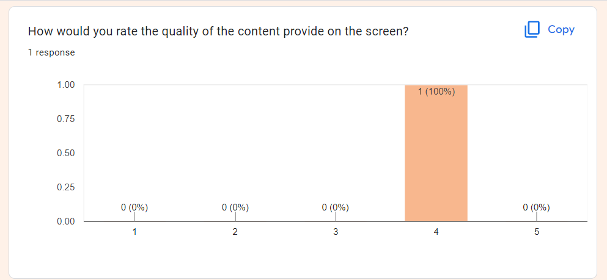

# Milestone 5: Wireframes, Prototype

## IT20125066

### User Side

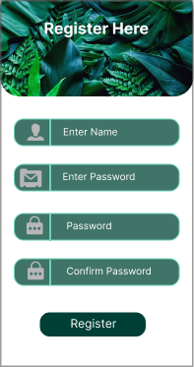

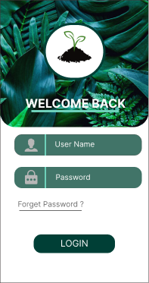

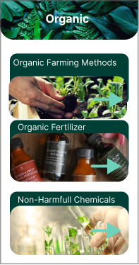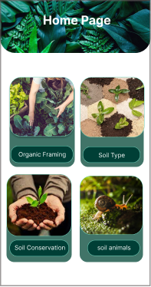

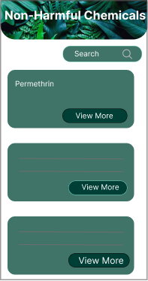

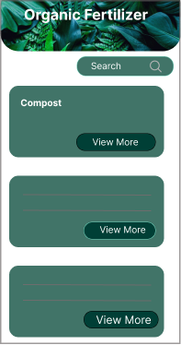

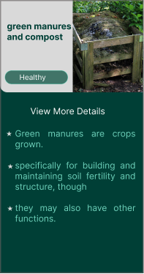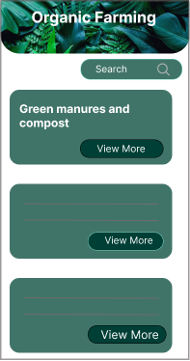

### Admin Side

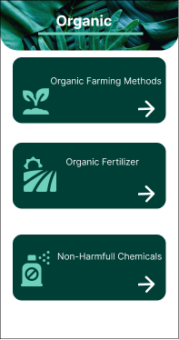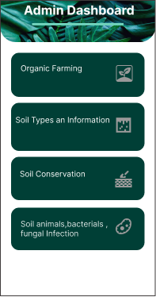

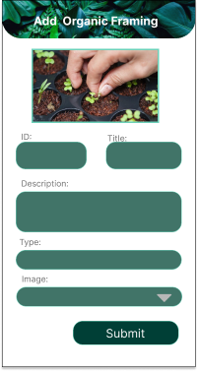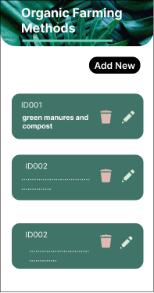

1. Prototype Links

Admin Part:

<https://www.figma.com/file/kRSnFRlmFwYCDNBPT0kaV1/Untitled?node-id=1%3A141>

User Part:

<https://www.figma.com/file/kRSnFRlmFwYCDNBPT0kaV1/Untitled?node-id=0%3A1>

## User Feedback Gathering

Video link -: <https://drive.google.com/file/d/1q0jCFso0sSkTYdw3CJdfp_cyAr5ENXy8/view?usp=sharing>

## IT20258030

# User Side UIs

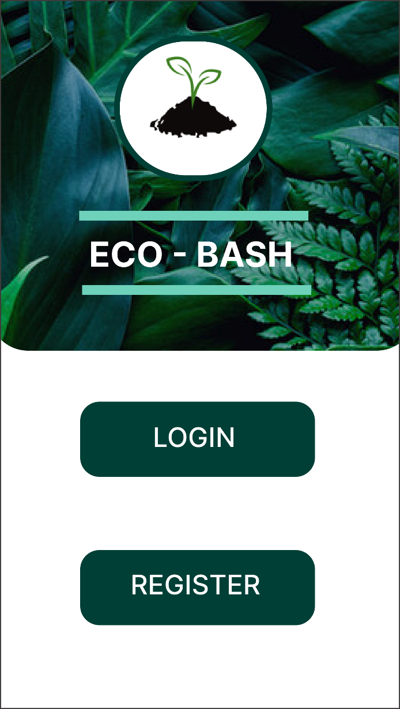

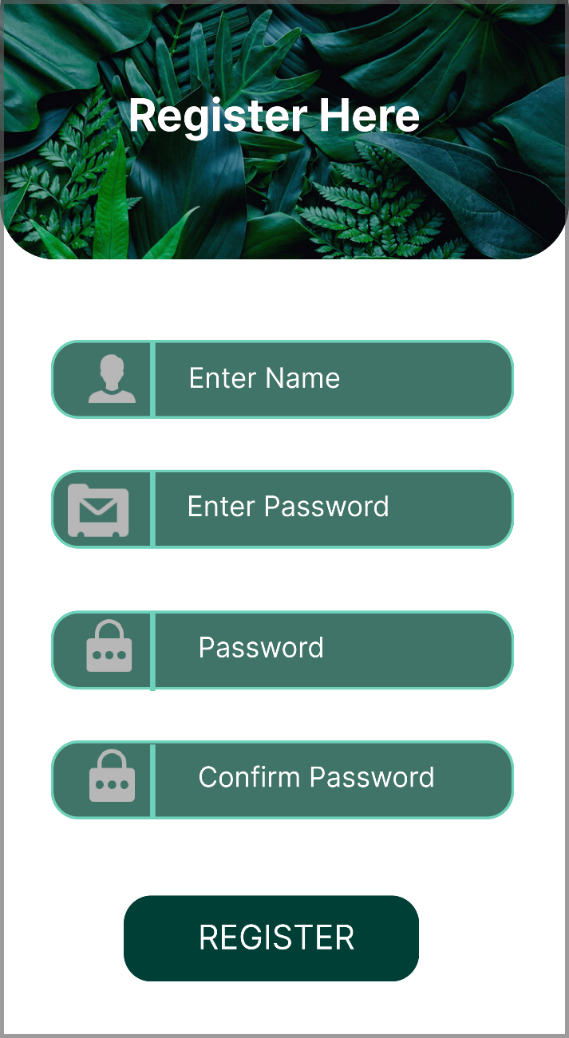

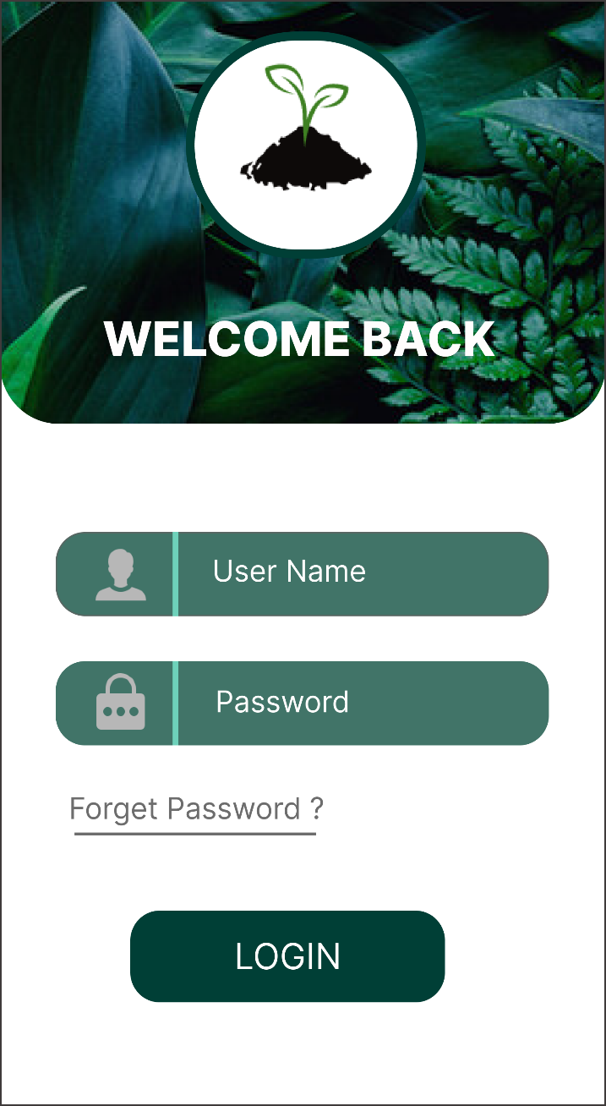

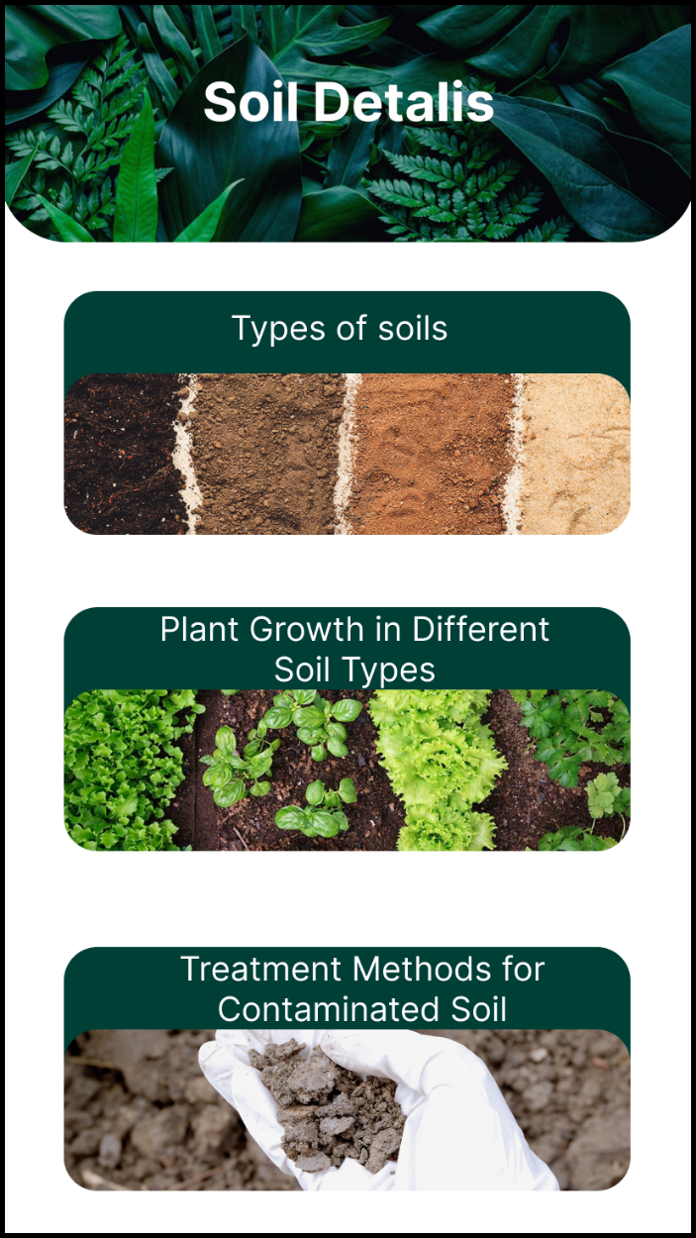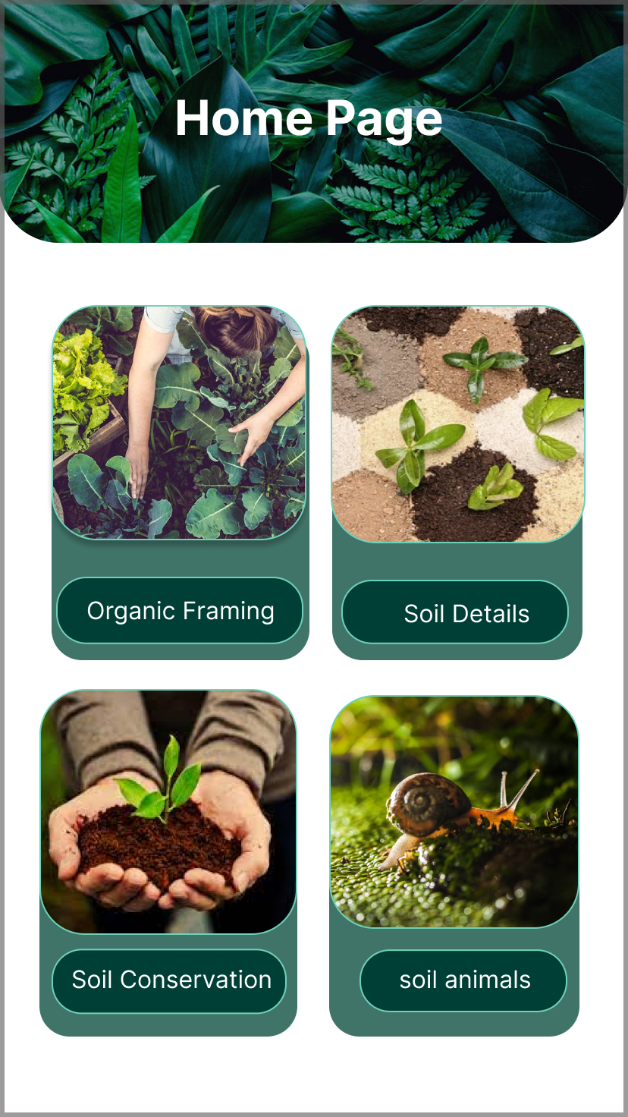

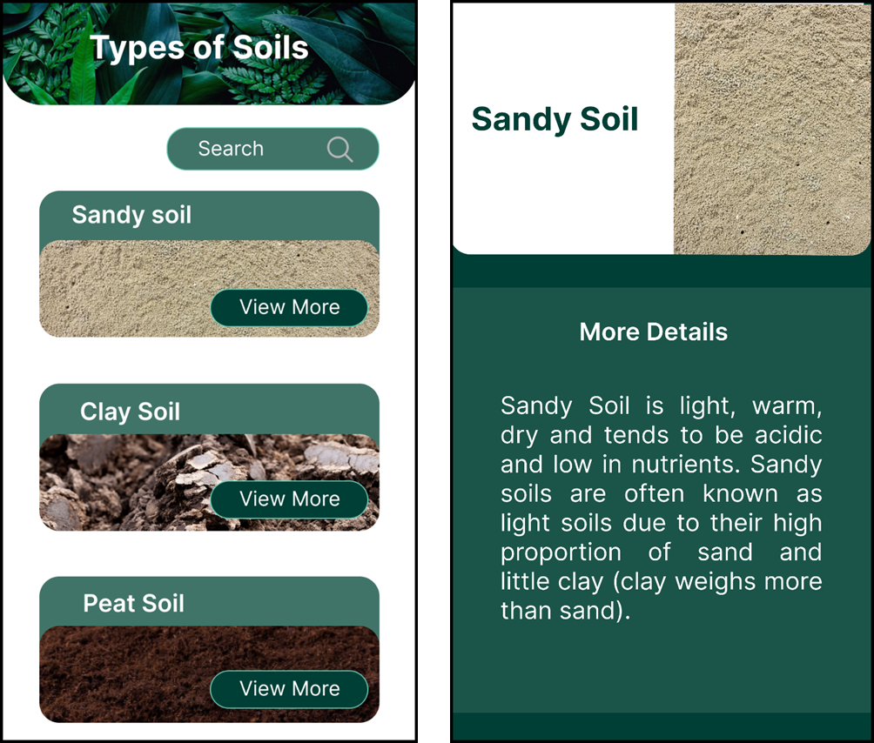

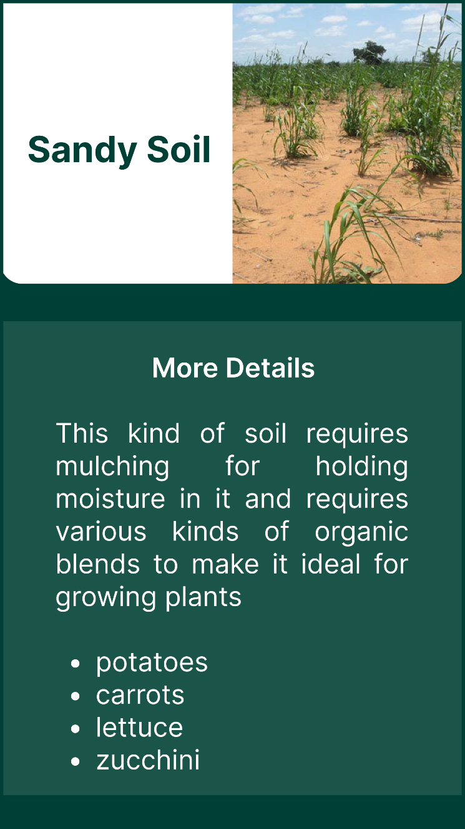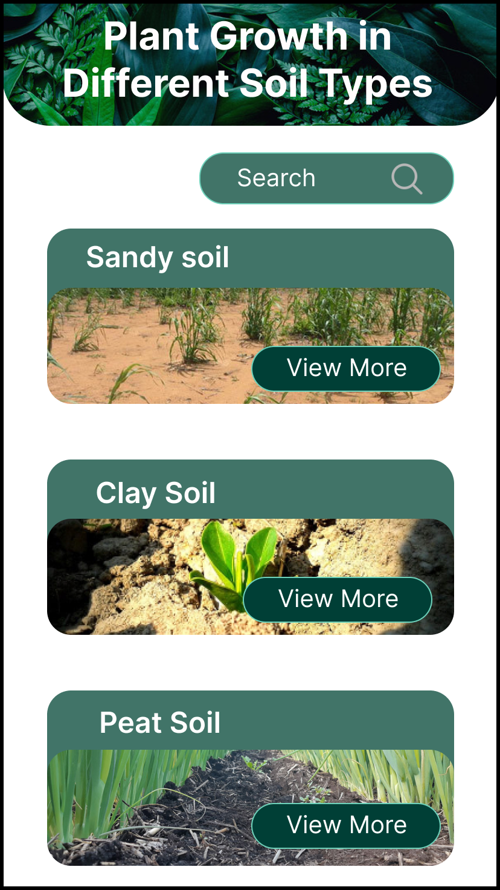

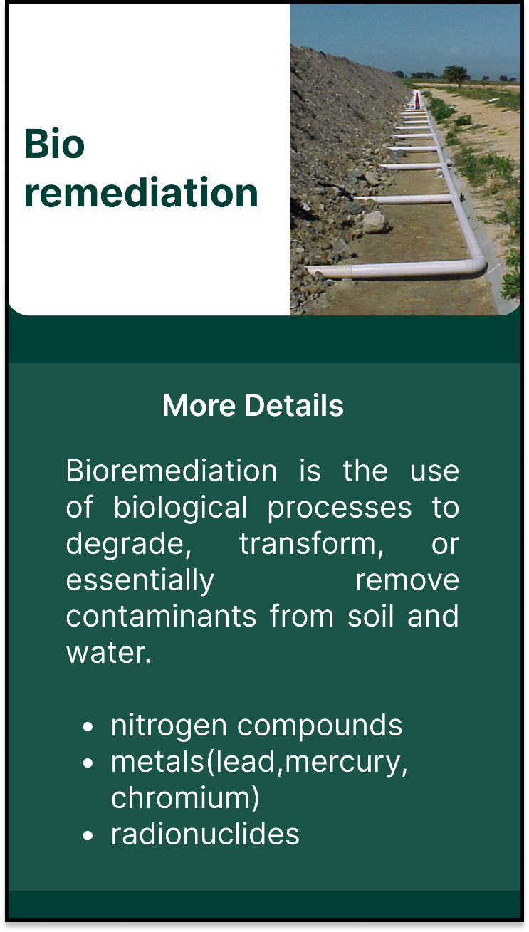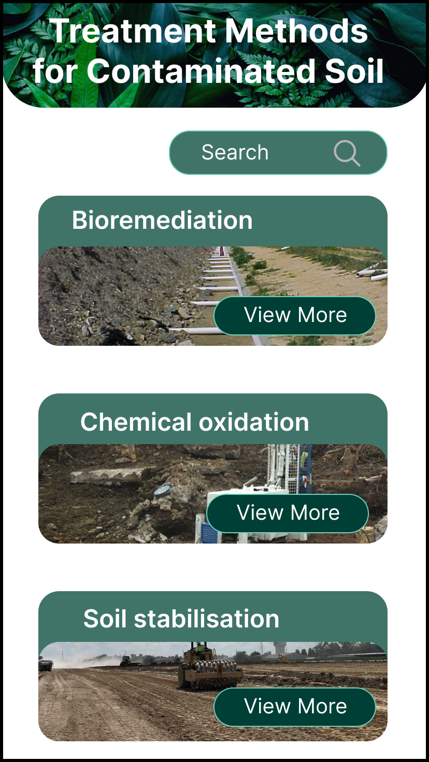

# Admin Side UIs

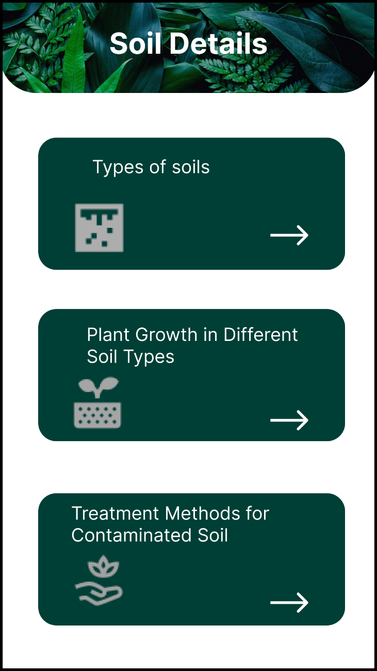

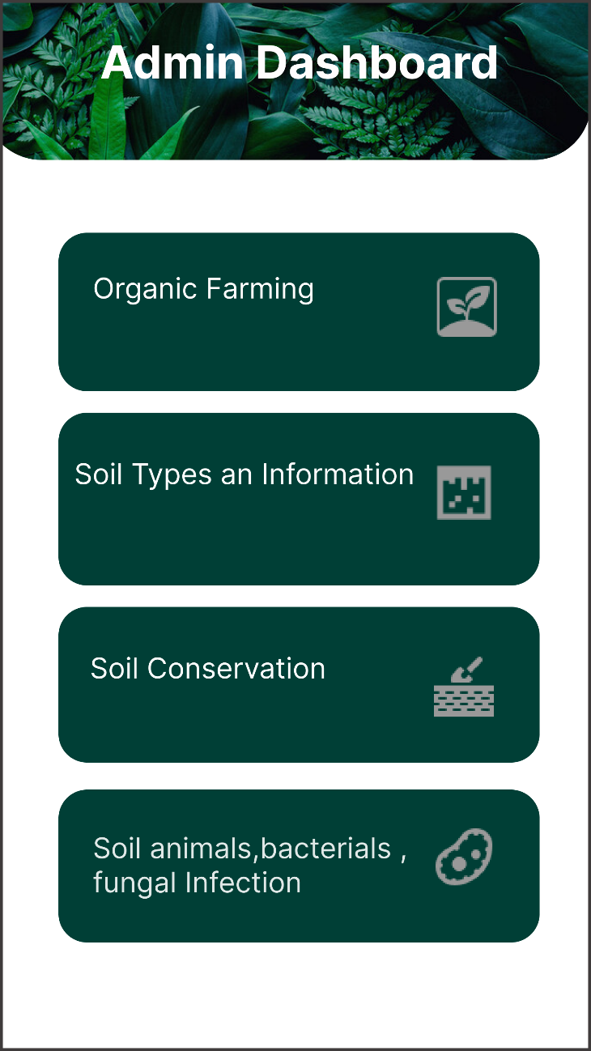

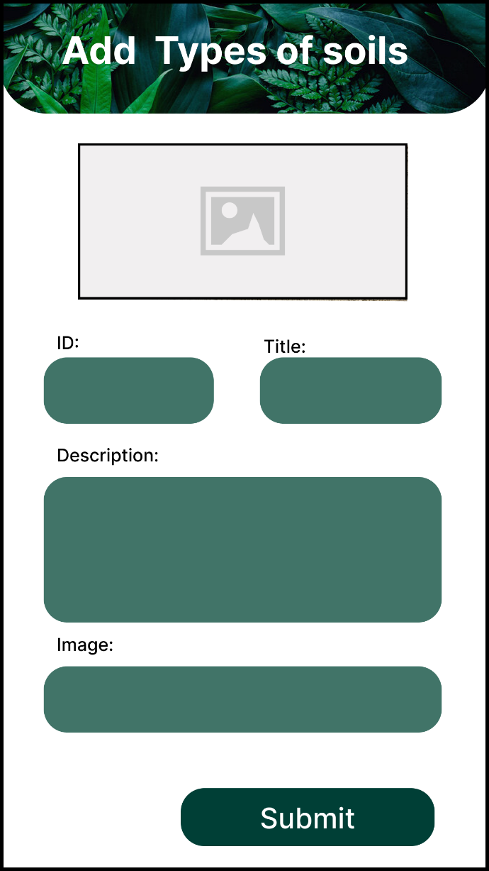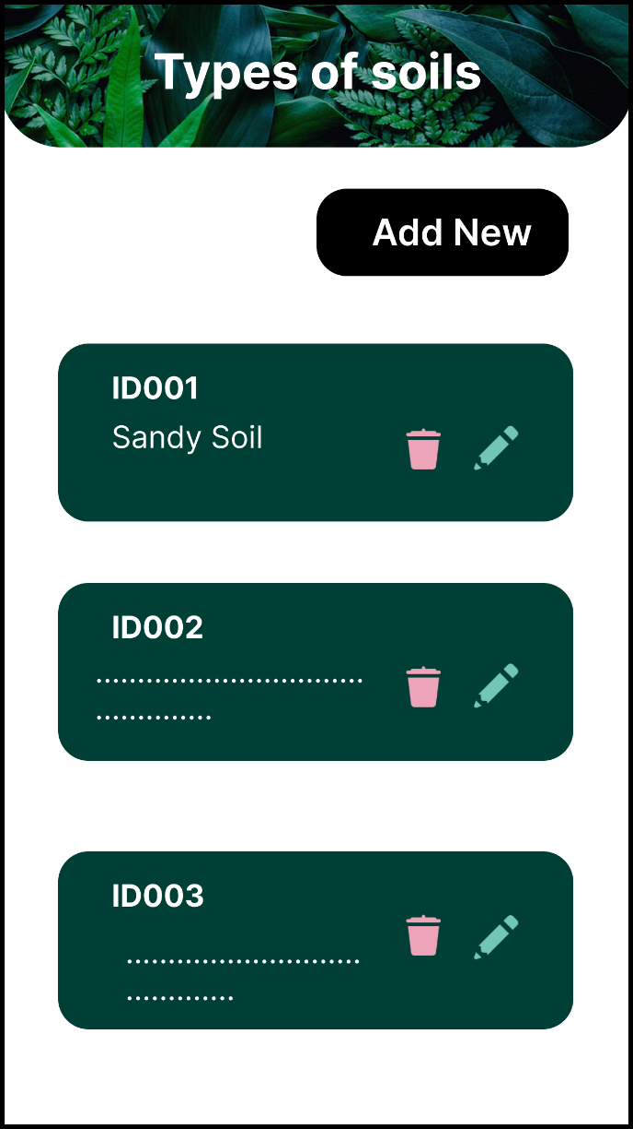

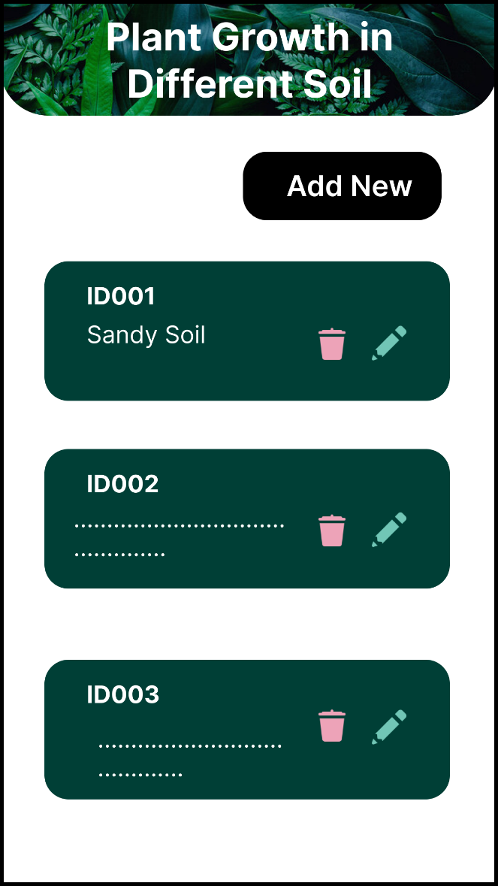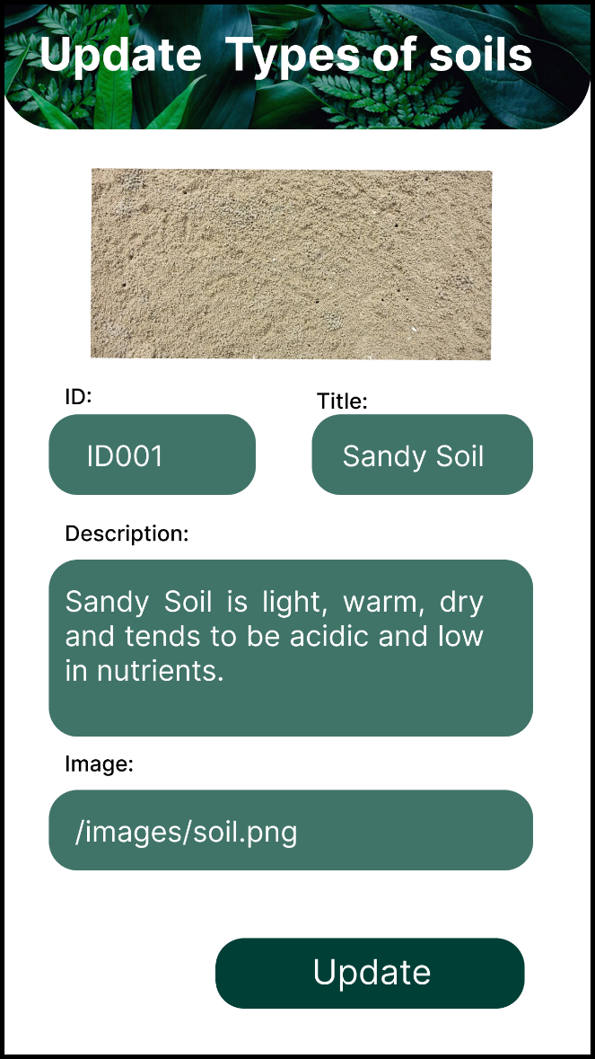

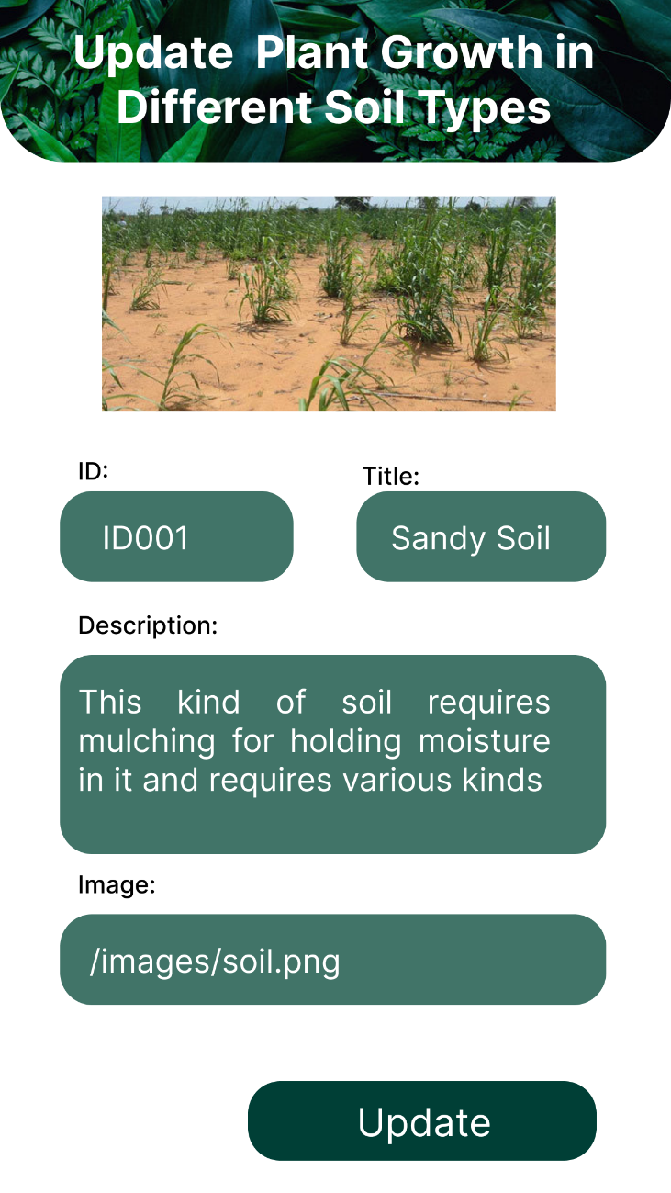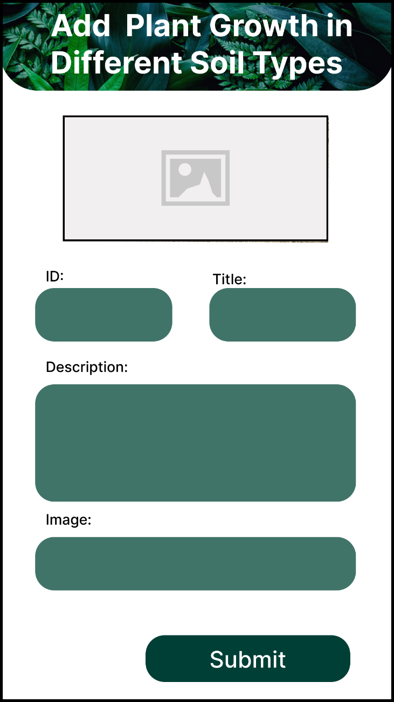

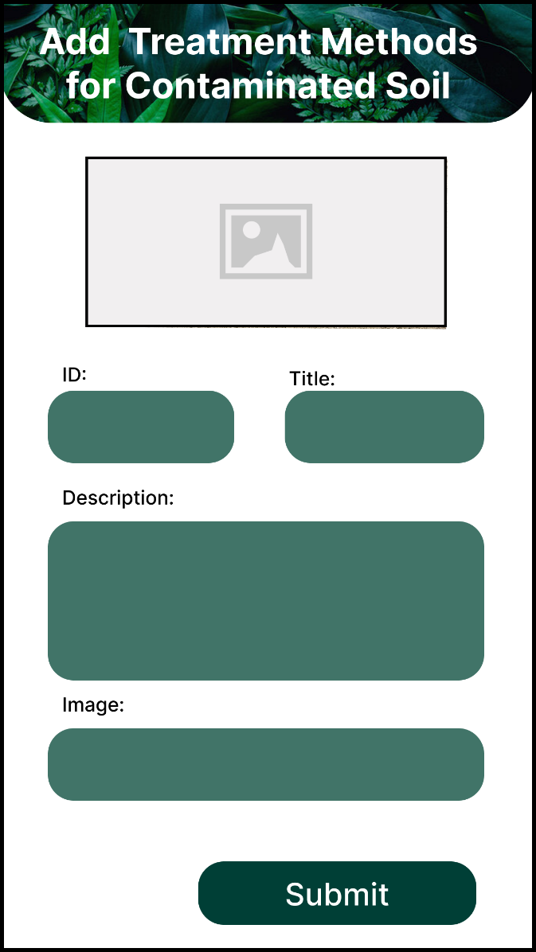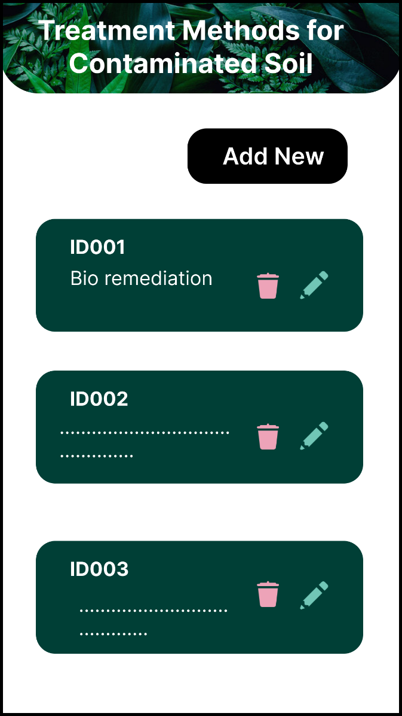

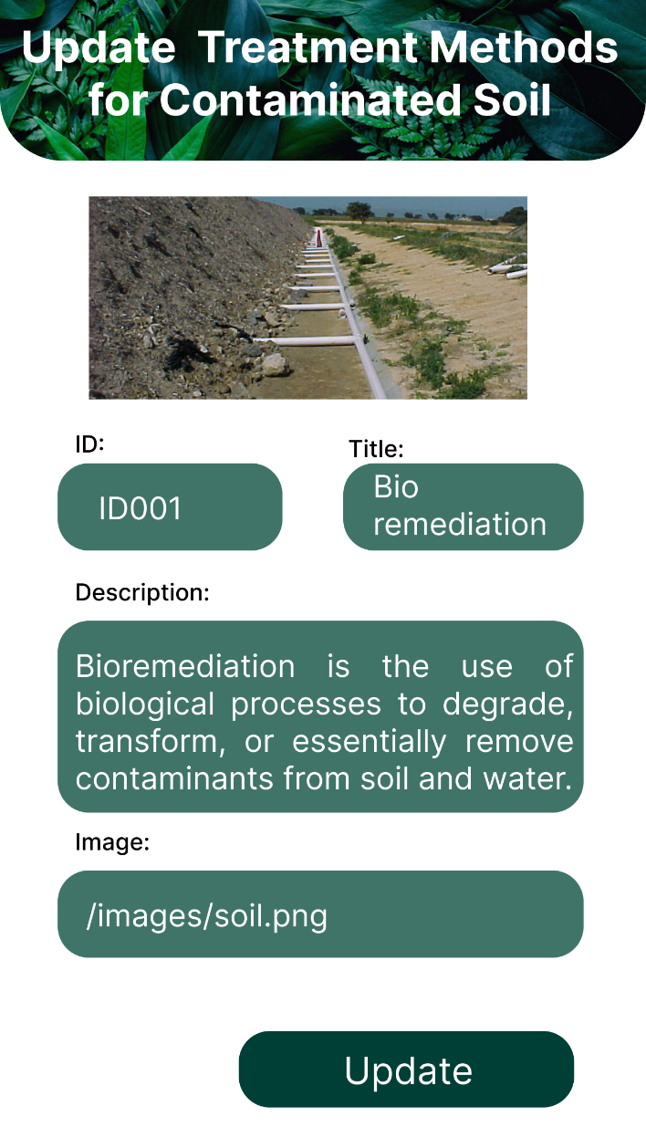

## Prototype Link

<https://www.figma.com/proto/OgwqJ4HOC6DyBGxkoVpAjl/Untitled?node-id=129%3A44&scaling=scale-down&page-id=21%3A2&starting-point-node-id=129%3A2&show-proto-sidebar=1>

## User Feedback Gathering

<https://www.dropbox.com/s/potcwg1hr1qw59i/protypeV2-video-IT20258030.mp4?dl=0>

## IT20147082

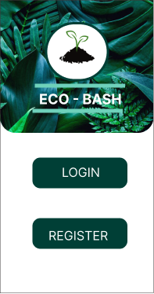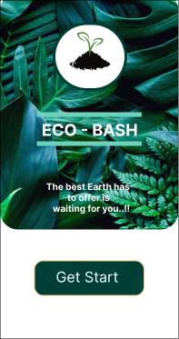





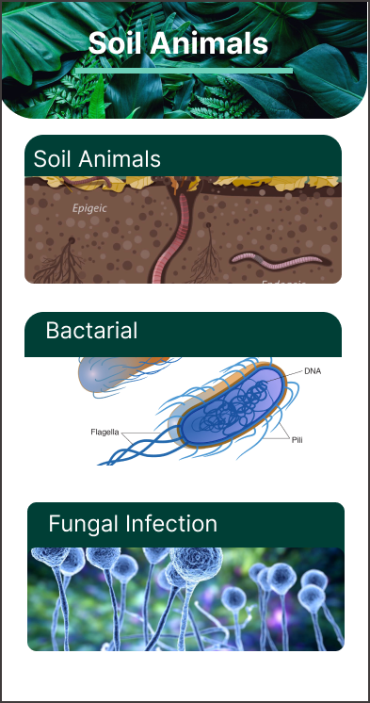

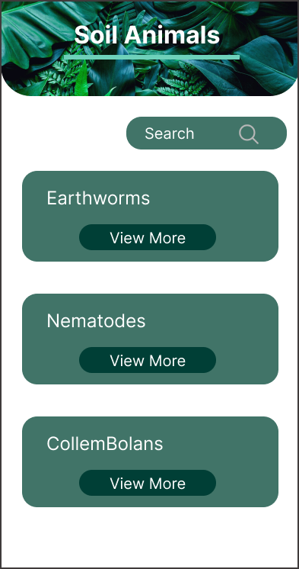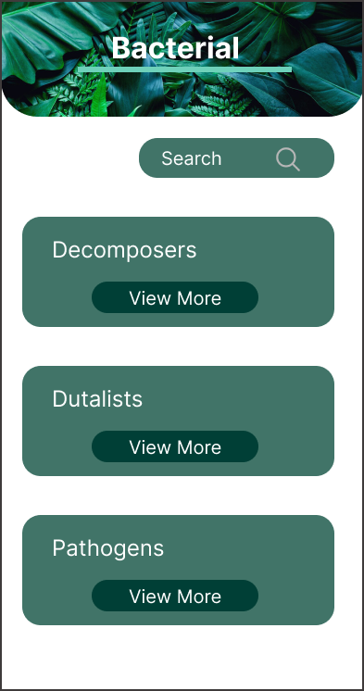

*

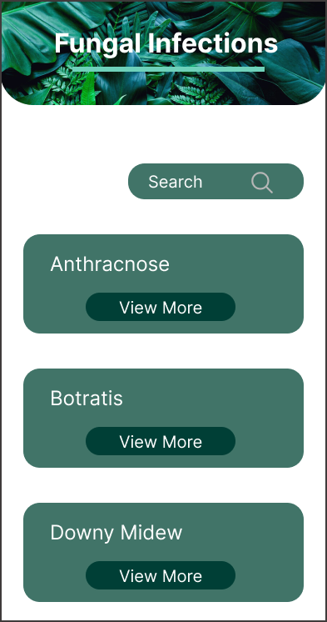

## UI DESIGNIGIN

### Admin Side

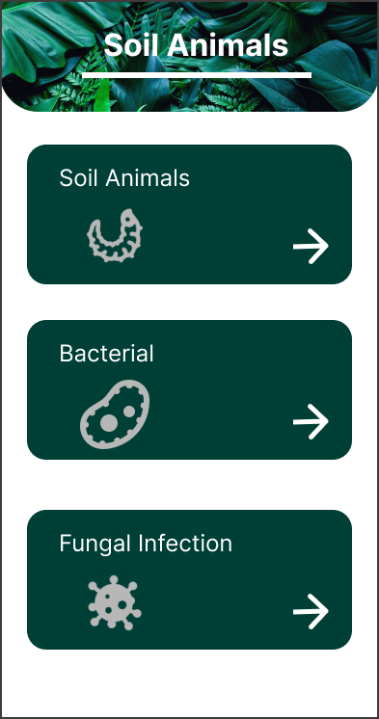



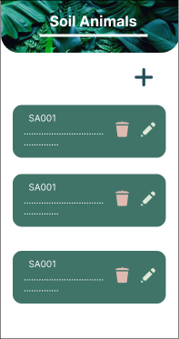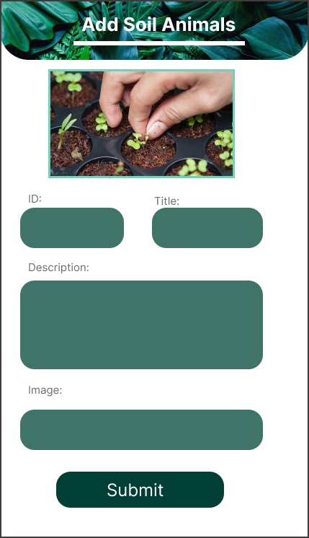

### Prototype Links

### Admin Part:

<https://www.figma.com/proto/doAxc3kRxJxwM0lgw49l1g/My-function-UEE?node-id=112%3A103&scaling=min-zoom&page-id=0%3A1&starting-point-node-id=112%3A103>

### User Part:

<https://www.figma.com/proto/doAxc3kRxJxwM0lgw49l1g/My-function-UEE?node-id=112%3A103&scaling=min-zoom&page-id=0%3A1&starting-point-node-id=112%3A103>

### User Feedback Gathering

Video link -:

<https://drive.google.com/drive/folders/1Wfg2aeWasQR54T7x0iNWlZL6xrG2gThb?usp=sharing>

## IT20136710

### User Feedback Gathering

<https://drive.google.com/file/d/1XOxSNtS7L1Vy5MCjC3CVzMDQbf8qv10z/view?usp=share_link>

### Prototypes Links

**The link below is the link to the prototype video of our project. You can navigate to my functionalities and go through the process.**

### User Side prototype version 2

<https://www.figma.com/proto/hOim0kh1TJtn9uwrnSBx5p/Samsung-Galaxy-S9-Flat-Mockups-(Community)?node-id=111%3A3057&scaling=min-zoom&page-id=111%3A2291&starting-point-node-id=111%3A3117>

### Admin Side prototype version 2

[[[https://www.figma.com/proto/hOim0kh1TJtn9uwrnSBx5p/Samsung-Galaxy-S9-Flat-Mockups-(Community)?node-id=111%3A485&scaling=min-zoom&page-id=0%3A1&starting-point-node-id=111%3A5055&show-proto-sidebar=1](https://drive.google.com/file/d/1XOxSNtS7L1Vy5MCjC3CVzMDQbf8qv10z/view?usp=share_link)](https://www.figma.com/proto/hOim0kh1TJtn9uwrnSBx5p/Samsung-Galaxy-S9-Flat-Mockups-(Community)?node-id=111%3A485&scaling=min-zoom&page-id=0%3A1&starting-point-node-id=111%3A5055&show-proto-sidebar=1)](https://www.figma.com/proto/hOim0kh1TJtn9uwrnSBx5p/Samsung-Galaxy-S9-Flat-Mockups-(Community)?node-id=111%3A3057&scaling=min-zoom&page-id=111%3A2291&starting-point-node-id=111%3A3117)

### User Side UI (Prototype version2)

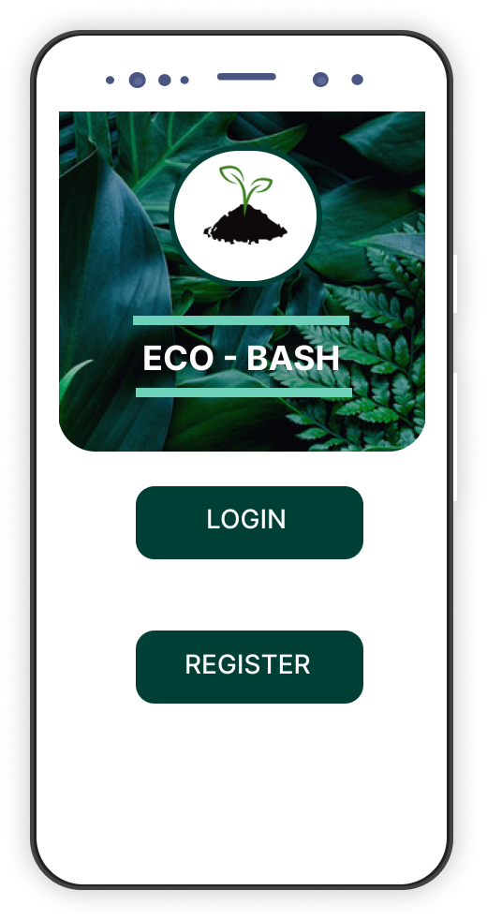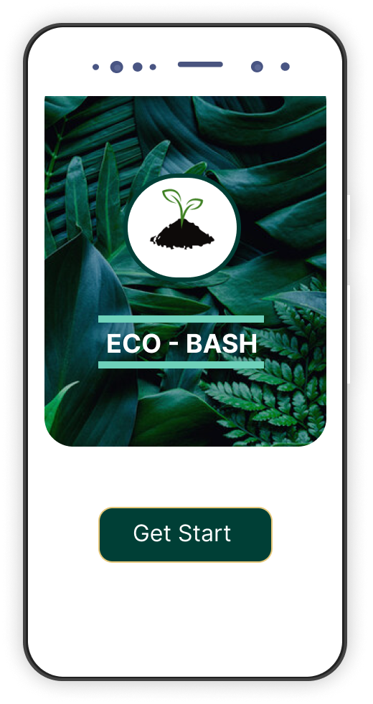

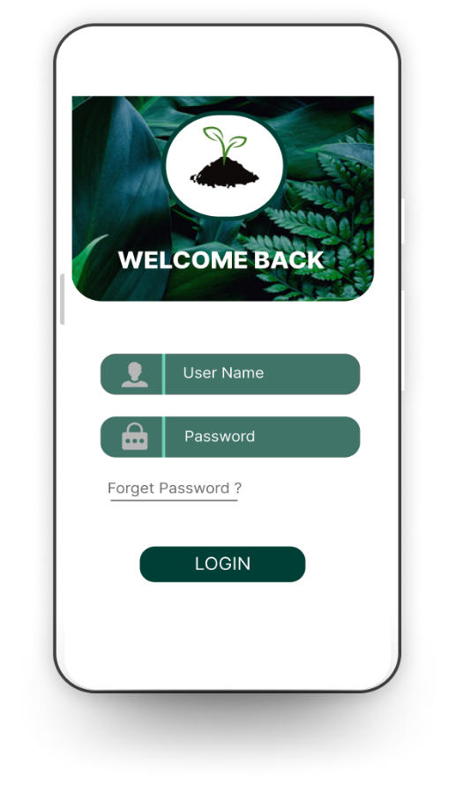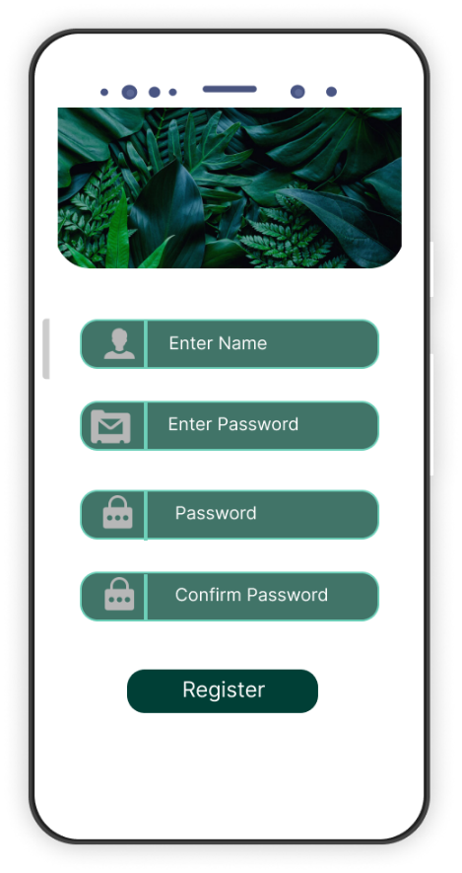

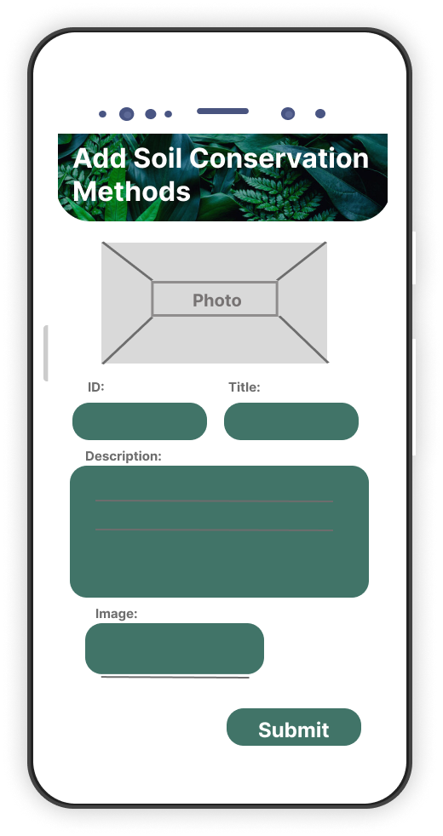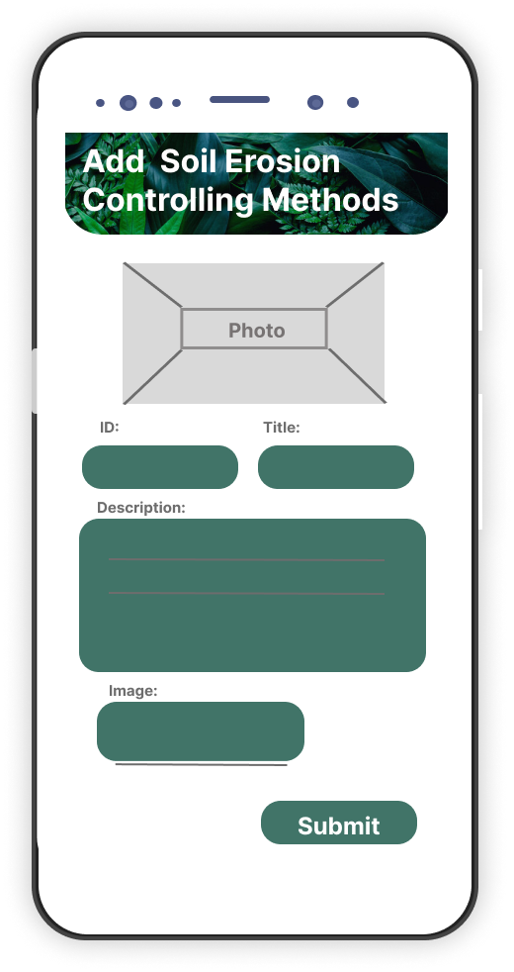

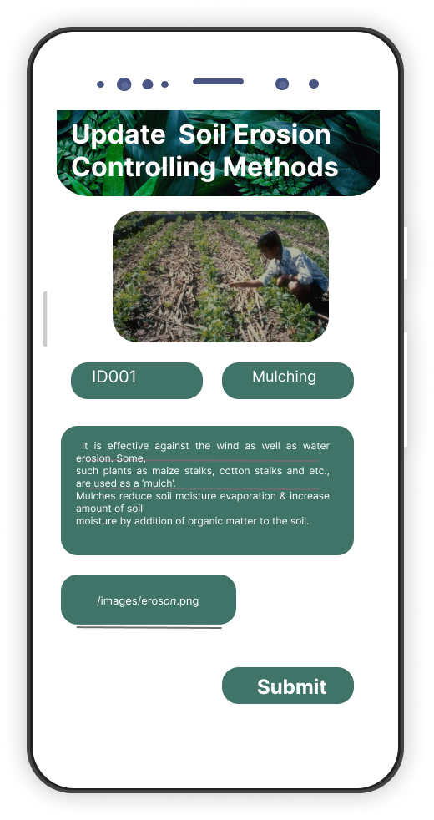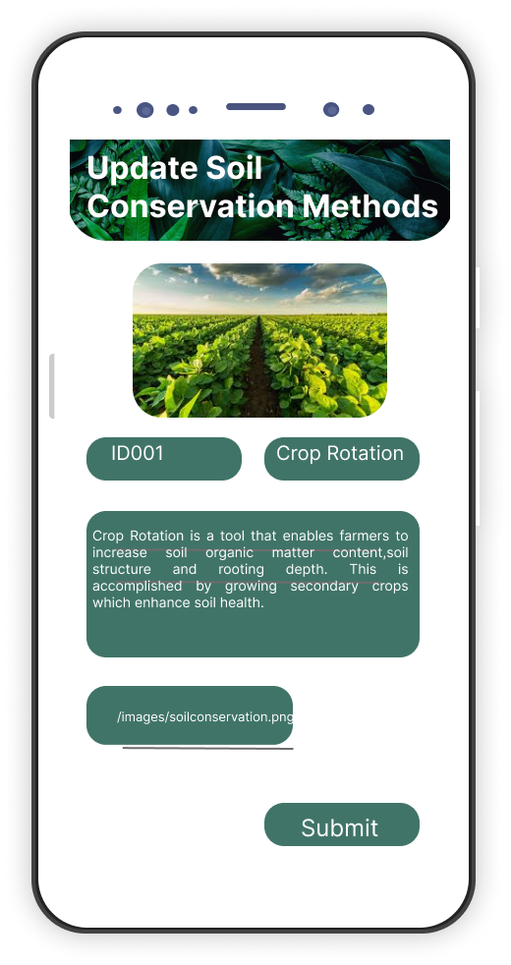

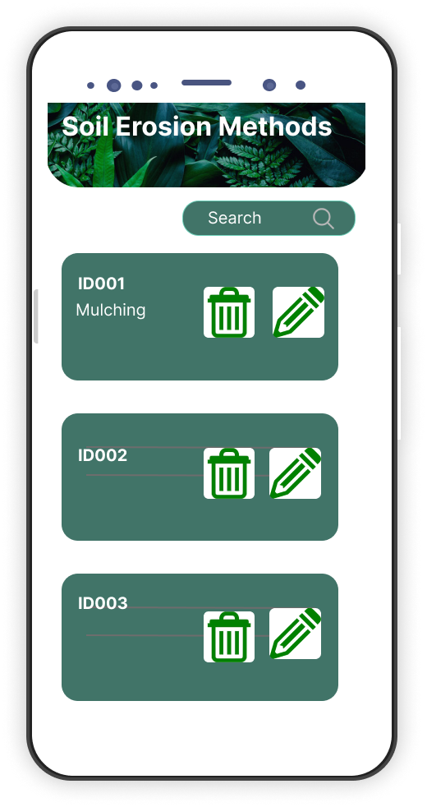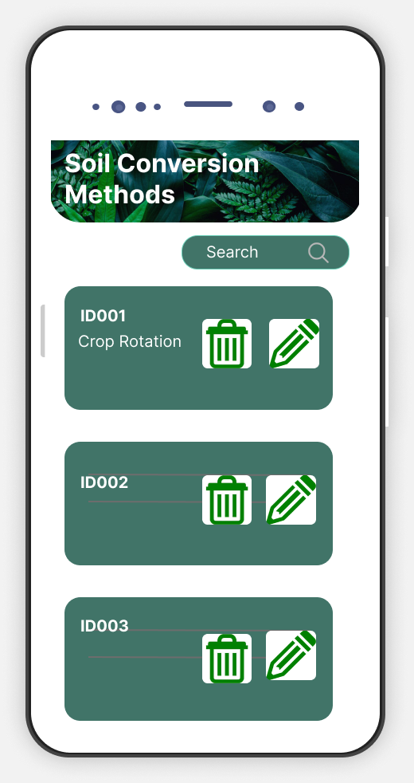

# Milestone 6: User Feedback for your Prototype

## **IT 20125066**

Video link -: [**https://drive.google.com/file/d/1q0jCFso0sSkTYdw3CJdfp_cyAr5ENXy8/view?usp=sharing**](https://drive.google.com/file/d/1q0jCFso0sSkTYdw3CJdfp_cyAr5ENXy8/view?usp=sharing)

## **IT20147082**

Video link -: [**UEE-Milstone-05 - Google Drive**](https://drive.google.com/drive/folders/1Wfg2aeWasQR54T7x0iNWlZL6xrG2gThb)

## **IT 20258030**

Video link -: [**Dropbox - protypeV2-video-IT20258030.mp4 - Simplify your life**](https://www.dropbox.com/s/potcwg1hr1qw59i/protypeV2-video-IT20258030.mp4?dl=0)

## **IT 20136710**

Video link -: [**IT20136710.mp4 - Google Drive**](https://drive.google.com/file/d/1XOxSNtS7L1Vy5MCjC3CVzMDQbf8qv10z/view)

# Milestone 7: Implementation

GitHub link : <https://github.com/SLIIT-FacultyOfComputing/final-project-uee_fp_ser028/tree/main/Milestone%2006>

# Requirement Specification

## Usability Goals

**Easy Navigation**

Before developing the mobile we try to use inbuilt mobile application already in the market in using this app. The common issue is poor navigation in the mobile app. We want to think the easy navigating. So, in our requirement uses like to get their user requirement easily. after downloading the app, the want to easy navigation with friendly manner and we want to think about the struggle thing and how to effect to the users by using struggle things in here we focus to start to bottom by using.

**Minimize the number of steps**

Mobile application development Every time user come to the app to complete the action quickly. They want to state forward way to complete an action easily. think user want to search some organic farming method user had a barrier it is very harmful to searching quickly and getting the result . So we reduces step to the app and try to get quick inputs. as well as in here. We reduce our cognitive load by using difficult in the function part

**Remove Unwanted Things**

Every additional buttons images and icons make screen complicated. It's better to eliminate anything isn't necessary. in here we try to getting the mobile app with the best practices by keeping content and interfaces element to a minimum, only the present the user with what they want. design a mobile app is very important rather than design the web App. so we have the small size, and we want to give a good news output with better User experience.

**Clear and concise content**

Developing mobile app, it's common to simplify the content. So we want to think about the how to complete the user goals by given the sample size version. We should be tolerating our content for mobile rather than copying it from the web. So other thing it is our content should have little pinching and zooming as possible by presenting the information clear and consistency.

**Reduce Scrolling**

In here always we have to limit the screen. we avoid the scrolling. but try to avoiding side Scrolls its may hide the details

## User Experience Goals

A satisfactory user experience is one in which the user's purpose of using a product is fulfilled. We mainly focused on this. Designing the user interface is not enough, if the user is not satisfied in the first use, the app will fail. Therefore, we focused on this as user experience goals.

## Functional Requirements

A functional requirement is a service to be provided by the system. It describes the inputs to the software system, its behavior, and outputs. It gives a clear idea of ​​the entire process of the system

* The system should be able to include agricultural details and their content (soil type, soil conservation, farming, etc.). Including real world images of the relevant functions.
* In this the login process is secure and password protected.
* Ability to provide feedback to a user.
* Feedback report can be processed by the system.
* The user can proceed by clicking on the category he wants.
* user can view Relevant information.

## Non-Functional Requirements

Non-functional requirements specify the quality attribute of a software system. And non-functional requirements are essential to ensure the usability and effectiveness of the entire software system. • Eco bash is an agricultural app. This system is a community-based app. Therefore, this method can be used by any user. Employees can be used. You can use this app. System admin can enter details of agricultural information. Administrators can also search, delete and update records.

* Efficiency: This app can do almost everything efficiently.
* Availability: The system must be available 24/7 to perform the tasks. So we had to upgrade the system so that it runs smoothly while working.
* Scalability: The system should have the ability to work when the speed or scope of work increases or expands.
* Maintainability: This app is very easy to maintain. If there is a problem we can solve it easily.
* *Reliability: This system provides accurate agricultural details.

## Hierarchical Task Analysis

Topic Selection -:

Requirement Analysis -:

Find real user to gather details

Create personas

Create Empathy maps

Create User scenarios & User flows

Conduct meetings with real users

Create Sketches

Create Low fidelity wireframes and prototypes

Create High fidelity UIs and prototypes

Implemented the code

# Design Principles

**Sizes of Touch screen Targets**

People use their fingers and maybe their toes to engage with touch screens, but it's none of our business. Making interface components large enough to record these actions is crucial. But how large can you make them given the limited size of the screen?

When using their smartphones, people use their thumbs more frequently than any other finger. Small touch targets can be challenging since they need greater precision and are more prone to mistakes. The minimal goal size recommended by Apple's iPhone Human Interface Guidelines is 44 pixels wide by 44 pixels tall. Microsoft recommends a minimum touch target size of 7mm/26px and a touch target size of 9mm/34px in the Windows Phone UI Design and Interaction Guide.

The distance between targets is equally as essential as the target's size. When action buttons are placed too closely together, you run the danger of frustrating the user by having them take unintended actions. To prevent mistakes, it's especially crucial to leave room between action buttons that contradict one other, like the save and delete buttons.

**Provide User Control**

People enjoy having a sense of control over their behavior. You must thus give them that.

Permit consumers to customize their travels by making choices. The user feels in control of the system when they can modify settings, manage notifications, and stop actions. Apps can make recommendations or issue alerts, but they shouldn't make decisions on your behalf.

Inform the user whenever they require an update! Integrate feedback such as status and other types into your interface without interfering with the user's workflow. If an app requires signup, let users test it out beforehand or use it as a guest to try it out before committing. The user feels more liberated and transparent as a result of this.

**Visible Interface Elements**

Everywhere you go, people use their phones. They are using their phones everywhere—indoors, out, on buses, trains, and automobiles—as well as in underground and overground transportation (did you get that?).

Your designs must have enough contrast between the information and background for it to be readable in any environment, including outside in the sun. But it's not always simple to achieve the correct level of contrast. For both images and text, the WC3 Web Content Accessibility Guidelines provide recommended contrast ratios. Testing it out with users is crucial when choosing your text and background.

**Reduce Data Input**

Have you ever started typing on your phone and discovered a few extra letters that don't relate to what you're trying to say? The best of us experiences this. Unfortunately, there isn't a straightforward fix for the problem of typing on small devices except autocorrect, which isn't always accurate. However, you can get around the issue by reducing the amount of data that needs to be entered into your designs. Users are constantly looking for time-saving techniques and effective workarounds. By condensing forms, eliminating blank spaces, and utilising "remember me" choices for future usage, you can assist them in reducing the amount of typing required. Provide autocomplete, recent search history, and location detection to users to ease their burdens and speed up the process. When entering phone numbers, for instance, show the numeric keypad instead of the standard keyboard to speed up entry. All of these adjustments can significantly impact task completion rates and duration, but more importantly, they can keep users interested in and satisfied with your product.

**Prioritise the user**

The user should always come first in any design project, and on mobile devices, user needs are even more crucial (and specialised). This should go without saying. Users of mobile devices will easily switch to other websites, apps, or distractions if designers fail to address their needs. Here are a few strategies designers can employ to cater to the unique requirements of mobile users.

**Make Navigation Intuitive**

Your design's success depends on its capacity to be learned. Users should be able to execute all key actions without needing any explanations and should be able to navigate through your program naturally using clear paths. Users lack the perseverance to follow lengthy stages to accomplish their goals. You will likely lose people if it takes too long or too much work to determine how to utilize your product. User journeys must to be reasonable enough to allow the completion of a task in a single app. Avoid requiring users to navigate between pages and apps to complete tasks. Simplify the procedure and ensure access to all the information you require. The user should never be lost while browsing your app, wondering how they got there or what they should do next.

# Project Management

## Meetings

Mainly, there were several ways of conducting meetings. Basically, we went and met with the people related to the selected persona. then conducted meeting as physically . In addition, a meeting was conducted using Microsoft team and zoom technology with persona people who could not be conducted on the physically and the necessary information was collected.

## Risk Management

Technology risk is the main risk is while we are doing this project. already We have idea in here. We use flutter as our Technology choosing for our frontend technology . running a project is complex deliverable . so face risk in while implementing and running our project in flutter . We have risk of gathering the back end and to the frontend by using the rest API.

## Milestones

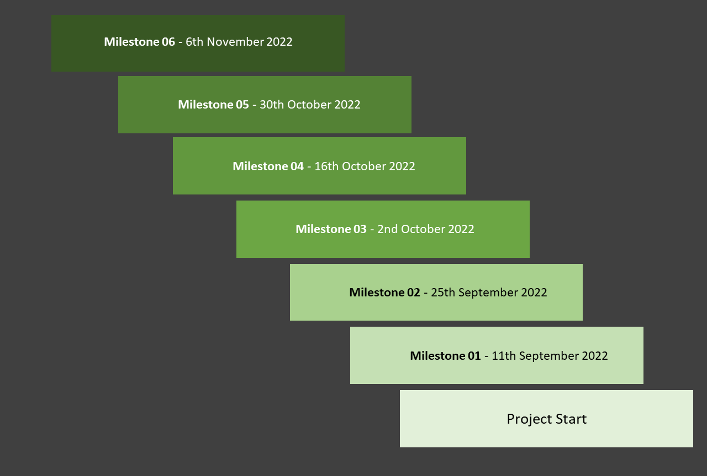

## Problems Encountered

While creating this application, there were almost several challenges which can be described as below. Basically there were cases where we could not go to meet the people physically and collect information from the person selected for the project. Then as a solution we had to organize the online meeting. There were times when due to busy schedule and various personal issues the person was not able to contact the selected people related to him. Apart from that, busyness and time management difficulties arose. After that we were tempted to share our work and deal with it. We were motivated to find the people we wanted and collect their relevant information again. Accordingly, we were able to face all those challenges and finally overcome them all and create a successful app.

# Conclusion

There are people who love agriculture and the environment as well as people who do agriculture as their livelihood. There are researchers who gather information about this. We can conclude that this app has been designed to be suitable for all these people. Our conclusion is that it has been designed to be easy for all of them to use. It is our conclusion that this app can be used in a very easy and comprehensible way for anyone who asks for information. This app has been created from the admin side so that the admin can do his management tasks easily. This app is rich in efficiency and user-friendliness and it is an ideal app for someone who is looking for information about soil type, soil animals, soil conservation, farming nowadays. This is the final conclusions about our eco bash app.

# References

<https://cropforlife.com/which-soil-is-suitable-for-agriculture/soi>

<https://eos.com/blog/soil-conservation/>

<https://parenting.firstcry.com/articles/magazine-best-soil-for-plants-in-your-home-garden/>

<https://www.iowaagliteracy.org/Article/Plant-Growth-in-Different-Soil-Types>

<https://byjus.com/biology/types-of-soil/>

# Appendix

## Initial User Survey Responses









## Links to Google Docs / MS Teams

<https://forms.gle/1wb36DD4AYDTyRtZA>

## Contribution Table

|  |  |  |
| --- | --- | --- |
| IT number | Name | Contribution |
| IT20125066 | Chandrasena. A.P.M | * Equally contributed to the document creation * Developed Own functionality of the app * Make own millstone documents |
| IT20147082 | D.H.S.V. Dhanapala | * Equally contributed to the document creation * Developed Own functionality of the app * Make own millstone documents |
| IT20258030 | Gunawardhana H.P.M.N | * Equally contributed to the document creation * Developed Own functionality of the app * Make own millstone documents |
| IT20136710 | Kariyapperuma K.M.K.R | * Equally contributed to the document creation * Developed Own functionality of the app * Make own millstone documents |